Break The Silence Sunday

April 26, 2020

A time for the church to learn together

about the realities of rape and sexual violence;

about ways to create a community where survivors
can share their stories and receive support, hope, and love;

and to prayerfully consider ways in which they can be advocates
for change in their communities, and around the world.

Resources for Worship

http://www.breakthesilencesunday.org
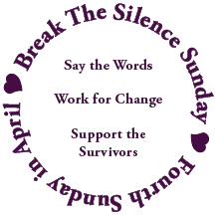

Table Of Contents

Acknowledgements 2

As We Begin 3

Introduction to The 2020 Break The Silence Sunday Materials 5

Sample Newsletter & Bulletin Article 12

Liturgy for Break The Silence Sunday 2020 13

Evening Liturgy For Break The Silence Sunday 2020 33
Liturgical Resources
Notes On Music From The Liturgy 46
A New Song Offering 51
Additional Song Suggestions 52
Additional Prayers & Liturgical Resources 54

Break The Silence Sunday 2020 Scripture Reflections 57

Sermon Suggestions & Advice For Preachers 59

Survivor Reflections
Harold Beer 62

Mollie Wang 63

Trish Kalhagen 68

Sample Sermon ~ Rev Moira Finley 75

Address to General Synod Committee #9 79

Address from Committee #9 to the General Synod Floor 83

Talking With Children & Youth 85

Strings of Strength (SOS) 87

Break The Silence Sunday In A Box 90

Break The Silence Sunday Clergy Commitment 91

Some Statistics 92

Helpful Definitions 94

Resources 96

Space For Notes, Doodles, Dreams, Fears, Questions 99

Feedback Form 100

Acknowledgements

Break The Silence Sunday would not be possible without those who contributed their words, their music, and their prayers. So many people have been a part of the years leading up to this project, who have patiently waited through the frustration, fears, anger, and silence.

- The Rev Franz Rigert for holding opening a door that sometimes still feels closed;
- The friends who have held my hand, offered tea, coffee, wine, and snacks; who have listened to my anger and frustration, and just plain loved me, I owe you more than you know ~ Richard & Trish Bruxvoort Colligan, Bryan Sirchio, Christopher & Carla Grundy (and the Grundlings), Andra Moran, Lisa Hart, Conie Borchardt, Ben Welch, Amy Englesdorfer, Brent & Sara Smith, Jody Clegg, Darryl Commings, Maggie Schultz, Helen Rowinski & Lella Baker;
- Bryan Sirchio for his amazing musical skills in setting my story to song and for the courage that entire experience has given me for this part of the work;
- The folks who have contributed to the liturgy…Christopher Grundy, Bryan Sirchio, Richard Bruxvoort Colligan, Maren Tirabassi, Holly Near, Don Niederfrank,
William Kesting, and Stephen Price;
- The amazing survivors who have offered their reflections and bravely allowed them to be included here: Harold Beer, Mollie Wang, and Trish Kalhagen;
- The churches, communities, and clergy who have been participating in BTSS through these early years, trailblazing with courage and hope and setting an example for what the church truly can be;
- The amazing folks of the Tri-Jo Parish United Church of Christ (Trinity UCC Shiocton, WI and St John’s UCC Cecil, WI and St. John’s UCC Black Creek, WI who trust me with the privilege of being their pastor, and who graciously give me time every year to write these materials;
- Eden Theological Seminary in Webster Groves, Missouri who gave me housing and space in the reading room to write the materials this year;
- Severin Provance, for his logo design;
- My survivor siblings, particularly my support pit bull Lella Baker, who understand how hard this work is, and how incredibly important it is as well;
- My community of friends around the world who remind me that I’m not alone, and that somewhere there is always someone awake who will talk me through the struggle;
- For all the survivors who are stronger than they imagine because they get up and face each day, I hope we have done well by your stories;
- For all of you reading this who shall faithfully plan and lead worship to help us break the silence; my gratitude for your courage.

In faith and hope, Moira Finley
As We Begin

As you begin planning for Break The Silence Sunday you may feel many things, wondering if you can bring this word of hope to your congregation, and how they will respond when you do.

You could be wondering what kind of stories will be shared with you, and if you will be able to hear them with your whole heart. You might be afraid of not knowing answers that you think are needed by those who come to you with questions about this day, with stories of their own, with fears and insecurities.

You might be thinking “do we really need one more special day on the UCC calendar?”

You might be hearing the voice of that parishioner who asks, “Why do we have to do this again?” and you’re trying to find the words to tell them that the reality of rape and sexual violence need to be confronted over and over again until justice has come.

Or you might be thinking that yourself, that two years ago your congregation did something for BTSS so it’s time to move on.

Or you might be thinking, the world’s on fire and there are other things we have to be addressing.

Whatever you’re feeling, and thinking, please don’t panic. Your thoughts and feelings, and those of your parishioners, are understandable.

Yes, we’ve done this before, and we’ll do it again.

Yes, it needed a General Synod resolution and needs recognition on the UCC calendar because that’s the only way some will pay attention.

Yes, there are lots of things we can, and should be addressing and they’re all interconnected (the way we treat other people is mirrored in the way we treat creation).

This is a journey, and every step counts, no matter how tentative.

So sit in a comfortable place, take a few breaths, and then pray this prayer for yourself whether you are clergy or not because you (yes, you) are the one we need, in this moment, to raise their voice for survivors of sexual violence...

A Prayer For Hesitant Clergy
by the Rev Don Niederfrank

Divine Companion, you have encouraged and comforted me
at so many times,
in so many places,
with so many persons.

One more time, I ask, though afraid even in my asking,
be with me.

Strengthen my trembling knees,
that I may stand with those who have too often and too long stood alone.

Call to me in the tumult of my self-focused anxiety,
that I may bring your Presence, your Peace, to those whose terror is real.

Deliver me from my silencing fears
that I may speak your Word.

Holy Shepherd, I am yours. Send me to those you love.

Introduction to The 2020 Break The Silence Sunday Materials &

Notes For Worship Planners and Leaders

Break The Silence Sunday owes an incredible debt of gratitude to the churches and conferences of the United Church of Christ that supported the resolution we brought to the 32nd General Synod in Milwaukee, Wisconsin. Your courage is a model for all of us as we do this work, and your ability to evaluate and support the resolution during the season of Advent is a tribute to the grace that comes, even in the most busy of seasons, to remind us to look for God breaking in to all our lives to build the kingdom.

- St. John’s United Church of Christ of Cecil, Wisconsin;
- Trinity United Church of Christ of Shiocton, Wisconsin;
- St. John’s United Church of Christ of Black Creek, Wisconsin;
- Orchard Hill United Church of Christ of Chillicothe, Ohio;
- Valley City Congregational United Church of Christ of Valley City, North Dakota;
- Westmoreland Congregational United Church of Christ of Bethesda, Maryland;
- Second Christian Congregational United Church of Christ of Kittery, Maine;
- Bethesda United Church of Christ of Bethesda, Maryland;
- First Congregational United Church of Christ of Rochester, New Hampshire;
- Alfred Parish Church United Church of Christ of Alfred, Maine;
- Trinity United Church of Christ of Manchester, Maryland;
- Claremont United Church of Christ of Claremont, California;
- Epiphany United Church of Christ of St. Louis, Missouri;
- Berkeley Chinese Community Church United Church of Christ of Berkeley, California;
- First Congregational United Church of Christ of Grand Junction, Colorado;
- First Congregational United Church of Christ of Indianapolis, Indiana;
- Immanuel United Church of Christ of West Bend, Wisconsin
- Chinese Congregational Church United Church of Christ of San Francisco, California;
- Pilgrim United Church of Christ of Grafton, Wisconsin;
- Peace United Church of Christ of Webster Groves, Missouri;
- Wisconsin Conference United Church of Christ
- Penn Northeast Conference UCC

The resolution was assigned to committee number nine, under the leadership of the Rev Cheryl Lindsay, who led us with faith, and grace. The committee did incredible work, opening their hearts, minds, and spirits to the challenge of addressing sexual violence within the church. Stories were told, tears were shed, and the presence of the Holy Spirit was most surely felt.

The committee made several changes to the resolution, strengthening the historical background section reminding us that the universal church has often been complicit in perpetuating not only sexual violence itself, but also the victim blaming, the culture of purity, and the myth of easy forgiveness.

The committee also strengthened the wording of the be it therefore resolved sections, calling on the church to pay particular attention to the needs of survivors who are often overlooked including survivors of colour and GLBTQAI+ survivors. Unfortunately, in our attempt to be inclusive and avoid the gender binary, we failed to specifically include male survivors who struggle in particularly specific ways because of the cultural assumptions about what it means to be male. Please be reassured that we are trying to pay attention to the ways that BTSS can help churches create space for male survivors, as well as other specific survivor communities.

The committee referred the resolution to the floor of the General Synod where it passed with an overwhelming 691 votes in favor and 10 opposed. Now, of course, the real work begins: helping survivors know that they are believed and loved by God, helping congregations throughout the U.C.C. bring Break The Silence Sunday into their communities, and helping the church universal speak out against the horror of rape and sexual violence. Moving forward we will be looking to organize a small group of folks (clergy and laity, survivor and ally) who will help guide the vision of BTSS as it moves into its next phase. We will also be looking to expand our writer community with people from all walks of life who can help us dream bigger, more radical, and faithful things.

In the midst of all this work, rape and sexual violence continue to be in the news. As this is being written, in New York a jury is being selected for the trial of Harvey Weinstein (the Hollywood film producer accused of rape, sexual assault, and sexual abuse) and in Cyprus, a young British woman has been sentenced to jail (albeit a suspended sentence) for making a false rape claim despite biological and video evidence to the contrary. Articles have appeared saying that the #metoo movement has passed its prime, that it’s doing more harm than good. Dr Dennis Mukwege and Nadia Murad were awarded the 2018 Nobel Peace Prize “for their efforts to end the use of sexual violence as a weapon of war and armed conflict". Chanel Miller, previously known as Emily Doe (the victim of Stanford rapist Brock Turner), bravely came forward to share her story in an effort to destigmatize being a survivor.

And in our daily lives, things continue to be both struggle and triumph. I wrote last year that ugly things have been revealed about our society, things brought out into the open – racism, sexism, heterosexism, and their related prejudices – that had once been hidden. It’s a good thing to bring them out into the open because they only get stronger when they’re hidden, but at the same time it’s making life quite literally a living hell for many victims and survivors.

For every case that makes the national spotlight there are hundreds of thousands of cases in our own neighborhoods. For every survivor bravely and publicly speaking up, there are so many more struggling with their stories in silence and fear. For every survivor who finds support and resolution in the criminal justice system, there are legions of survivors who are belittled, doubted, judged, blamed, and harassed by the same system.

Friends, these are hard times for survivors of rape and sexual violence. Old wounds have been broken open by public discourse, by folks who think asking for trigger warnings makes us weak and fragile, and by simply living in a world where rape and abuse are still used as plot points to make movies and TV more “believable”.

Now, more than ever, we need to hear the voice of the church. We need to hear of God’s radical and welcoming love that embraces survivors as they are, that offers support instead of doubt. We need to hear from the church that you are willing to sit with the pain of being a survivor instead of rushing us to move through it with cheap and flimsy theologies about grace and forgiveness. We need to hear from the church that survivors are whole as they are, that their stories have meaning and value in the community of Christ’s people. We need to hear, clearly and often, that we are believed.

We, as the church, can no longer afford the excuses. We can’t say it’s private and personal or that it will make people uncomfortable. We can’t defend our silence because we are under or un-prepared. We can’t use our support of comprehensive sexuality education as a reason why we can let support of survivors fall away. Please don’t read that to mean we think sexuality and consent education don’t matter. They are indeed an incredibly important part of the church’s wider work in changing rape culture, BUT they are not enough. For survivors sitting in our pews, that education didn’t work, and it’s too late. We can and must do both – sexuality education AND support survivors.

Yes, it will be overwhelming. Yes, you will hear things you’d rather not – stories of violence, power, and fear. Yes, your heart will break because in so many of these cases there is nothing you can do except listen. But don’t ever underestimate how incredibly important listening is. A shared burden is a lighter burden, and a kind heart that is willing to sit with the awfulness of a survivor’s story makes more of a difference than you may ever know. Imagine the power of an entire community, a congregation that seeks to follow Jesus, sitting together with the collective pain and grief of survivors and testifying that, despite being uncomfortable and afraid, they know their words, songs, and prayers are opening up holy, healing spaces for survivors, allies, and the entire body of Christ.

So here we are with Break The Silence Sunday, now in its fifth year and with a General Synod resolution in our tool box, to help you and your community reach out to courageously support survivors, and to speak out clearly denouncing rape and sexual violence as crimes against the body of God.

To do this, you will need to prepare – yourself, your worship team, and your congregation/community. You need time, and patience, and support. You can email us at breakthesilencesunday@gmail.com for support at any time. On our website, you’ll find other contact information: https://breakthesilencesunday.org/contact-us/ Please don’t hesitate to reach out, let us know you’re with us in the work, send cute pictures and memes (we all need a break from the intensity of this work sometimes).

In the meantime, welcome to the work!

Prepare Yourself
Start with some deep breaths and a nice cup of tea (or whatever helps you). Seriously, you need to care for yourself so that you are equipped to care for others. You need to pray, to ask God to guide and sustain you during this time, to fill you with a spirit of gentleness and humility, and to give you the words that you truly need to speak in this time, and in your particular place.

Prepare Your Worship Team
They might like some tea and cookies as well. Then start with some prayer, relying on God’s guidance and love as you plan your Break The Silence Sunday services. Think together about how this time will be structured, what the pace will be, what the lighting will be like, what all the other wordless things are that contribute to or detract from worship. Whether you’re using these materials to plan an entire service dedicated to BTSS, or you’re going to have a mid-week time of prayer, or an evening healing service, or a single prayer in the midst of other things, you need to pay attention to your feelings, and those of the other worship leaders, honoring and respecting the stories, fears, and hopes you bring to this moment.

An important note – it is our strong belief that no one under the age of 18 should be involved in the leading of worship for BTSS, and particularly that no one under the age of 18 should ever be sharing their story in public without an abundance of preparation.

There are, of course legal issues, and if you’re a clergy person reading this you are most likely a mandatory reporter. In addition, disclosing and sharing your story as a survivor is profoundly difficult under the best of circumstances. There are, perhaps, situations in which a survivor, their parents or guardians, and others decide that it will be a good and transformational thing to share their story, but that situation is the exception to the rule.

Prepare Your Congregation & Community
Start NOW. Yes, NOW. They need lots of time to prepare because this is hard. These materials come to you in February with a proposed observance in April because you really, truly do need these months. Everyone needs to be made aware that Break The Silence Sunday will be observed, that explicit words like rape and assault will be used during worship. They need to know that worship will likely be emotionally challenging, regardless of the specific words used, because you will be talking about things many would rather we never spoke of.

Prepare Survivors In Your Community
If you know who they are, please reach out to them individually to prepare them. Don’t let them just hear about BTSS in your newsletter or on your social media pages. Let them know, well in advance, what you are planning, perhaps even sharing a draft of the worship service to help them see what will happen. Reassure them that it’s OK if they opt out of worship that day, if the service is not something they are prepared for at this point in their lives, that you understand the opening of wounds that might happen during worship could be overwhelming. Remember that not every survivor is at a place where their participation in or presence at Break The Silence Sunday is either healthy, or safe. They may have resistance to the work of BTSS, and that’s ok. Go gently. And if you’re thinking to yourself that there aren’t any survivors in your community or congregation, think again. You only hear the stories survivors can bear to tell, and the pure math tells us that there are absolutely survivors who worship with you. The most conservative estimates are that 1 in 6 women and 1 in 33 men are victims of sexual violence in their lifetime. In reality, because of low reporting rates and other factors, it’s probably closer to 1 in 3 women and 1 in 10 men. Think of your community, the people you sit with during worship. Some of those people are survivors, most of them whose stories you won’t know. They need your help in preparing for Break The Silence Sunday as well.

Prepare For After BTSS
You will also need to do some after-care – for yourself, your worship team, and your community – so prepare for that too. Take the time you need to think, pray, and reflect on how the observance of Break The Silence Sunday went. Make sure you know your local resources for survivors who may come forward and need help accessing clinical help, and then offer to go with them, or meet them after for coffee, or simply be with them. When a survivor shares their story with you, be gentle and remember that they are trusting you with some of the hardest parts of their life, hoping that you will be the living presence of God in their lives.

Through all of this, please try to keep in mind that Break The Silence Sunday is a movement and a work of hope. It is a movement, and it takes time. We believe that, as individuals, as congregations, and as the wider church we can do better in supporting survivors, creating space where they feel safe sharing their stories, and honoring their courage and resiliency. We can find new ways of thinking about, and talking about our faith that don’t glorify suffering and don’t perpetuate the abuse that so many have suffered. And we believe that we can work together to change the culture that allows sexual violence to happen, building a future where survivors can share their stories without shame, and where all can live free from sexual violence.

And if nothing else gives us reason to hope it’s that you, yes you, are sitting here reading this material. Maybe your community has a supportive pastoral staff and all you need to participate fully. Maybe you’re the pastor who is going to invite your congregation to observe BTSS for the first time and you’re anxious, but also confident, that it’s what your community needs right now. Maybe you’re reading this and thinking you’d like to suggest it to your pastor or worship committee or whoever in your context might be most supportive, and you’re just not sure any of them will be. Maybe you’re a survivor who thinks you’re perhaps, possibly ready to share your story and hoping your faith community will receive it with grace and love. Whoever you are, whatever the situation you find yourself in, you are the reason Break The Silence Sunday will ultimately make healthy, sacred space for survivors in our faith communities.

The suggested date for Break The Silence Sunday is the fourth Sunday of April. This keeps us within the national observance of Sexual Assault Awareness Month (SAAM), but it is just a suggested date. In 2020, that date is Sunday April 26th. This is, in the UCC’s calendar also Pacific Islander Asian American (PAAM) Sunday, a vital part of the diversity of our life together. There are also churches that will observe Earth Day events at the weekend, particularly given the current state of climate crisis and that 2020 is the 50th anniversary of Earth Day.

Please feel free to pick a time that works best for your community. Some have held observances in October during the observance of Domestic Violence Awareness Month, remembering that much rape and sexual violence occurs within domestic relationships. Other communities observe during the summer, and still others find Lent an appropriate time to take on the challenging work of learning about sexual violence and creating space for survivors. Whatever date you choose please feel free to adapt these materials, use them for inspiration, and craft whatever you need – worship, prayer, study – that best fits the needs of your community.

There are a few new things for this the fifth year of BTSS:
- an evening worship liturgy, coming from the needs of my own parish where one of our three churches worships on Sunday nights;
- Strings of Strength (SOS), a project to provide comforting items to survivors who share their stories;
- the opportunity to get a BTSS Box with promotional materials, display information, and more for your church, or wider church event.

If you’ve been with us from the beginning, thank you. You may well see similarities between this year’s basic materials and those from previous years. We continue to work on the possibility of a three year cycle of readings, hymns, and prayers along with new material for each year. The archive of materials is available on our website and you are welcome to change and modify them so they work best for your community. All we ask is that you use proper attribution for those who have written these materials.

Please, whatever you do, we would appreciate feedback about what you liked, and didn’t like, about these materials, what worked for you, what was a challenge, and what could be provided in coming years to help you better implement BTSS in your community. There’s a feedback form at the end of these materials if you’d like to mail it in, of you’re welcome to send questions and comments to our email at breakthesilencesunday@gmail.com.

Again, please be in touch if there’s anything here you need to talk through, if you have questions or concerns, if you need to share your story, or if you just need a cheerleader as you work towards bringing Break The Silence Sunday to your community.

God’s blessings on your work.

Peace and grace, Moira Finley

Sample Newsletter & Bulletin Article

It’s in the news nearly every day, a story of sexual harassment, abuse, rape, and violence. The #metoo movement, and some high profile cases have broken open things that have lived in hiding for decades. Every day courageous people are speaking out.

Survivors can’t do this on their own. We too, as people of faith, must be courageous.

The survivors of sexual violence are our friends, neighbors, colleagues, family, and members of our congregation. They need us to help them, to listen as they speak out, to create a place where their stories can be heard without fear, or judgment. They need us to witness with them to the pain of their stories, and to stand with them, reminding them of the healing love of God.

Join us for Break The Silence Sunday on _________________.

In worship we will acknowledge the reality of rape and sexual violence, that every 98 seconds someone in the United States is raped or sexually assaulted.

We will hear the stories of survivors, trusting in the good news of God’s love and grace.

We will commit ourselves to being a listening people, and a people dedicated to changing the reality of violence in the world.

This service may be difficult and challenging. Some parents may not want their young children to be present. Please take time to prepare yourself . Ask God for the strength to open your heart and mind, that we shall support all the survivors who are part of our church, our community, and the world.

If you have questions or concerns about the service, or if you would like to help with worship leadership, please contact ___________________

Liturgy For Break The Silence Sunday ~ April 26, 2020

Unless otherwise noted, prayers are written by the Rev Moira Finley.

Musical Prelude

Welcome
Welcome to worship. Today we stand with all who have been victims of rape and sexual assault. We witness to their pain, and their strength; to their questions, and their faith; to what keeps them up at night, and what they need from us, as individuals and as communities of faith. Today we start to speak out, to break the silence of complicity and fear, and through it all trust in the good news of God’s incredible love for us, and for all the world.

Call To Worship

One: We gather today, a community of hope,
Many: surrounded by the grace of God,
One: filled with the love of Jesus,
Many: trusting in the Spirit’s presence.

One: We gather today, a community of compassion,
Many: to listen to what may break our hearts,
One: to hear the pain of our siblings in faith,
Many: to speak together words of comfort and commitment.

One: We gather today, a community of justice,
Many: to worship,
One: to pray,
All: to break the silence!

Gathering Prayer

Inspired in part by a prayer by Howard Thurman, the full text of which may be found in the Liturgical Resources section. The prayer is intended to be said responsively with the leader having the lines in regular type and the congregation the lines in bold type. The prayer could also easily be said in unison, removing the phrase “Holy One, help us” from between the stanzas, retaining it as the closing line of the prayer.

Holy One, you breathed the world into being, and in your love you created each of us, a living embodiment of your image.
You weep with us when our hearts are broken, and you carry our pain with us when it is too much to bear.

Holy One, help us.

You know the stories our siblings hold in their hearts, and their bones.
You know their fear, the shame and grief that lives in them because it has not been given voice.

Holy One, help us.

We cannot fully know the pain of those who have experienced sexual violence, nor truly understand what they feel, but we offer what we can – the strength of our caring, the warmth of our efforts to understand, and the presence of our lives that their path, as lonely as it may be, will never be walked alone.

Holy One, help us. Amen.

Hymn ~ “Help Us Accept Each Other”, New Century Hymnal #388
Lyrics: Fred Kaan
Tune: Aurelia (“The Church’s One Foundation”), Samuel Wesley

Help us accept each other as Christ accepted us;
teach us as sister, brother, each person to embrace.
Be present, God, among us, and bring us to believe
we are ourselves accepted and meant to love and live.

Teach us, O God, your lessons, as in our daily life
we struggle to be human and search for hope and faith.
Teach us to care for people, for all, not just for some,
to love them as we find them, or as they may become.

Let your acceptance change us, so that we may be moved
in living situations to do the truth in love;
To practice your acceptance, until we know by heart
the table of forgiveness and laughter’s healing art.

God, for today’s encounters with all who are in need,
who hunger for acceptance, for righteousness and bread,
Bring us new eyes for seeing, new hands for holding on;
renew us with your Spirit; God! Free us, make us one!

Why We Have Come ~ Acknowledging The Reality Of Sexual Violence

This prayer is not necessarily one for survivors to pray. It is, instead, for those who have had the privilege of living free from these experiences, perhaps with blinders on, unaware of the reality of rape and sexual violence in our communities, and around the world. During this prayer you might consider lighting candles (or inviting survivors and allies to do so) to symbolize the experience of all those who live this reality in their daily lives.

One: We have come…

Many: to listen, and to hear things that will unsettle us, and make us uncomfortable, challenging things we think about the world.

One: We have come…

Many: to hear the guilt, fear, and shame that survivors carry, the stories of those who have survived things we cannot begin to imagine.

One: We have come…

Many: to listen to what keeps our siblings up at night, to listen with compassion, and love.

One: We have come…

Many: to be present for survivors, doing our own spiritual work, so that we might listen without judgement or pity.

One: We have come…

Many: to hear the memories, and nightmares, and flashbacks; the violation, cruelty, and suffering.

One: We have come…

Many: to remember that not everyone survives the violation of rape and sexual assault, and that the grief and pain overwhelm many who seek to escape through self-harm, and suicide.

One: We have come…

Many: to commit ourselves to the messy, difficult, sometimes excruciating work of changing the world, to the path that Christ showed us, the work of making the world whole.

One: We have come…

Many: to remember that taking small, uncertain steps is an okay way to begin, that we do not have to do everything, but that we must do something, that we must listen, and then raise our voices for the world is depending on us.

All: Amen.

Hymn ~ “We Have Come”
by Christopher Grundy, © Hand and Soil Music, 2009; used with permission
(this was written to be sung acapella)

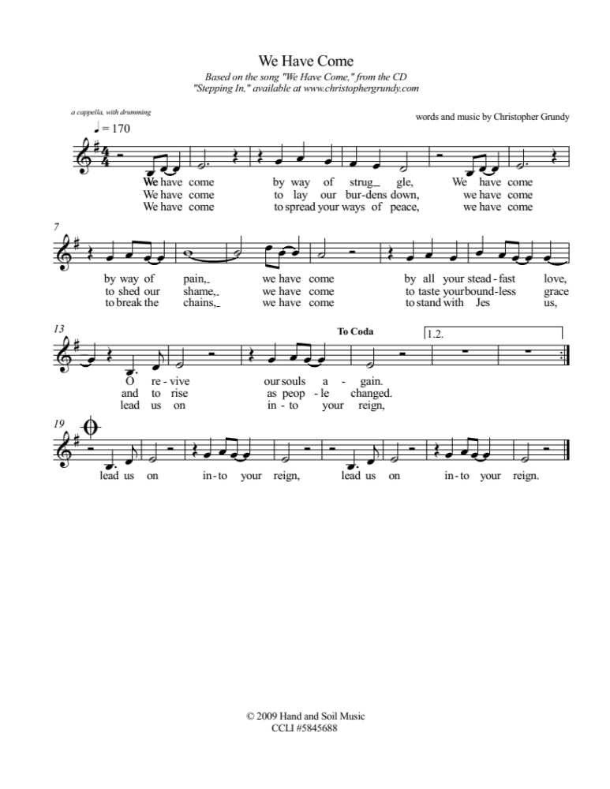

Breaking The Silence ~ A Time For Prayer
Silence in worship can be powerful, a time for people to listen to the voice of their heart and soul, to connect with the Holy, and to rest in the knowledge that we are held in God’s care. However, this is Break The Silence Sunday, a time to no longer keep silent about things that must be spoken if the body of Christ is going to be whole.

This time of prayer seeks to provide some silence, acknowledging the reality of rape and sexual violence, but also breaking the silence of our complicity. In the United States, someone is sexually assaulted an average of every 73 seconds. While this prayer uses statistics for the U.S., the problem is not unique to our country, and so we stand with our survivor siblings around the world who live in the shadow of rape, and sexual violence.

This prayer can be unsettling, partly because we are not accustomed to silence, but also because it demands we pay attention to the urgency of this work. Allow that unsettledness to be real and recognized, and work towards trusting that God is with us in even our most unsettled and uncomfortable moments.

One: Once, in every seventy-three seconds…

a silence of 73 seconds is held, then a bell is chimed

One: Once, in every seventy-three seconds someone in the United States is sexually assaulted.

a silence of 73 seconds is held, then a bell is chimed

One: Once, in every seventy-three seconds, 1,184 times every day someone in the United States is sexually assaulted, and the church?

a silence of 73 seconds is held, then a bell is chimed

One: The church has been deafeningly silent, shaming survivors, perpetuating a culture of victim blaming, and offering up pity, contempt, and harmful theologies when survivors dare to speak the truth of their experience.

a silence of 73 seconds is held, then a bell is chimed

One: The time for our silence as the church is over. Rev Dr Martin Luther King, Jr once said, “In the end we will remember, not the words of our enemies, but the silence of our friends.”

a silence of 73 seconds is held, then a bell is chimed

One: It is time for us, the body of Christ broken by rape and sexual assault, to speak up. Our survivor siblings can wait no longer. We must open our hearts, our minds, and our churches to the stories of survivors, trusting in the grace and love of God that sustains us, and that can, in time, bring hope.

a silence of 73 seconds is held, then a bell is chimed

One: Now! Now is the time for us to break our silence!

a bell is chimed

Sung Response ~ “I Am Welcome”
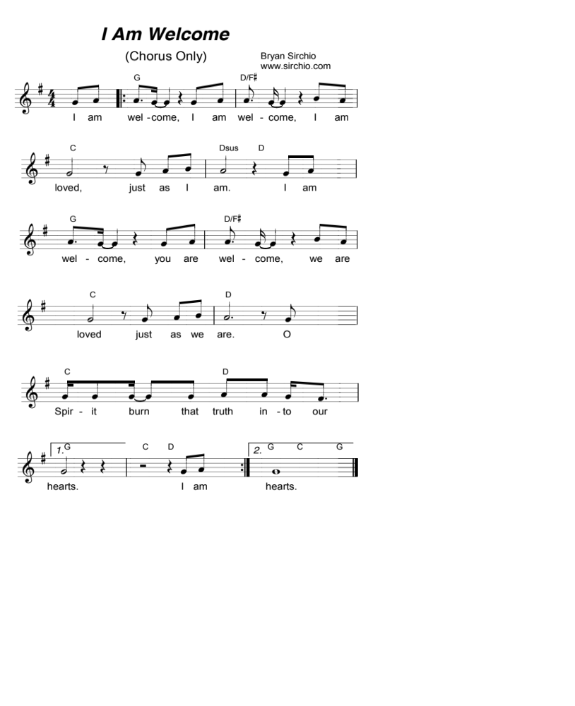
by Bryan Sirchio, used with permission (see Liturgical Resources section for accompaniment)

Invitation To Confession
We have, as the church and as its individual members, been silent when lives of are shattered by sexual violence. We have shied away from those who would share their stories, afraid of what we might hear, of what it might mean for us, and for our lives. We have been quick to ask questions – what were you doing, what were you wearing, why didn’t you fight back – placing blame on survivors instead of where it belongs, with the perpetrators. We have offered flimsy theology, holding on to unhealthy ideas about purity and virginity, demanding quick forgiveness, and ignoring our own involvement in a system that allows sexual violence to continue. Together let us confess trusting in God’s grace to lead us on a new path.

Responsive Prayer Of Confession

This prayer is intense, calling out the reality of sexual violence and our complicity in it, individually and as the church. Don’t rush through these words. Allow this prayer to take some time. Remind people that it’s ok if the words are too hard to say out loud, at least right now, and that praying them in their hearts is an important first step. This prayer could also be said as a unison prayer, combining sections and allowing a brief time for silence after each section.

One: Today we have come to listen, and to take responsibility.

All: We have come to confess what we have done, and failed to do, that has allowed sexual violence to continue and has caused survivors to feel that they cannot share their stories with us, in the shelter of Christ’s church.

One: We confess that sexual violence is real and present in our communities, in our church, in our families, and around the world.

All: We confess that we are afraid, that we would prefer to believe the statistics are wrong.

One: We pretend that this kind of violence and violation can’t happen to us, or to someone we love.

All: We pretend that we don’t know any survivors, that no one in our family, none of our friends, and surely no member of our church could possibly have endured what we cannot face.

One: We confess that the church has often silenced survivors with bad theology, holding up sacrifice and suffering as ideals of faithful living, and shaming survivors with our assumption that rape and abuse are about sex, rather than acts of violence, power, and control.

All: We confess that we feel powerless, that we do not know how to help.

One: We confess that our fear of what we might hear, of what survivors might tell us, is paralyzing.

All: We confess that it feels like anything we might do is too small to matter, that the reality of rape and sexual violence seems overwhelming.

One: And yet, we confess that we know we must do something, that our siblings are depending on us to listen, to hear them, to honor their questions and their struggles, to speak out, and to work for change.

All: We pray for the grace to be present, with open hearts and minds, that the wounds might begin to be healed, and that the world might begin to be changed. In hope we pray, Amen.

Assurance Of God’s Grace

Holy One, you know who we are, and who we might yet become. You know where we have not done the work of listening, of supporting, and of working on behalf of those who have suffered violence. We trust in your forgiveness, in another chance to be good companions on the journey with those who have experienced the trauma of rape and sexual violence. We give thanks for your grace and love that will not leave us where we are, but that guides us as we work with you, and with one another, to rebuild the world. Thanks be to God.

Scripture Readings

These are suggestions, but there are many other scriptures you might consider. Please see the Liturgical Resources section for suggestions. These are adapted from the NRSV for more expansive language about the nature of God.

Isaiah 43.1-3a ~ God’s promise to name and claim each of us
But now says the Lord,
the One who created you, O Jacob,
the One who formed you, O Israel:
Do not fear, for I have redeemed you;
I have called you by name, you are mine.
When you pass through the waters, I will be with you;
and through the rivers, they shall not overwhelm you.
when you walk through fire you shall not be burned,
and the flame shall not consume you.
For I am the Lord your God,
the Holy One of Israel, your Savior.

Psalm 121 ~ Trusting in God’s presence on our journey of life
I lift up my eyes to the hills –
from where will my help come?
My help comes from the Lord,
who made heaven and earth.
God will not let your foot be moved;
the One who keeps you will not slumber.
The One who keeps Israel will neither slumber nor sleep.
The Lord is your keeper;
the Lord is your shade at your right hand.
The sun shall not strike you by day,
nor the moon by night.
The Lord will keep you from all evil,
God will keep your life.
The Lord will keep your going out and your coming in
from this time on and forevermore.

Luke 8.42b-48 ~ Jesus heals a woman with a flow of blood
As Jesus went, the crowds pressed in on him. Now there was a woman who had been suffering from hemorrhages for twelve years; and though she had spent all she had on physicians, no one could cure her. She came up behind Jesus and touched the fringe of his clothes, and immediately her hemorrhage stopped. Then Jesus asked, “Who touched me?” When all denied it, Peter said, “Master, the crowds surround you and press in on you.” But Jesus said, “Someone touched me; for I noticed that power had gone out from me.” When the woman saw that she could not remain hidden, she came trembling; and falling down before Jesus, she declared in the presence of all the people why she had touched him, and how she had been immediately healed. He said to her, “Daughter, your faith has made you well; go in peace.”

Sermon/Reflection/Stories From Survivors/Speaker From Crisis Shelter

Sung Response ~ “God Who Remembers”
by Richard Bruxvoort Colligan, used with permission
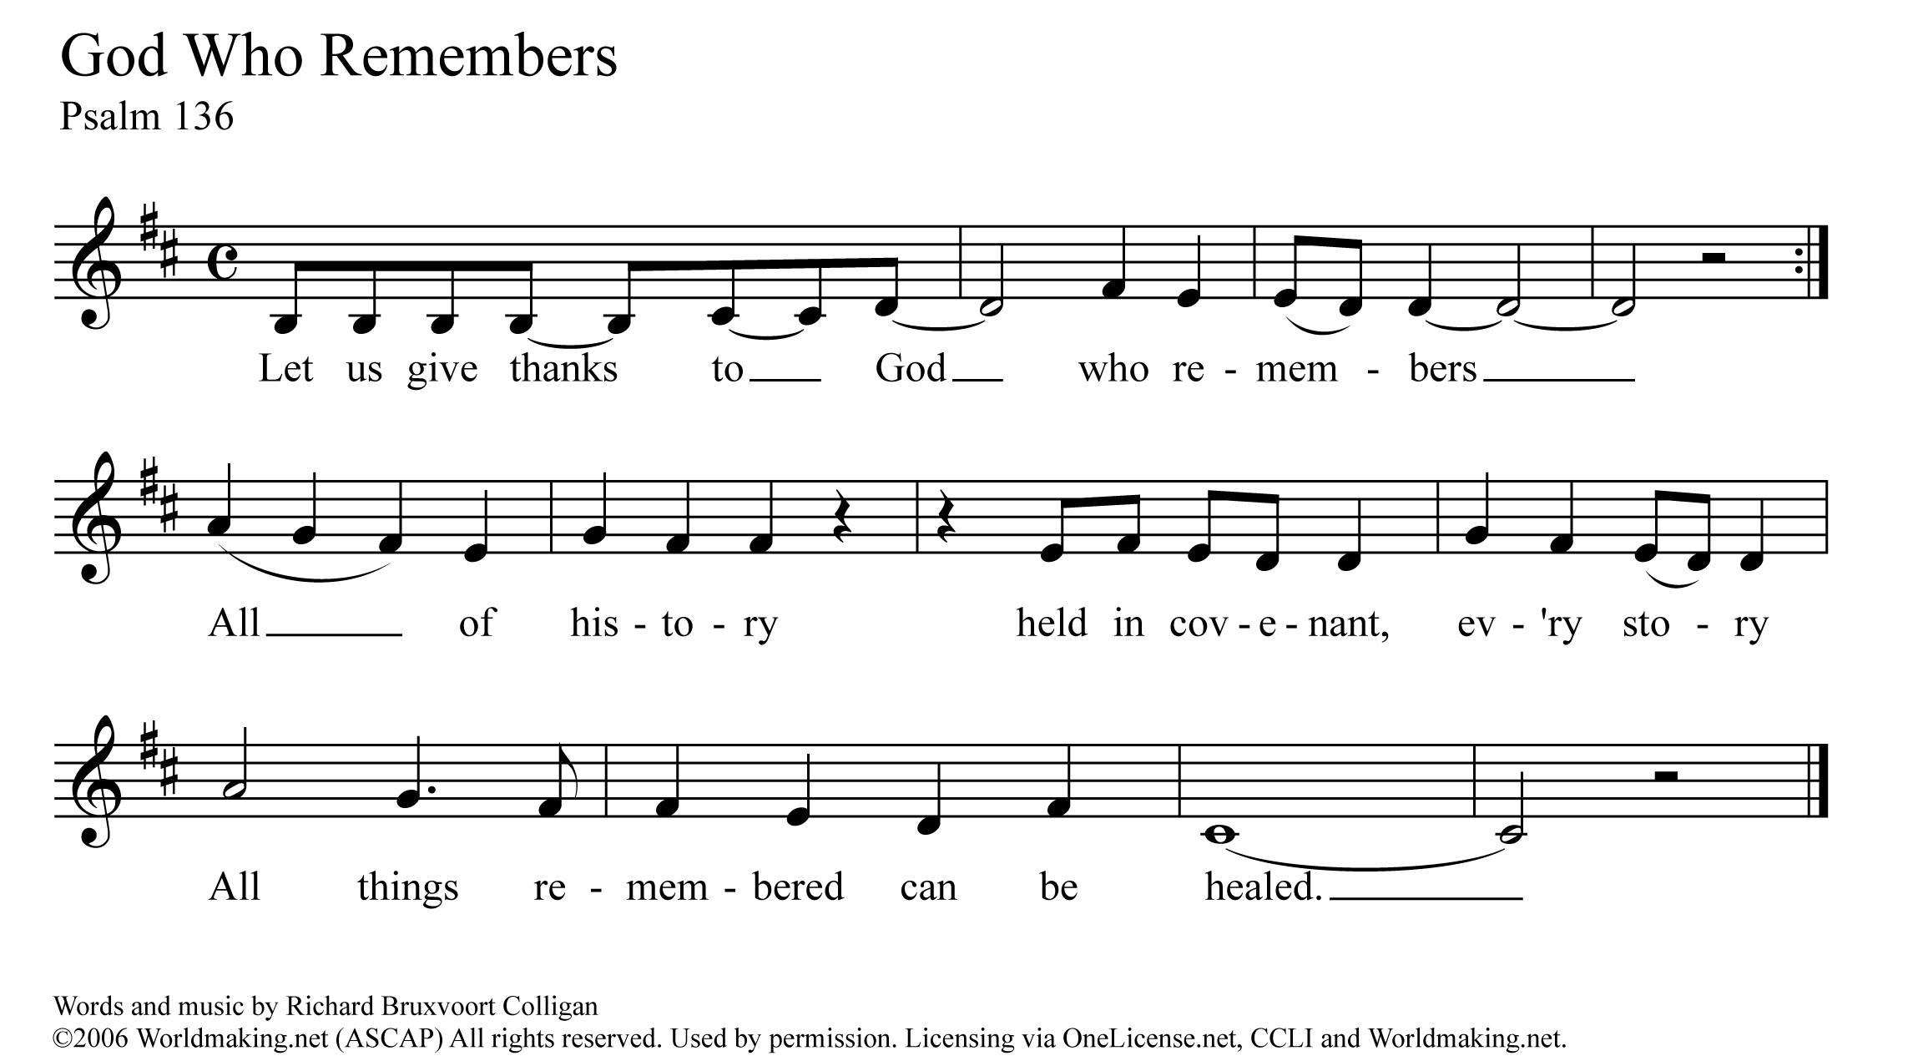
(please see Liturgical Resources section for accompaniment)

A Time Of Prayer
Holy One, you filled the world with your love, and your Spirit, breathing into each of us the breath of life. You named and claimed each of us as your very own. But some of your beloved children have been hurt, deep in their souls. They have experienced great violation through rape, abuse, incest, harassment, trafficking, and assault.

Listening God, your children come asking to be heard and believed, welcomed into the body of Christ as they are, without judgment or shame. They come, needing to be healed by your unending love and grace. They come, asking us to stand with them and work for justice.

Nurturing God, we pray for your healing this day. We pray for your love to be poured out abundantly on all those who have been hurt by rape and sexual violence – the survivors, and those who love them. May your healing presence guide every survivor in their path towards wholeness, and hope.

Courageous God, we pray your Spirit would fill all of us gathered here today. May we have the wisdom to listen, to hear, and to be changed. May we have the strength to speak out, to be bold, to trust in you. May we have the words we need to offer comfort to those who struggle, and the commitment we need to work tirelessly for the wholeness of all your people, and all creation.

These and all our prayers we pray with the words Jesus taught his first disciples, saying together…

The Prayer Jesus Taught
Our Father, who art in heaven, hallowed be thy name, thy kingdom come, thy will be done, on earth as it is in heaven. Give us this day our daily bread, and forgive us our debts as we forgive our debtors. Lead us not into temptation, but deliver us from evil. For thine is the kingdom, and the power, and the glory forever and ever. Amen.

Offering Our Gifts
You might consider designating the offering, or a portion of it, to the local sexual violence resource center in your area, or to a national organization such as RAINN (Rape Abuse Incest National Network). You can also help the work of Break The Silence Sunday by making a donation to our ministry. Gifts are welcome electronically with PayPal & Venmo at breakthesilencesunday@gmail.com and information about other ways to contribute to our work can be found on our website: breakthesilencesunday.org

Unison Prayer Of Dedication
Generous God, we are grateful for all that you have given to us. We bring you these gifts, signs and symbols of our gratitude. We entrust them to you in the faithful hope that the work Jesus began – the work of listening to the stories of God’s people, of healing the brokenness of the world, and of restoring creation – might continue in us, and through us. Grant us the courage and the faith to listen, to pray, and to speak out. In hope we pray, Amen.
Hymn ~ “I Love To Tell The Story
Re-sung For Break The Silence Sunday”
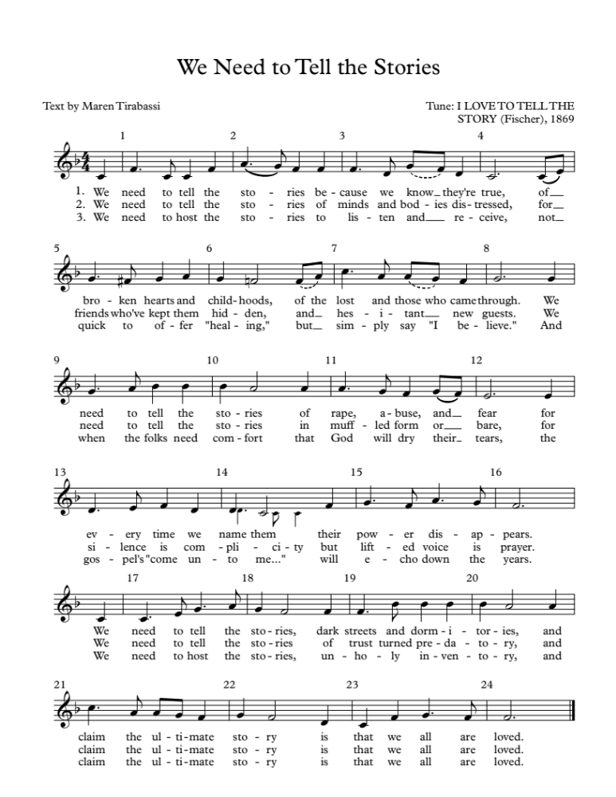

Celebrating Communion
One: This table is not ours, but it belongs to God. All who seek to be fed and nourished by God’s grace, and sustained by this community are welcome to share at this table. We come, from the shadows of a waiting, hurting world, knowing that, wherever we have been, whatever we have experienced, we will be fed, nurtured, and renewed. We reach for the bread of God’s grace, aware of a hunger in our souls for a world of compassion and peace. We reach for the cup of God’s love, aware of an unquenchable thirst in the depths of who we are, a thirst for justice and hope. We come, trusting that God will meet us here. Let us pray together…

All: Holy One, we come to share the richness of table. We ask for your healing grace to be poured out on all those who have suffered sexual violence. Renew and restore them, and your church. Be present with us, and remind us that your presence is with us always. Give us the courage to truly be the Body of Christ.

One: Gracious God, we come to this table to know you, to remember your love, and to confess that your grace is for all. Some of us come to this table tired and anxious. Some of us come with hope in our hearts. All of us come, trusting in your Spirit’s presence, and trusting in the promise that we might all be One, whole and healthy, as your people. Let us pray together…

All: We thank you God that, in Jesus, you have given us the greatest gift, the gift of your very self. We thank you that he lived among us, and knew what it was like to be human. Feed us at this table, and give us the courage to be faithful to the One who dared to come into our world. Renew and revive us. Give us the courage to listen, and to speak out today and always. Amen.

One: We know the stories about Jesus’ life, how he would come to share many meals with his disciples and friends. He would welcome those who had been cast to the margins of society, eating with sinners and prostitutes, with the sick and the lame, with the wealthy and the poor alike. On one of those occasions, as his earthly life was nearing an end, he found himself with his disciples and those who had followed him closely in an upper room in Jerusalem. They were there to share the story of hope, of release from captivity, of God’s promise of freedom. During the meal he would take the bread, bless it, break it, and offer it to them saying, “this is my body which is given for you.” Later, after supper, he would take the cup, give thanks, and say, “this cup is a reminder for us of the new relationship God has made possible between us, and all of creation.” The bread we share is a reminder for us that just as God blessed Jesus with an earthly body, so our earthly bodies are blessed. The cup we share is a reminder for us of Jesus’ life, and the grace of God that Jesus came to help us know. We pray that God would bless this bread, and this cup, and us as we receive them. We bring all our lives to God at this table, that we might be one people, united as the Body of Christ, working together for justice and peace. The gifts of God for the people of God. Come for all things are now ready. Come and see how good God is.

Sharing The Elements

Unison Prayer Of Thanksgiving
We give you thanks, Gracious God, that you come to us in bread and cup, and in the love of this community. Send us from this table, nourished and empowered. Help us listen with all our hearts, and speak with all our minds, that all your people might truly know peace. Amen.

Committing Ourselves To Change
One: In the presence of one another, we pledge ourselves to ending the violence of rape and sexual assault, working towards a vision of the Beloved Community where all can live in dignity and peace. We acknowledge the reality of rape and sexual violence, a plague that brings hopelessness and fear to our siblings here, and around the world.

Many: We stand in solidarity with those who have been victims. We promise to be open to their stories, and with the grace of God, to listen and hear without judgment.

One: We know the promise of wholeness, and hope that Jesus came to bring to the world.

Many: We affirm the promise of God’s love for all the survivors in our world, those whose stories are known to us, and those whose stories are still shrouded in silence and fear.

One: We know that we have not done enough, that we have been silent when those around us have been struggling.

Many: We look forward with hope, trusting in God’s ability to give us strength to listen with courage, and to be silent no longer.

One: We believe that the future depends on us.

Many: We believe that there is something we can, and must do, as people of the Good News, and as members of one human family, to end the violence of rape and sexual assault.

One: We recognize that we cannot do this alone. We know we must learn to depend on each other, and on God, in the struggle to end sexual violence, and create justice.

All: Gracious God, help us to be aware of your loving disruption of our lives. Give us the courage to work with you, and with each other, to transform our hurting world. Empower us with your Spirit that we might break the silence of sexual violence. Help us listen and move together, from fear and pain towards your realm of peace and justice. In Jesus’ name we pray, Amen.

Hymn ~ “We Are A Gentle, Angry People”

by Holly Near, used with permission

These images are from “Singing The Living Tradition” © 1993, Unitarian Universalist Association of Congregations

You may, of course, choose whichever verses best fit your context.

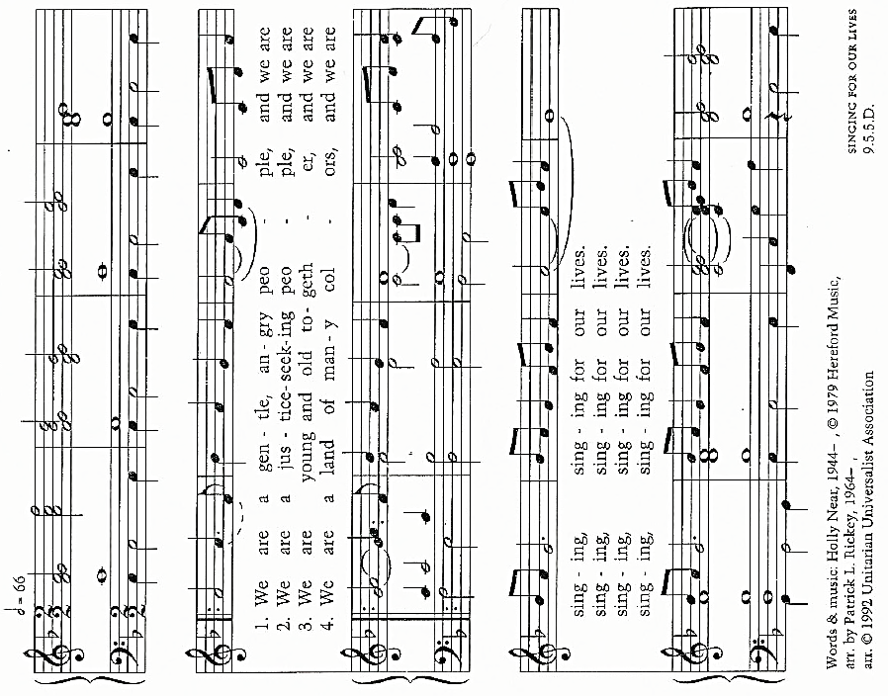

song continues on following page ---->

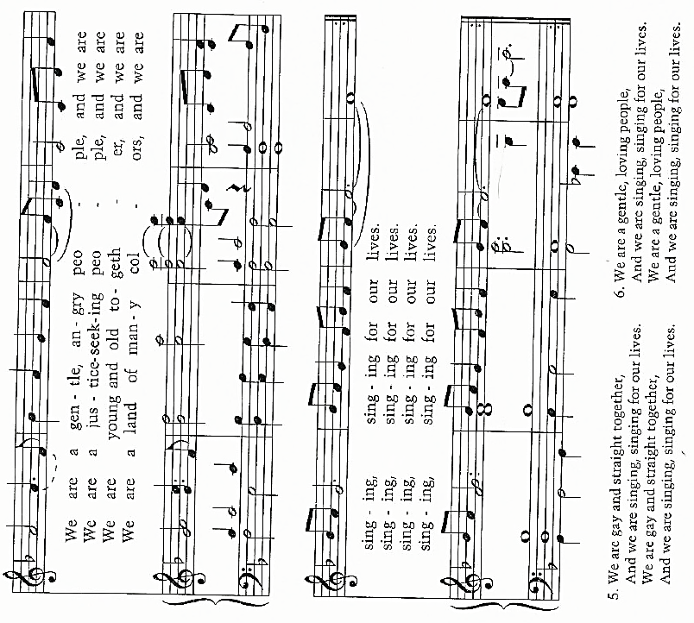

Benediction & Musical Postlude

Evening Liturgy For Break The Silence Sunday ~ April 26, 2020

One of the churches I serve worships on Sunday evenings. The rhythm of that worship is different. We are ending our day, thinking about all that the week ahead will hold, and getting ready to head towards bed. The worship we share is designed to help enter more fully into our trust in God, releasing whatever we have been doing during the day, and helping us find some peace before our night’s rest.

Some of the prayers are the same as in the liturgy above, and others have been written specifically for an evening service, either on a Sunday or at another time when your community gathers. As with all the BTSS materials, please feel free to adapt and interpret this liturgy as it best fits your community.

Pay particular attention to your selection of songs and hymns, thinking about ones that will allow people to slow down, to rest their bodies and souls in the music. Simplicity and repetition can be extremely helpful in an evening service’s music choices. Some suggestions are made here, but please use the ones that your community knows, that speak to your experience of the God who desires wholeness for us, and for all creation.

An important part of our evening worship is also remembering that we are embodied, that we were created in love, by God, in God’s very own image. Feeling at home, safe in a body that has been violated is something many survivors struggle with. Recognizing that a body that has been violated could still be in the image of God is an even greater struggle. Part of this liturgy is a guided meditation/prayer about embodiment, about seeing and recognizing the divine in bodies that have known violence, in bodies that don’t look like magazine models, in bodies that are utterly human.

Please take your time with this prayer, and indeed with the entire evening liturgy. This is not something to be rushed, but a time to open space, to allow the Holy to come into our lives in new ways, to resist the rush of modern life, to breathe, to listen, and to transform our lives together. ~ Pastor Moira

Gathering Music

Ringing The Bells & Kindling The Light
As you begin, with the sun setting and the moon rising, consider what light might come into your worship space You might think of lighting candles to represent all survivors, or for those who cannot share their stories, or for those who did not survive the violence done to them. You could also consider having members of the congregation each light a candle holding in their hearts the survivors they know.

Opening Prayer (responsive)

Inspired in part by a prayer by Howard Thurman, the full text of which may be found in the Liturgical Resources section. The prayer is intended to be said responsively with the leader having the lines in regular type and the congregation the lines in bold type. The prayer could also easily be said in unison, removing the phrase “Holy One, help us” from between the stanzas, retaining it as the closing line of the prayer.

Holy One, you breathed the world into being, and in your love you created each of us, a living embodiment of your image.
You weep with us when our hearts are broken, and you carry our pain with us when it is too much to bear.

Holy One, help us.

You know the stories our siblings hold in their hearts, and their bones.
You know their fear, the shame and grief that lives in them because it has not been given voice.

Holy One, help us.

We cannot fully know the pain of those who have experienced sexual violence, nor truly understand what they feel, but we offer what we can – the strength of our caring, the warmth of our efforts to understand, and the presence of our lives that their path, as lonely as it may be, will never be walked alone.

Holy One, help us. Amen.

Song ~ “We Have Come”
by Christopher Grundy, © Hand and Soil Music, 2009; used with permission
(this was written to be sung acapella)

A Time Of Prayer ~ “I am awesomely, wondrously made.”

As we enter into a time of prayer you are invited to close your eyes if that is comfortable for you. Bring your attention to your body, to the sound and feel of your breathing, to the sound and feel of your heart beating.

Throughout this time of prayer, if you get distracted, bring your focus back to your body, to your breath, to your heartbeat. Allow your breath to fill your body as much as you are able, lungs and belly expanding, and allow it to leave your body as completely as you are able. Hear these words from Psalm 139…

“I will praise You for I am awesomely, wondrously made.” ~ Psalm 139.14a

(from the Tanakh)

Breathe in and out, knowing that you were created in the image and likeness of God. Know that your body, as it is in this very moment, is the living presence of God on earth. Know that you, yes you with all your strengths and struggles, with all your joy and sadness, with all your beautiful contradictions, you are created in the image and likeness of God.

“I will praise You for I am awesomely, wondrously made.” ~ Psalm 139.14a

(from the Tanakh)

Breathe in and out, thinking about all the things your body has done. Think about the places you have visited, the places you have lived, the ways your body has celebrated with laughter, and energy, and hope. Think about the memory of all those places and all that joy living in your body, in your very cells, and how your body has supported you through all of it.

“I will praise You for I am awesomely, wondrously made.” ~ Psalm 139.14a

(from the Tanakh)

Breathe in and out, thinking about all the challenges your body has faced. Think about the days you have lived through, the things you thought you couldn’t survive, the ways your body has struggled with health, and violence, and fear. Think about how you are here, having lived through all those things you thought you couldn’t get through, and how your body has supported you for all these days.

“I will praise You for I am awesomely, wondrously made.” ~ Psalm 139.14a

(from the Tanakh)

Breathe in and out, thinking about the places where your body is holding stress right now, perhaps in your shoulders, or your jaw, or your hands. Think about the places in your body that don’t feel as strong as they once were, where you are feeling a scar, or the legacy of an old injury, or the challenge of aging, or the ache of overwork. Bring your attention to those places of stress, or pain, or vulnerability. Imagine those places as particularly filled with the goodness of God, the grace of God, the love of God that breathed you into life.

“I will praise You for I am awesomely, wondrously made.” ~ Psalm 139.14a

(from the Tanakh)

Breathe in and out, thinking about what you and your body will be doing in the coming days, or weeks, or months. What joy awaits you, and what might you celebrate – birthdays and anniversaries, new relationships, a new season in your life? What challenges are ahead, and what might you struggle with – a decision, a change in your living situation, a loss or grief? In this place of sanctuary, allow yourself to feel the excitement and the fear of all that awaits you and your body.

“I will praise You for I am awesomely, wondrously made.” ~ Psalm 139.14a

(from the Tanakh)

Breathe in and out, allowing the breathe to fill you completely from your head to your toes. Feel the breath in your fingertips, and your ears. Feel the breath in your legs, and your shoulders. Feel the breath in your belly, and your arms. Feel the breath in your face, and your heart. Feel the breath, the Spirit of the living God, moving within you, reminding you that every part of you is forever loved, and created in God’s image.

“I will praise You for I am awesomely, wondrously made.” ~ Psalm 139.14a

(from the Tanakh)

Now, open your eyes if they were closed, and know that you are held, with gentle strength, with fierce tenderness, and with courageous humility in the love of all God has been, is now, and will ever be. Know that nothing in all the world, no human action, violence, or abuse could ever make you less than who you are, a beloved child of God, created in God’s very own image. And together let us pray the words that Jesus taught his first disciples saying together…

Our Father, who art in Heaven, hallowed be thy name.

Thy kingdom come. Thy will be done, on earth as it is in heaven.

Give us this day our daily bread.

And forgive us our debts as we forgive our debtors.

Lead us not into temptation, but deliver us from evil.

For thine is the kingdom, and the power,

and the glory forever, and ever. Amen.

Song ~ “God Who Remembers”
by Richard Bruxvoort Colligan, used with permission
(please see Liturgical Resources section for accompaniment)

Invitation To Confession
We have, as the church and as its individual members, been silent when lives of are shattered by sexual violence. We have shied away from those who would share their stories, afraid of what we might hear, of what it might mean for us, and for our lives. We have been quick to ask questions – what were you doing, what were you wearing, why didn’t you fight back – placing blame on survivors instead of where it belongs, with the perpetrators. We have offered flimsy theology, holding on to unhealthy ideas about purity and virginity, demanding quick forgiveness, and ignoring our own involvement in a system that allows sexual violence to continue. Together let us confess trusting in God’s grace to lead us on a new path.

Responsive Prayer Of Confession

This prayer is intense, calling out the reality of sexual violence and our complicity in it, individually and as the church. Don’t rush through these words. Allow this prayer to take some time. Remind people that it’s ok if the words are too hard to say out loud, at least right now, and that praying them in their hearts is an important first step. This prayer could also be said as a unison prayer, combining sections and allowing a brief time for silence after each section.

One: Today we have come to listen, and to take responsibility.

All: We have come to confess what we have done, and failed to do, that has allowed sexual violence to continue and has caused survivors to feel that they cannot share their stories with us, in the shelter of Christ’s church.

One: We confess that sexual violence is real and present in our communities, in our church, in our families, and around the world.

All: We confess that we are afraid, that we would prefer to believe the statistics are wrong.

One: We pretend that this kind of violence and violation can’t happen to us, or to someone we love.

All: We pretend that we don’t know any survivors, that no one in our family, none of our friends, and surely no member of our church could possibly have endured what we cannot face.

One: We confess that the church has often silenced survivors with bad theology, holding up sacrifice and suffering as ideals of faithful living, and shaming survivors with our assumption that rape and abuse are about sex, rather than acts of violence, power, and control.

All: We confess that we feel powerless, that we do not know how to help.

One: We confess that our fear of what we might hear, of what survivors might tell us, is paralyzing.

All: We confess that it feels like anything we might do is too small to matter, that the reality of rape and sexual violence seems overwhelming.

One: And yet, we confess that we know we must do something, that our siblings are depending on us to listen, to hear them, to honor their questions and their struggles, to speak out, and to work for change.

All: We pray for the grace to be present, with open hearts and minds, that the wounds might begin to be healed, and that the world might begin to be changed. In hope we pray, Amen.

Assurance Of God’s Grace

Holy One, you know who we are, and who we might yet become. You know where we have not done the work of listening, of supporting, and of working on behalf of those who have suffered violence. We trust in your forgiveness, in another chance to be good companions on the journey with those who have experienced the trauma of rape and sexual violence. We give thanks for your grace and love that will not leave us where we are, but that guides us as we work with you, and with one another, to rebuild the world. Thanks be to God.

Song ~ refrain to “You Are Mine” by David Haas
Reproduced under OneLicense.net #A-707385

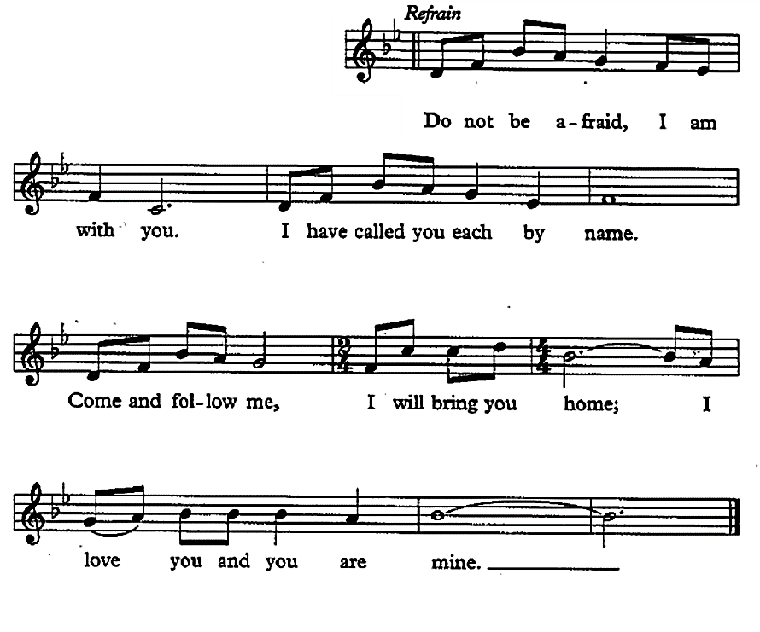

Scripture Reading ~ Luke 8.42b-48
Jesus heals a woman with a flow of blood (adapted from the NRSV)
As Jesus went, the crowds pressed in on him. Now there was a woman who had been suffering from hemorrhages for twelve years; and though she had spent all she had on physicians, no one could cure her. She came up behind Jesus and touched the fringe of his clothes, and immediately her hemorrhage stopped. Then Jesus asked, “Who touched me?” When all denied it, Peter said, “Master, the crowds surround you and press in on you.” But Jesus said, “Someone touched me; for I noticed that power had gone out from me.” When the woman saw that she could not remain hidden, she came trembling; and falling down before Jesus, she declared in the presence of all the people why she had touched him, and how she had been immediately healed. He said to her, “Daughter, your faith has made you well; go in peace.”

Sermon/Reflection/Stories From Survivors
In evening worship, think about keeping this short, allowing for silence and space to think, to breathe, and to simply be.

Offering Our Gifts
You might consider designating the offering, or a portion of it, to the local sexual violence resource center in your area, or to a national organization such as RAINN (Rape Abuse Incest National Network).

You can also help the work of Break The Silence Sunday by making a donation to our ministry. Gifts are welcome electronically with PayPal & Venmo at breakthesilencesunday@gmail.com and information about other ways to contribute to our work can be found on our website: http://breakthesilencesunday.org

Unison Prayer Of Dedication
Generous God, we are grateful for all that you have given to us. We bring you these gifts, signs and symbols of our gratitude. We entrust them to you in the faithful hope that the work Jesus began – the work of listening to the stories of God’s people, of healing the brokenness of the world, and of restoring creation – might continue in us, and through us. Grant us the courage and the faith to listen, to pray, and to speak out. In hope we pray, Amen.

Song ~ “God Is Holding Your Life” (chorus)

by Richard Bruxvoort Colligan © 2006, Augsburg Fortress,

Reprinted under OneLicense.net #A-707385

full accompaniment can be found at https://www.psalmimmersion.com/psalm-121

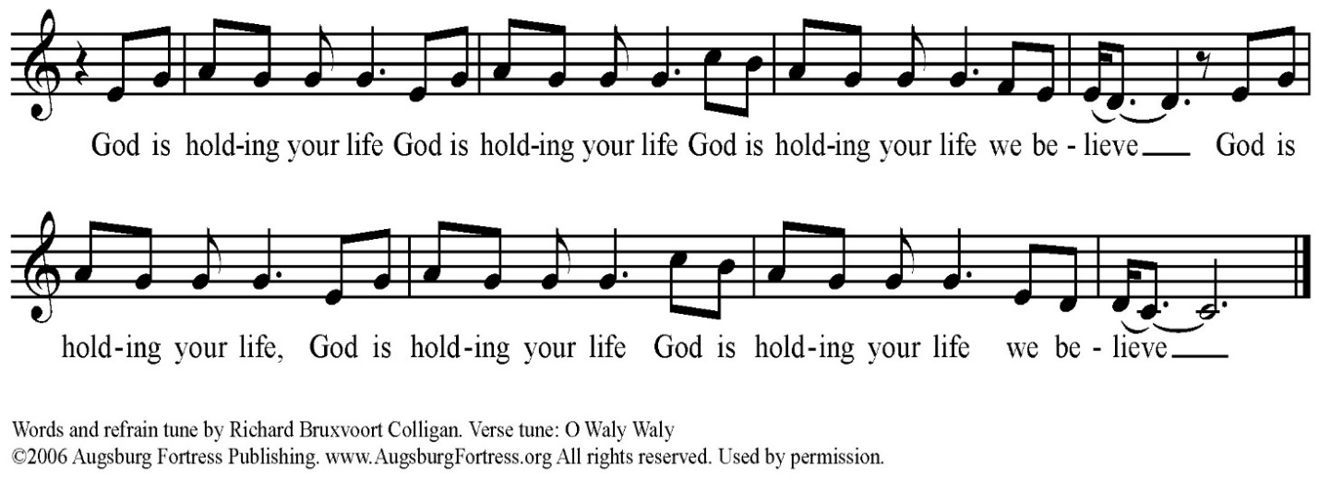

Celebrating Communion
One: This table is not ours, but it belongs to God. All who seek to be fed and nourished by God’s grace, and sustained by this community are welcome to share at this table. We come, from the shadows of a waiting, hurting world, knowing that, wherever we have been, whatever we have experienced, we will be fed, nurtured, and renewed. We reach for the bread of God’s grace, aware of a hunger in our souls for a world of compassion and peace. We reach for the cup of God’s love, aware of an unquenchable thirst in the depths of who we are, a thirst for justice and hope. We come, trusting that God will meet us here. Let us pray together…

All: Holy One, we come to share the richness of table. We ask for your healing grace to be poured out on all those who have suffered sexual violence. Renew and restore them, and your church. Be present with us, and remind us that your presence is with us always. Give us the courage to truly be the Body of Christ.

One: Gracious God, we come to this table to know you, to remember your love, and to confess that your grace is for all. Some of us come to this table tired and anxious. Some of us come with hope in our hearts. All of us come, trusting in your Spirit’s presence, and trusting in the promise that we might all be One, whole and healthy, as your people. Let us pray together…

All: We thank you God that, in Jesus, you have given us the greatest gift, the gift of your very self. We thank you that he lived among us, and knew what it was like to be human. Feed us at this table, and give us the courage to be faithful to the One who dared to come into our world. Renew and revive us. Give us the courage to listen, and to speak out today and always. Amen.

One: We know the stories about Jesus’ life, how he would come to share many meals with his disciples and friends. He would welcome those who had been cast to the margins of society, eating with sinners and prostitutes, with the sick and the lame, with the wealthy and the poor alike. On one of those occasions, as his earthly life was nearing an end, he found himself with his disciples and those who had followed him closely in an upper room in Jerusalem. They were there to share the story of hope, of release from captivity, of God’s promise of freedom. During the meal he would take the bread, bless it, break it, and offer it to them saying, “this is my body which is given for you.” Later, after supper, he would take the cup, give thanks, and say, “this cup is a reminder for us of the new relationship God has made possible between us, and all of creation.” The bread we share is a reminder for us that just as God blessed Jesus with an earthly body, so our earthly bodies are blessed. The cup we share is a reminder for us of Jesus’ life, and the grace of God that Jesus came to help us know. We pray that God would bless this bread, and this cup, and us as we receive them. We bring all our lives to God at this table, that we might be one people, united as the Body of Christ, working together for justice and peace. The gifts of God for the people of God. Come for all things are now ready. Come and see how good God is.

Sharing The Elements

Unison Prayer Of Thanksgiving
We give you thanks, Gracious God, that you come to us in bread and cup, and in the love of this community. Send us from this table, nourished and empowered. Help us listen with all our hearts, and speak with all our minds, that all your people might truly know peace. Amen.

Committing Ourselves To Change
One: In the presence of one another, we pledge ourselves to ending the violence of rape and sexual assault, working towards a vision of the Beloved Community where all can live in dignity and peace. We acknowledge the reality of rape and sexual violence, a plague that brings hopelessness and fear to our siblings here, and around the world.

Many: We stand in solidarity with those who have been victims. We promise to be open to their stories, and with the grace of God, to listen and hear without judgment.

One: We know the promise of wholeness, and hope that Jesus came to bring to the world.

Many: We affirm the promise of God’s love for all the survivors in our world, those whose stories are known to us, and those whose stories are still shrouded in silence and fear.

One: We know that we have not done enough, that we have been silent when those around us have been struggling.

Many: We look forward with hope, trusting in God’s ability to give us strength to listen with courage, and to be silent no longer.

One: We believe that the future depends on us.

Many: We believe that there is something we can, and must do, as people of the Good News, and as members of one human family, to end the violence of rape and sexual assault.

One: We recognize that we cannot do this alone. We know we must learn to depend on each other, and on God, in the struggle to end sexual violence, and create justice.

All: Gracious God, help us to be aware of your loving disruption of our lives. Give us the courage to work with you, and with each other, to transform our hurting world. Empower us with your Spirit that we might break the silence of sexual violence. Help us listen and move together, from fear and pain towards your realm of peace and justice. In Jesus’ name we pray, Amen.

Song ~ “We Shall Overcome”
(tune: We Shall Overcome, public domain)
Music can be found in many hymnals including in the New Century Hymnal #570

We shall overcome, we shall overcome,
We shall overcome, some day;
Oh, deep in my heart, I do believe,
We shall overcome, some day.

We are not afraid, we are not afraid,
We are not afraid, today.
Oh, deep in my heart, I do believe,
We are not afraid, today.

The truth shall set us free, the truth shall set us free,
The truth shall set us free, some day;
Oh, deep in my heart, I do believe,
The truth shall set us free, some day.

Blessing & Closing Music

Liturgical Resources

The full text of the poem that inspired the gathering prayer may be found here, and in the Chalice Hymnal #508
“For One Who Suffers”
Howard Thurman, 20th century African-American church leader
I know I cannot enter all you feel
Nor bear with you the burden of your pain
I can but offer what my love does give –
The strength of caring
The warmth of one who seeks to understand
This I do in quiet ways –
That on your lonely path you may not walk alone.

Notes On Music From The Liturgy

You’re thinking to yourself, “wow, that’s a lot of music for one worship,” and you’re right. There’s a reason for it. The content of Break The Silence Sunday is intense, and it requires a lot of heart-opening, a lot of willingness to let the Spirit move us in ways that probably make us uncomfortable. Music has the ability to let us rest, while also stretching and challenging us. It gives us the opportunity to hear, and learn our faith story, our theology, our call to God’s work in the world in a different way than simply spoken words do. Feel free to use all, or some, or none of these songs during your community’s worship time. There are additional suggestions for songs that speak well to the work of Break The Silence Sunday, and we welcome your suggestions of music that is helpful for your community.

“Help Us Accept Each Other”

Working with the familiar tune “Aurelia” to which “The Church’s One Foundation” is set, these words Dutch theologian Fred Kaan (ordained in the United Reformed Church in England and Wales) date from 1974 and are a reminder that God’s acceptance changes us and asks us to be accepting people in response. It can be found in many hymnals including the U.C.C.’s New Century Hymnal at #388.

“We Have Come” by Christopher Grundy

This was written to be sung acapella, but a skilled musician can add simple cords to make congregational singing easier if acapella is difficult for your community. You can listen to a recording at http://www.christophergrundy.com/recordings/

The song is on the album “Stepping In”, track number four.

“I Am Welcome”

Used with grateful permission of Bryan Sirchio;

You may hear a recording at

http://sirchio.com/cds/01--worship/01--CDs/937

Accompaniment follows below on pages 48-49

“God Who Remembers”

Used with grateful permission of Richard Bruxvoort Colligan

You may hear a recording at http://www.psalmimmersion.com/psalm-136
Richard’s work as a psalm scholar and musician, writing contemporary songs inspired by the psalms, can be found at www.psalmimmersion.com
Accompaniment follows below on page 50

“I Love To Tell The Story Re-sung For Break The Silence Sunday”
Many thanks to Maren Tirabassi for her re-wording of this familiar hymn, and to Amy Englesdorfer for her transcription. “I Love To Tell The Story” is often sung to “Hankey” (in the New Century Hymnal #522), but here it is set to “Fischer”. Either setting will work.

“We Are A Gentle Angry People”
used with grateful permission of Holly Near
An American folk music icon, she has released 31 albums using the power of music to change lives, personally and collectively, calling on all of us to work together for a more just world.
You can see her entire music catalogue at https://www.hollynear.com/music/

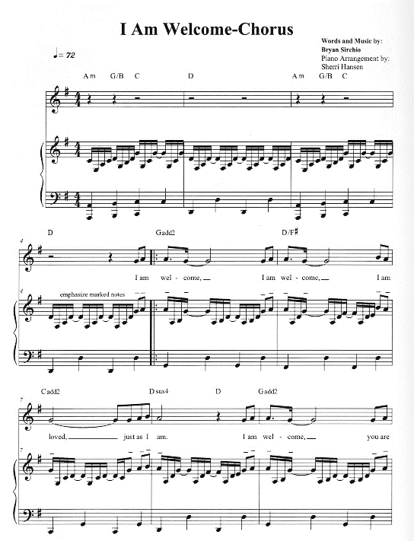

song continues on following page ---->

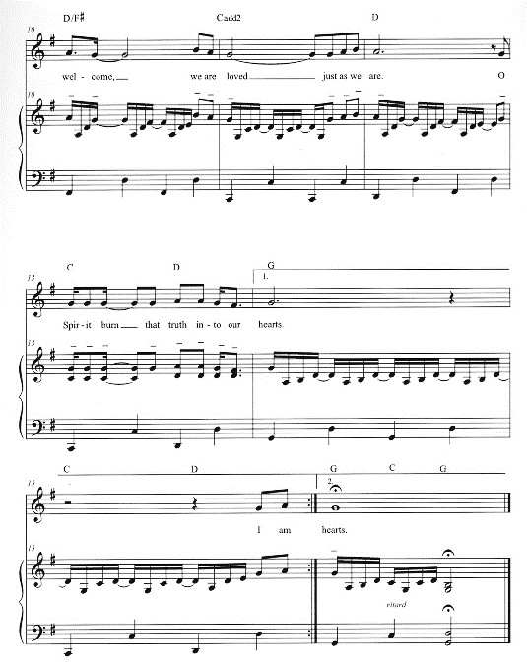
A New Song Offering
With many thanks to the Rev Amy Brooks of First Unitarian Church of Alton, Illinois we offer you this song, a call to listen, to believe, and to speak.

Silent No More © Amy Brooks, 2018
to the tune of “Stille Nacht” by Franz Gruber
Used with permission

Silent day, silent night,
Broken trust, abuse of might.
Whispered threats of shame and fear
Keeping quiet for all of these years
Asking, “Who would believe?”
Asking, “Who would believe?”

Silent day, silent night,
Name the wrong, claim the right
Beat the drum and ring the bell
Share the tale that is yours to tell.
Know that I believe you.
Know that I believe you.

Holy day, holy night
Chalice burns, clear and bright
Brave survivors sound the alarm
Bravely we receive stories of harm
We are silent no more
We are silent no more.

Additional Song Suggestions

In addition to the song suggestions in the liturgy, you might consider other hymns with themes of healing, and justice. These are some suggestions from the New Century Hymnal (NCH):

“I Was There To Hear Your Borning Cry” (NCH #351)
“Help Us Accept Each Other” (NCH #388)
“How Firm A Foundation” (NCH #407)
“My Life Flows On In Endless Song” (NCH #476)
“Amazing Grace” (NCH #547)
“Out Of The Depths, O God, We Call” (NCH #554)
“Lead Us From Death To Life” (NCH #581) – particularly the chorus
“Let Justice Flow Like Streams” (NCH #588)
“We Shall Overcome” (NCH #570)

Additional music you might consider for choir, band, teaching the congregation, or simply for listening:

“God Is Our Refuge And Strength” by Andra Moran
https://www.etsy.com/shop/AMMOMusic

“Light Of Heaven” by Andra Moran
http://www.andramoran.com/track/8132/light-of-heaven?feature_id=59929

“Here In This Place” by Christopher Grundy
http://sites.fastspring.com/christophergrundy/product/catalog

“From My Hands” by Christopher Grundy (particularly the second verse)
http://www.christophergrundy.com/recordings/
On the CD “In This Life”

“Welcome To This Circle” by The River’s Voice
http://www.riversvoice.com/shop.php

“Move (Psalm 109)” by Richard Bruxvoort Colligan
http://www.psalmimmersion.com/#!move/cd4h

“Stand With You” by Bryan Sirchio
http://sirchio.com/songs/f/c/196

“God Weeps” by Shirley Erena Murray
This hymn, a lament about “strength misused” and “trust betrayed” reminds us that God weeps at the way we walk with each other. It is included in The Faith We Sing at #2048

“I Will Change Your Name” by The Nebblett Family
This song talks about God changing the of those who struggle from “wounded, outcast, lonely or afraid” to “confidence, joyfulness, overcoming one”. You can see a video of the song here: https://www.youtube.com/watch?v=liOzd21u5MY

“God Will See Us Through” by Bryan Sirchio & Emma Ceurvels
For a recording and sheet music visit:
https://www.covergencemp.com/god-will-see-us-thoug.html

“All Belong Here” by Hannah & Lenora Rand and The Many
https://www.themanyarehere.com/allbelonghere

“How Could Anyone Ever Tell You”
by Libby Roderick © 1990
sung here by Trish Bruxvoort Colligan © 2003
https://trishbc.bandcamp.com/track/how-could-anyone
Lyrics:
How could anyone ever tell you
you were anything less than beautiful?
How could anyone ever tell you
you were less than whole?
How could anyone fail to notice
that your loving is a miracle?
How deeply you're connected to my soul.

Additional Prayers & Liturgical Resources

An Additional Prayer For Your Consideration
By the Rev William Kesting

Everlasting God, we are thankful for the courage of the people of the Break The Silence Movement. May we hear their stories. We pray that all people would truly listen to them. We pray for the healing of their pain and devastation that has occurred in their lives. We ask that all people in any type of power position would follow through on their accusations concerning their abuse. We seek justice for these victims. May this movement find your blessing of their sharing. May they feel your presence in their life long journey of healing. May the people in their lives who are secondary victims be caring and supportive of their search for wholeness. May they continue to choose life every day. In the name of the Holy One. Amen.

A Prayer for Peace After Sexual Assault
by Julia Park Rodrigues
From Women’s Uncommon Prayers Our Lives Revealed, Nurtured, Celebrated
Edited by Elizabeth Rankin Geitz, Marjorie A Burke & Ann Smith et al
Morehouse Publishing, Harrisburg, PA, 2000

This is one survivor’s prayer, and it moves through anger towards asking God to forgive their offender. This is not the path all survivors take, or need to. Coming to forgiveness is different for all survivors. This prayer is one approach, not the only approach.

Loving God, I know that you hold me in the palm of your hand.
I know it is so.
But why, O Lord, why?
I rage at this sin against me, at this defilement of my body,
this assault on my peace of mind.

I mourn my lost serenity, security, confidence;
I mourn the loss of my ease and open nature.
I hate what his assault has done to me.
I feel that my body and soul may never be the same.
What has been forced upon me may never be forgotten.

But send your healing upon me like cool rain.
Sooth my spirit with the balm of your tender love.
Help me to feel secure again, as safe as ever within the shelter of the Lord.

Let my anger not turn inward to self-loathing,
but outward for action and purpose: to help others like me,
to bring hope to those whose faith is not so strong.
Help me, with your grace,
to move beyond victim, to call myself survivor instead.

May you forgive this man’s offense against me,
and grant me the peace and serenity
of a mind and body made whole again.

Amen.
A Call To Worship
By the Rev Stephen Price © 2015
Interim pastor, Heritage Baptist Church, Annapolis, MD

There is anger in this prayer, a holy anger that has been building up, rising against the silence that so many survivors face on a daily basis, rising against the shame and guilt survivors feel, and rising against those who would seek to keep us silent. The words are intense, and point to a deep need for survivors to be heard.

Leader: We come to break our silence this morning. We will shatter it like a plate thrown in rage.
People: It has not been a holy silence where we could meet God; but one in which the demonic howled in the darkness, and toxic feelings drifted like fog.
Leader: It has not been a silence we asked for, but a rag stuffed down our throats, the waterboarding of our souls.
People: A silence in which we hurt ourselves, or others, just to lessen our anguish.
Leader: A silence in which we ran from those who loved us, and clung to those who caused us pain; because they spoke the language the silence had taught us.
People: A silence we thought was God’s silence because we could not imagine God loving people like us.
Leader: Our breaking the silence will not be pretty, this is not a Hallmark moment. Someone stole from us, then pawned the pieces.
People: This morning we are kicking in the doors and windows of the pawnshop; we are taking ourselves back.
All: Join hands with us this morning, if you dare. But know this, we will break the silence, we will not be broken by it. And where once we cowered in paralyzed fear, we will rise, and rise, and rise.

Break The Silence Sunday 2020 Scripture Reflections

Isaiah 43.1-7

One of the things many survivors struggle with is feeling as if what happened to them has damaged the core of who they are, that the violation of rape and sexual abuse has made them damaged goods, unclean in the eyes of the world, and unworthy in God’s eyes. This passage from Isaiah offers a powerful reminder that each of us has been named, and claimed by God, that whatever challenges might come in life we are secure in God’s care for us, a God who will be with us always. In addition, many (most) survivors ask where God was when they were in the midst of their trauma, and where God is now that they are trying to heal. Without dismissing the pain, this passage reminds us that God is with us when the rivers overflow, and when the fires feel as if they will consume us. God is with us in the midst of the suffering, continuing to claim us as God’s very own, and perhaps in that there is hope, a realization that God stands with us, weeps with us, and holds us in the darkest moments of our lives.

Psalm 121

This is the traveler’s song, perhaps meant for those who were making the pilgrimage to Jerusalem for the celebration of Passover or another festival. It is a fitting psalm for survivors because the work of healing is a journey, the journey of an entire lifetime. Healing from rape and sexual violence is not something that can be accomplished by checking off a series of steps and then leaving it all behind. Instead, it is a journey full of U-turns, and pitfalls, moments of great clarity, and moments when it feels like all the work has been for nothing and that you’re back where you started. In those moments, the psalmist reminds us that God will never tire of walking with us, will be with us in the heat of the day and in the depths of the night keeping our lives through whatever challenges may come. Much like the passage from Isaiah, this psalm is a reminder that God is with us in the muck, in the middle of the challenges, carrying us through when we feel as if we can no longer carry ourselves. How might the church model this kind of journeying together in supporting survivors?

Luke 8.42b-48

This passage makes people uncomfortable because it describes so clearly the struggle of the woman in need of Jesus’ healing. It feels intimate to know that this woman has been suffering from hemorrhages for twelve years, visiting doctor after doctor none of whom are able to help her, draining her purse, but offering her no relief. The valuable part of this passage to me as a survivor is verse 47 (from the NRSV):

When the woman saw that she could not remain hidden, she came trembling; and falling down before him, she declared in the presence of all the people why she had touched him, and how she had been immediately healed.

She tells her story, in front of the entire gathered crowd, and in that telling she finds strength. A story we cannot tell eats at us. A story we cannot tell is a burden that will we eventually find too great to bear. But when we are able to tell our story, to have it heard, and honored, and respected then we find our strength, our healing, and the ability to go on. The church can do what the community did for this woman – they can listen, they can hear the story of the struggle, of the pain we carry, and how having someone else to help carry our story will make all the difference.

Sermon Suggestions & Advice For Preachers

You need to carefully consider what your community needs during the sermon or reflection time on Break The Silence Sunday.

Are you part of a community that is already familiar with the issues of rape and sexual violence?

Is yours a community where these are new, and frightening topics?

Does your community frequently engage in justice work in the world beyond the church doors?

Are you aware of survivors in your pews, some who have shared their stories with you?

Is this your first year participating and so all this seems overwhelming?

Have you been part of Break The Silence Sunday for several years and it still feels overwhelming, but at least you’ve been there before?

You could choose to use one of the sermons or survivor stories included in these materials (additional ones are on our website). You could invite someone from a local resource organization to speak about their services to your community. It’s possible that there’s a survivor in your community who is willing and able to share their story, but please ask gently and kindly. You don’t want to overwhelm them if they aren’t ready to take their story public, or if the idea of public speaking is simply too much.

And, of course, you can craft your own sermon. If you choose to write your own sermon, you need to go carefully. The work of Break The Silence Sunday is to support survivors in their journey of healing. Don’t preach about any shoulds. Don’t tell survivors that they should forgive those who have hurt them, or should share their stories, or should behave in any particular way. Don’t focus on perpetrators and the need to welcome them into the community. This is also not the moment to glorify the cross, so please don’t preach about the redemptive suffering of Jesus.

This is a time to speak about healing and wholeness, and the hope that Christ’s community can provide. This is a time to talk about justice – a justice for individual survivors (perhaps through the criminal justice system, but surely through having their voice heard and their stories honored in the church); and justice for all creation as we work to change the culture that allows this violence to continue.

There are scripture suggestions in the included liturgy. Isaiah 43.1-7 speaks of God’s claiming and naming each of us, walking with us through the struggles and fear of our lives; Psalm 121 is a prayer of trust, remembering that our lives are in God’s care and keeping all our days; and that God will always be with us; and Luke 13.10-17 tells the story of Jesus healing a woman and encountering resistance from the religious establishment because the healing took place on the Sabbath day.

These scriptures all point toward a God of hope, of companionship, and of justice. There are other scriptures that you could use to speak of God’s support for those who are suffering, those who have been victims of injustice and violence, and those who have been silenced. You might also consider some of the other healing stories in the New Testament, but remember that healing is not necessarily physical, but an ability to fully participate in the life and work of the community, the chance for someone to be remembered, honored, and respected.

If your community is already engaged in the difficult work of justice on behalf of survivors, if you feel you have the trust and support of the folks you’ll be preaching with, and if you’re feeling particularly brave, you might consider the story in Judges 19. It is a difficult scripture, and you will want to do considerable exegetical work, some discussion in small group Bible study, and a lot of faithful preparation of your community so they are ready to hear, and receive the text.

You might want to begin with this article ~ “An unnamed concubine’s story in Judges is our story: Will we remain asleep to sexual violence?” ~ from Baptist News Global.
https://baptistnews.com/article/an-unnamed-concubines-story-in-judges-is-our-story-will-we-remain-asleep-to-sexual-violence/?fbclid=IwAR2z7RgmfcfNXSgN3O-h_YLMYdX-0ddmx046JDyGkeu4YvXCVOe7MEFJFVA#.Xh4yIiNMHIU

You are invited to consider the final lines of Judges 19, whether you use that scripture in worship or not. Verse 20 reads (from the NRSV, emphasis added):

Then he commanded the men he sent, saying, “Thus shall you say to all the Israelites, ‘Has such a thing ever happened since the day that the Israelites came up from the land of Egypt until this day? Consider it, take counsel, and speak out.’”

That is the work of Break The Silence Sunday, and your work in preaching and leading worship …
- Consider it - recognize the problem, admit that rape and sexual violence are real, hurting members of your community, and society as a whole
- Take Counsel – learn about rape and sexual violence, listen to the stories of survivors without judgment, walk with them through the struggles, support and encourage them as they journey towards healing and hope
- Speak Out – say something, often, be a voice for justice, for changing our communities, for creating places of peace and safety for all
Survivor Reflection ~ Harold Beer
Edgewood United Church, East Lansing, Michigan
Used with permission.

“I Wish”

When I was growing up...
I wish I had known it was okay to say no.
I wish I had known it could happen to men, too.
I wish I had known that women could be perpetrators.

When it happened...
I wish I had seen the warning signs.
I wish I hadn’t frozen up.
I wish I hadn’t blamed myself.
I wish I hadn’t felt shame for what happened to me.
I wish she hadn’t said that nobody would know. My body would know. I wish I hadn’t buried it in a pit of depression and suicidal thoughts.
I wish I could have told someone.
I wish I could have dealt with it in therapy back then.
I wish I hadn’t carried it alone for two decades.

When I turned to the clergy...
I wish the men had not excluded me when talking about sexual assault survivors.
I wish that, when I said a woman had assaulted me, she knew how much it hurt when she quipped, “How is that even possible?”

Now...
I wish the church was as courageous as I have to be.
I wish I had known that sometimes I would feel like a survivor
and sometimes I would feel like a victim.
I wish I always felt as brave and as strong as others say I am.
I wish there was an end to sexual assault.
Survivor Reflection ~ Mollie Wang
delivered at First Congregational U.C.C. Hillsboro, Oregon on April 28, 2019
Used with permission.

In August of 2014, I started my sophomore year at Northern Illinois University. I was 19 years old. I had recently started my new job as a community advisor in the dorms, was volunteering with an organization with adults with disabilities, which I loved, and I was in the process of starting a co-ed a cappella singing group with two of my friends. I had a solid friend group, loved my classes, and was enjoying a successful start to my second year of college. I was excited to be singing in the university’s choir this year too. That’s where I met Dan. Honestly, I don’t even remember how we began talking, but he seemed nice enough. I’d met him in choir, after all, so he seemed pretty safe. We hung out once at his house and had a great time. When he invited me back over that weekend and said he was having some people over, I figured why not? I felt like I could trust him. That weekend, I showed up and realized I was out of my comfort zone. Most of the night is a blur, but there are certain things that will always stick with me. That night, October 24th, 2015, is the night that I became part of the 1 in 4 statistic of women who experience non-consensual sex during college. 1 in 4. The next day and a half or so were a blur of questions, doctors, nurses, and emotion. I couldn’t really explain or remember most of the night, and as the memories came back, I didn’t want to admit what had happened anyways. I was shocked, confused, and upset. The day after I got home from the hospital, I got up and went to class like usual, pretending nothing had happened. Nobody needed to know what had happened over the weekend. I carried on with my semester, really only confiding in one close friend (He’s still one of my very best friends today, and I can’t imagine what I would have done without him). I was embarrassed, ashamed, and blaming myself. How could I let something so stupid happen to myself? I had been raised to know better and be more careful. I never should have gone to his house that night. I never should have taken a drink from him. I never should have trusted him. I should have said “no” louder. I should have fought back. There seemed like so much that I could have done differently. I was so angry at myself for letting it happen. This entire experience was totally out of character for me. I was always the level-headed friend that wanted to take care of everyone else. How did I get myself into a situation like this? Ignoring it seemed like the only way to move on and finish the semester.

Ignoring it wasn’t going well. I was maintaining A’s in my classes, succeeding in my extracurriculars, but I was using them to cover up how I was really feeling. It was a mix of stress, fear, anger, and plain numbness, so in March of 2015, I finally sought the help that I needed, and I’ll always be grateful for that therapist. See, I’m kind of stubborn. I absolutely LOVE helping and caring for others, but I hate admitting when I need help of my own. This therapist finally made me realize that it’s totally okay to not be okay all the time. She helped me label what had been happened that night, because I still hadn’t been able to say it. I had been raped. I hadn’t asked for it; I had said no; it wasn’t my fault. She helped me realize I needed to forgive myself and start to heal. It’s an ongoing process.

Fast forward to Thanksgiving of 2015. Towards the end of the semester, I finally decided I was fed up with how he had messed up my life and then so easily walked away. With several pep talks from my therapist, I filed a police report. Unfortunately, it was too late for anything to ever come of that, and I didn’t have any evidence. No one would actually believe me if I were to pursue anything. The police officer said not to expect anything to happen. In early January of 2016, on my last day home for winter break, I finally told my parents what had happened that night, and thank God, they believed me. I still remember the fear that I had in telling my parents. It was a conversation my therapist and I talked through many times. I was so terrified that it would absolutely devastate them, or that they would be mad, or that I would have to dive into details of how, when, why, where, who. I didn’t want them to have to go through all of the feelings that I had been going through. I didn’t want to do that to them. Although I know they were upset when I told them, it wasn’t at me. What hurt my mom most was knowing that I had gone through so much of it on my own. More than anything, my parents just wanted to support me through it. It shouldn’t be something I was facing alone. Seems obvious now, but it sure didn’t then.
I was so afraid because society puts up this horrid stigma, and I’m still hesitant to this day. I’ve sure come a long way about talking about it. Never in a million years would I have imagined talking about this in front of a crowd, let alone my church! There’s still a small fear in me anytime I mention it that someone will blame me, think I’m overreacting, or simply “not want to hear about it right now.” “This isn’t the time or place.” I’m always afraid of burdening others too---after all, I don’t want to be a “downer”, and I’m sure others have had way worse experiences.

So, in September of 2018, I took a big step. With the Kavanaugh trials overwhelming my Facebook feed, I had to say something because I needed to speak up for another woman. All of the feelings of fear, guilt, and shame instead turned into feelings of anger, anxiety, and overall just feeling fed up. I was so sick of victims being blamed. I had no evidence when I was finally ready to report my rape, and I could’ve used a lot more people saying “I believe her.” I officially “came out” on Facebook and shared my story in the form of an “I believe her” post. The responses to my post were completely overwhelming, and guess what? So many of the responses were from members of this church that are sitting here today. I literally sat at home crying reading my Facebook comments, but this time, they were tears of relief. I was SO relieved that people believed me and cared enough to respond. Even better, was that it was my church community. And it wasn’t just me, SO many people were sharing their stories, and it felt like more people were believing than shaming. I didn’t feel embarrassed anymore; I felt heard.

That’s when I approached Pastor Adam to suggest the idea of a Break the Silence Sunday this year. I learned about Break the Silence Sunday a couple years ago. My mom (who is here with me today) met Reverend Moira Finley at a church conference meeting and noticed her pin that said “This is what a rape survivor looks like.” My mom made a comment on the pin and mentioned my experience. Moira immediately gave my mom the pin to give to me, and I’ve been following the movement on Facebook ever since. Although I’ve often been too afraid to wear this pin, today I’m actually kind of proud. Sounds weird, but I’m proud because I’ve come a long way, and I’m privileged enough to be able to stand here and speak. My hope is that starting this conversation now in the church can make the healing journey a little bit easier for others because I know I’m not the only one here today who’s been affected.
In 2014, I could have used the support I have from this church now. I needed a church where I could walk in, feeling broken, guilty, and confused about my own identify and be received with open arms telling me that I wasn’t any different in their eyes. I needed this community. You see, when you experience something like rape, it has a lasting impact. It shakes your core, your identity. Who am I to have let something like this happen to myself? How do I move on from this? How has this changed me as a person? There’s no doubt that it’s changed me. I double or triple check the locks on my door at night. I’ll constantly look over my shoulder if I’m walking to or from my car at night. I avoid people named Dan. I get sick to my stomach when I see someone that slightly resembles him or when I drive by that house. I panic and over analyze when a guy offers to buy me a drink on a date. October 24th is no longer a normal day for me. It will always be the anniversary of that night. Those aren’t the only ways it’s changed me though. I now have a loud voice. I’m even more stubborn. I’m not afraid to advocate for my needs, and self-care is now a huge priority. I’m actively working on being comfortable and confident saying “no”. I am also extremely dedicated to living my life to the fullest, trying new things, and going on adventures! I refuse to let him hold me back in any way.
I have to be honest and say that when planning this service, I struggled a bit with the scripture and what to say about it. I actually picked a different one originally and changed it to this once I re-read it. Today’s passage speaks of God’s presence with us through the fire or when the rivers overflow, and really, it didn’t always feel like that. Early on after my experience, I didn’t think much about God being there at all. I felt like I was just trying to get through each day, and it felt pretty lonely at times. I don’t imagine that I’m the only one that would have feelings like this. Where was God when this happened, and why would something like this be allowed to happen? I think the point is though, that even when terrible, horrible things happen, and we feel totally alone, we aren’t. God’s there, crying and hurting with us. Even better news? She loves us still the same, “Because you are precious, honored in my sight, and I love you.” When something like rape happens, it can feel like the very core of my being has been violated or damaged. You feel dirty and ashamed, and church doesn’t necessarily feel like a comforting place. I felt like I had to hide what had happened to me because it’s “not appropriate for church”, and that was the part of me that needed support the most. This is why I needed that reminder, that throughout the healing and recovery journey, at our lowest and highest points, we are named and claimed by God, and loved just the same. It certainly doesn’t dull the pain, but it provides a hope that we’re not alone. It might feel overwhelming, but it’s reminder that this won’t consume use. We will learn to move on and live with it eventually, and God is with us the entire way.

What does that mean for the church though? Our scripture might provide comfort in knowing we aren’t alone, but are we acting that out as a community? One in five women and one in 71 men will be raped at some point in their life. With statistics like these, why aren’t we talking about this in the church? I’m going to argue that it’s not just God that’s supposed to be there through the fires or river overflowing---it means us, the church! We are the ones that are supposed to be acting this out! We are a powerful body of people working for positive change in so many areas, but because this is such a sensitive or taboo topic, it seems to be left behind. Are we creating a worship space that feels safe for survivors to be their true self? Even on their lowest days? Are we trauma-informed and sensitive in our planning. How does our environment and building welcome people who have experienced trauma? We need the voice of the church to break the silence that is around rape and sexual violence. Not all survivors are in a position to advocate for themselves, so that’s where we the church need to truly be the church and step in for them. Yes, it might be uncomfortable, especially when we often come to church hoping to walk away with a “feel good” sermon. The reality is though that sometimes we need to sit in the discomfort so that we can learn how to make a positive change. We need to normalize the conversation. It’s absolutely okay to talk about rape in the church. Church should be a place people can feel comfortable expressing who they are and where they are in their healing journey. They shouldn’t fear judgement, shocked responses, or even excessive pity. I believe that having a service like this is the first step in that process of acknowledging that no matter who you are or what you’ve been through, you are not only welcome here, but this is a safe place for you.
I want to close by sharing the words of Reverend Moira Finley, who started this entire movement, because I think she puts it best. This is her call to the church from her first ever Break the Silence Sunday sermon, and I’m now calling upon each of you:
“What we need, from those of you who don’t bear the scars of rape, is for you to listen. We need for you to listen to our stories, to not turn away. Yes, it will be uncomfortable and yes, it will break your heart. We need you to deal with all of that, all of your own discomfort, so that you can listen to us, support us, encourage us as we deal with the winding, difficult journey of healing. We need you to listen to our fears, to try to understand our anxieties. We need you to be patient with how we tell our stories, with the stops and starts, with a sudden flood of memories that come and have to be shared or they will overwhelm us. We need you to hear the details, the awful specific things that happened, and we need you to understand that sometimes we can’t share those details with you, or with anyone. We need you to try and understand what it’s like to live with post-traumatic stress disorder, to need to sit on a particular side of the table, or triple check the locks on the door, or a thousand other things that help us navigate our days while our brains, and hearts are torn between the present and the past. We need to know that we aren’t a burden to you, that you’re in this with us for the long haul, that you’ll stand with us in the good days when we are enjoying life, because we do have them, but also in the dark days of self-doubt, fear, anxiety, and despair, because we have those days as well. We need your voices, the voices of allies in this struggle, to stand with us and help us change the world, to create a future where no more people face the sleepless nights burdened by memories of what someone else inflicted on us, a future where saying “no” is respected, and a future where children will have to ask “what was rape?”. Amen.

Survivor Reflection ~ Trish Kalhagen
delivered at McFarland U.C.C. McFarland, Wisconsin on April 28, 2019
Used with permission.

Good Morning. My name is Trish. Before I begin sharing, I ask that we pause for a moment, and if you’re comfortable with it, briefly close your eyes and take a nice deep breath, with a hand on your heart.

I offer this prayer: Holy One, There is no mistaking when You show up. The undeniable love and peace that You bring, surrounding us. Please bless each and every person here with us today. Also those who may have wanted to be here. May we truly know just how loved we are. Amen.

I am a survivor of childhood sexual abuse. This is the first time I have said those words in public. I have shared this within private conversations only, until today. Growing up, I do remember many hours alone in my room singing and dancing my heart out to release the pain of the verbal and physical abuse that has always been a part of my memories. When I reached the age of 33, the memories that I had tucked away within my brain regarding sexual abuse came rushing out after an inappropriate encounter at the hands of a co-worker. Needless to say, my life was forever changed. Through much love and support from my husband and therapist, I dove in to begin my healing journey. Initially, it became extremely difficult to function as this all began to unfold. I am beyond grateful to my husband Kevin for staying by my side and having my back. Our son Tom who is with us here, was not yet born.

At the time all this began, I was diagnosed with depression and Post Traumatic Stress Disorder. I was diagnosed with a condition that veterans returning from combat had experienced.

It was a lonely time. I was frightened and in shock.

People close to me that I had trusted had betrayed me and friendships were gone. This included people within my family.

It was suggested that I begin journaling. One reason would be to place the strong emotions on paper, to help begin to release the energy of what was rumbling through me. I began to see the importance of giving these experiences a voice. To no longer hold it all inside. In the future I would begin to see in writing how hard I had worked as eventually things began to improve for me. This was also a way to remember the positive things that would happen along the way. This became an important part of the initial healing. I talked to and cried out to Y’shua (the Aramaic name for Jesus) on a regular basis. The journaling soon became heartfelt prayers. Many times the words that needed to be written down would come to me in the middle of the night. Journaling is still an important part of my practice.

I was not very actively seeking God at the time when all this began, but I do remember this. In what could be called a prayer I said, Get us out of here and help us to sell our home. You see, at the time we were living not far from the house where I had been raised. After we put our home up for sale, it sold in 6 days. My cries had been heard.

I was told that if I did not come back to the family and apologize for the “lies” and making up this story, that I would be disowned. That I never really was like the rest of the family, anyway. I took this as a compliment, believe it or not. I was becoming free and beginning to heal. And for the first time, speaking out and finding my voice.

A few months after the memories began to surface, I had a profound spiritual experience. I was at the lowest point of my life. For the first time ever, passing thoughts of ending my life started to enter my brain. The pain was just too much to bear.

Working from home I turned off my computer so I could have a good cry. It was one of those times where the crying was from the depths of my soul. A deep cleansing cry. Alone in the house (no television or radio on) I clearly heard a voice. This gentle voice simply said, I love you. I stopped, listened and began to feel calm. Then what felt like tender supportive arms wrapped around me and held me for a long time. A peace like I had never felt before swept over me.

I had received an unexpected and much needed blessing. Before that moment Kevin and our first born son, Chad were the only people who had ever said the words, I love you, to me. That moment changed my life and began the next part of my healing .

When all of this began to unfold, I did not have a church that was able to support me and my story. One pastor advised me to stay quiet regarding this. He said he would advise me to not even consider legal action.

Years ago we attended the Catholic Church. When the first church sexual abuse scandal hit the news, shortly thereafter I knew another part of my self-care was to leave the denomination. I needed to keep moving forward.

Several years later I experienced receiving hands on healing prayer numerous times at a local church community. This brought peace and support along with quite a bit more healing.

One of the most important parts of my life? Music. It was and still is my “drug of choice” bringing healing, comfort and joy.

I do believe our healing tears are waiting for us to release them and say yes. Asking for help is not a sign of weakness; it’s a sign of strength. Most people need love and acceptance more than advice. We’re all imperfect and we all struggle. You are not defective, powerless or insignificant. Please try to not feel ashamed like you have to hide the struggles. No matter what the struggle is, it’s part of being human. You can be the person that breaks the cycle of abuse.

Here’s a great quote from Wes Angelozzi: “Go and love someone exactly as they are. And then watch how quickly they transform into the greatest, truest version of themselves. When one feels seen and appreciated in their own essence, one is instantly empowered.”

Survivors want to be loved and accepted just like we all need to be. This topic of sexual abuse should no longer be taboo to talk about. There are millions of us everywhere. You are the author of your life story. You can start a new chapter anytime you choose. Never think that what you have to offer is insignificant. There will always be someone out there who needs what you have to give.

Joseph Campbell said, “The privilege of a lifetime is being who you are.”

Kevin and I encountered many painful experiences within the walls of various churches that we had attended over the years. Eventually, we made the decision to stop attending church altogether.

Sunday morning “church” for me eventually became watching Oprah interview spiritual teachers and others on Super Soul Sunday. This became a Holy time for me.

Last year Oprah presented a story on 60 Minutes around childhood trauma. This story hit me right between the eyes. Here is what I held close to my heart after watching the story: Those who grow up in a well-cared for environment are more likely to have a well wired brain. Those who grow up in an environment with chaos, uncertainty, violence and neglect, your brain is being wired differently. It becomes a challenge to function in the world. I could relate to the second example here.
Oprah called her discovery during the taping of this story, life changing. This included the realization that when someone is struggling with anger, pain and abuse the question that is usually asked of someone is, What is wrong with you? However, the question that needs to be asked is, What happened to you?

I want to repeat this one more time. The question that needs to be asked of someone is, What happened to you? This in my opinion, is absolutely correct!

These words are from Cynthia Occelli:
“For a seed to achieve its greatest expression, it must come completely undone. The shell cracks, its insides come out and everything changes. To someone who doesn’t understand growth, it would look like complete destruction.”

Growing up I would have given anything to have heard that I mattered, that I was worth something and that I was loved. Marianne Williamson says that “healing is a return to love.”

After 9/11, I heard about the daily prayer of a Franciscan chaplain named Mychal Judge who died that day supporting the police and firefighters. What was his prayer? Each morning before he would leave for the day he would say, Show me where I’m to go, What I’m to do and Whom it is I am to be with. This is one of my prayers.

These words are from Richard Rohr:
“It has been acceptable for some time in America to remain "wound identified" (that is, using one's victimhood as one's identity, one's ticket to sympathy, and one's excuse for not serving), instead of using the wound to "redeem the world," as we see in Jesus and many people who turn their wounds into sacred wounds that liberate both themselves and others.”

Along this path I have discovered that to finally be heard and understood is a great gift and an extremely important part of this healing process. To heal well, this must be included.

When the healing shows up through memories, emotions and feelings it has been a great help for me to use a Buddhist practice. It is called inviting Mara to tea. Mara is the unpleasant “visitor” or pain that you don’t necessarily want to experience, yet you know it is important to allow it to be. To sit with it so you can continue to move forward. Some actually say, I see you Mara or Mara I welcome you to tea. This is accepting yourself right where you are so you can continue to heal. By saying yes to Mara, (or the pain) it will pass more quickly so as not to be as painful for you in the future.

One important personal discovery for me has been this. I made the decision some time ago to live my life more inclusively by choosing to accept varying religions, practices and people. This decision was in part a result of experiencing music and worship that included many forms of religions. That experience brought the Holy much closer to me during a retreat weekend. I am grateful to Richard and Trish Bruxvoort- Colligan for this blessing, by their choice to present this experience that weekend.

For some reason it was easy to make the choice to be open and receive the experience that weekend. It was surprising at the time and amazing just how tangible that kind of experience can be. Interesting how when you remove the walls between people and religions, a Holy Presence seems to rush right in.

I also discovered the Madison Sufis who present once a month, the Dances of Universal Peace. You gather to sing, learn simple dance steps and connect with people from all walks of life. Wow, what an amazing and powerful time this was! God was there among us, big time. Yup, more healing and love showed up. Such a tender, comforting energy with this practice, connecting us together.

These words are from Gloria Naylor: “Not only is your story worth telling, but it can be told in words so painstakingly eloquent that it becomes a song.”

I really hope to make a positive difference in the world. I want to say thank you to Bryan and the people of this church community for welcoming us with open arms, genuine kindness and love.

I have prayed for a long time to find the right community for Kevin and I. The very first loving hug I received in this church was from our former high school English teacher, Denny Blackmore. I want to publicly express my gratitude to him.

“Shikata Ga Nai” this is a Japanese phrase meaning, letting go. Accepting things you cannot change.

I want to share a poem with you now. If you would, close your eyes for another moment and take a nice, deep breath with me.

She let go. By Safire Rose

She let go. Without a thought or a word, she let go.
She let go of the fear.
She let go of the judgments.
She let go of the confluence of opinions swarming around her head.
She let go of the committee of indecision within her.
She let go of all the ‘right’ reasons.
Wholly and completely, without hesitation or worry, she just let go.
She didn’t ask anyone for advice.
She didn’t read a book on how to let go.
She didn’t search the scriptures.
She just let go.
She let go of all of the memories that held her back.
She let go of all of the anxiety that kept her from moving forward.
She let go of the planning and all of the calculations about how to do it just right.
She didn’t promise to let go.
She didn’t journal about it.
She didn’t write the projected date in her Day-Timer.
She made no public announcement and put no ad in the paper.
She didn’t check the weather report or read her daily horoscope.
She just let go.
She didn’t analyze whether she should let go.
She didn’t call her friends to discuss the matter.
She didn’t do a five-step Spiritual Mind Treatment.
She didn’t call the prayer line.
She didn’t utter one word.
She just let go.
No one was around when it happened.
There was no applause or congratulations.
No one thanked her or praised her.
No one noticed a thing.
Like a leaf falling from a tree, she just let go.
There was no effort.
There was no struggle.
It wasn’t good and it wasn’t bad.
It was what it was, and it is just that.
In the space of letting go, she let it all be.
A small smile came over her face.
A light breeze blew through her. And the sun and the moon shone forevermore…

Bless you for being here. I leave you with the following quotes:

And now a final quote from Dr. Rosenna Bakari :

“We lived in silence, not because we never spoke, but because no one listened. We lived in silence, not because we hid our scars, but because no one ever noticed us. We lived in silence, not because we were small, but because the world made us invisible. We lived in silence, not because we were afraid, but because we were bullied. We lived in silence, not because we didn’t want to be heard, but because we didn’t want to be hurt…anymore. … Now, time is up and you will hear us roar. So, don’t be surprised when you hear what was never heard before.”

Sample Sermon ~ Rev Moira Finley
delivered at Trinity U.C.C. Shiocton, Wisconsin; St. John’s U.C.C. Black Creek, Wisconsin; and St. John’s U.C.C. Cecil, Wisconsin on April 28, 2019
Used with permission

Break The Silence Sunday is now four years old and looking back through the reflections I have offered over these years I have apparently always begun in the same way – by saying I wish we didn’t have to be here, that Break The Silence Sunday didn’t have to be a thing, that the church simply did the work of supporting survivors of sexual violence as part of who we are as followers of Jesus.

But, we do have to be here, working and praying through our fears and anxieties about what we might hear, how it might make us feel, and why we give over an entire Sunday to this subject. We have to be here because the problem isn’t going away, and truthfully it isn’t getting better either.

But, I want to say, near the beginning here, how incredibly grateful I am for you, for the faith-filled members and friends of all three of the churches I am blessed to serve. I know that this is a hard day for many of you, and I am grateful for your support and encouragement of me, and of this work, and of Break The Silence Sunday. It means more than I will ever be able to put into words.

April is Sexual Assault Awareness Month and this year I’ve been posting pictures to my social media sites nearly every day calling attention to the scope of the problem of rape, the struggle survivors have in being believed, and in rebuilding their lives. It’s been an interesting experiment, the feedback being almost entirely supportive, but it’s that tiny percentage of push back, of doubters, and questioners, and devil’s advocates that stick in my head because, as we all know, the negative things are often so much easier to remember.

One of those doubters was someone a couple of weeks ago lamenting that I wasn’t putting up enough pictures of my kittens being cute, that they were really rather tired of hearing about rape and sexual violence because it makes them sad, and uncomfortable.

Wanting to scream and throw things at them, I instead responded as diplomatically as I could. I said that I would stop talking about it, stop posting about rape and sexual violence when no survivor had to live through it anymore, when every survivor had the support and resources they need to rebuild their lives, and when our children can honestly ask us “what was rape?”.

So here we are, because it isn’t yet a memory, because survivors still face an uphill climb in being believed and supported, because a judge in New Jersey just last month asked a survivor if she had tried “closing her legs” and a man in Italy was acquitted of rape because the survivor looked, in the words of the judge, “too masculine” to have been raped.

Because I’m who I am, and I will talk to anyone, and because I wear either my “this is what a rape survivor” or “break the silence” buttons I am privileged to hear a great many stories. It is a rare day when I don’t hear at least one, and at the recent conference annual meeting five separate people sought me out to tell me their stories, all before lunch. From the man at the grocery store, to the woman at the gas station, to the server at the restaurant, to an email, or a text, or a phone call from someone who has seen my work on the internet and reaches out for a listening ear, a caring heart, a voice from someone in the church who might meet their story not with judgement and criticism, but with love and compassion.

Think about the reading we heard from Luke’s gospel this morning.

Jesus is traveling about in the region around the sea of Galilee, and it just so happens to be a sabbath day when he goes into a synagogue to teach. A woman is there, completely bent over and had been for eighteen long years. Jesus, upon seeing her, immediately offers her love, and grace, and the healing she needs, laying his hands on her and curing her. She stands up, straightening her back for the first time in nearly two decades, and starts to praise God.

But the synagogue leaders, they don’t celebrate her healing, her returning to herself, the grace that they witnessed. No, they criticize Jesus for healing on the sabbath, in the synagogue. Couldn’t, they beg, this have been done somewhere else, on some other day, when not everyone was around. Isn’t this, they wonder, a private matter, best dealt with quietly, not drawing attention to it. Surely, this isn’t the work of the synagogue on a holy day.

The church today is, sadly, doing just what those synagogue leaders did all those years ago – trying to hush up survivors, to say that sexual violence is a private, personal matter best dealt with somewhere else, by someone else, surely not something we can give an entire Sunday’s worship over to, definitely not something we should be talking about from the pulpits and the pews.

There are, of course exceptions, churches and pastors and communities that are rising to the challenge, stepping up to find ways to support survivors, challenge the toxic parts of our culture that allow these crimes to happen, no longer allowing “boys will be boys” or harmful, hurtful, and abusive theology to be taught in their midst, and working for meaningful, long-lasting change.

I have been told that I’m too hard on the church, that I’m asking too much of it because, after all, the church is a group of imperfect people, and I’m told there’s a lot of other things that demand our attention as well – hunger, homelessness, racism, poverty, war,

I suppose it’s true, I am hard on the church, but that’s only because I know what it can be when we get it right. I know, because I have experienced it first hand, that the church can be for survivors a place of refuge, and strength, a place to be loved and to learn to love again, a place to reclaim your body from what others did to it, to reclaim your faith from all that has tested it, and to find your voice when others have tried to silence you.

When the religious leaders of his day argued that the woman shouldn’t have been healed on the sabbath, in the synagogue, Jesus is angry. I imagine him actually raising his voice to say “ought not this woman … be set free from this bondage on the sabbath day?” What better time, what better place he wonders, than the synagogue and the day set aside for worship for someone to be made whole, to be heard, and seen, and healed surrounded by the love of the community.

The church I grew up in held me and my family together through the most unimaginable horror of our lives, offering space, and time, and food, and rides, and more than anything relentless love that reminded me that as damaged and broken as I might have felt, nothing could ever destroy the love God has for me. They did what we can do each and every time a survivor comes to us as the church, but we have to choose to do so.

My friends, we have a choice before us, a choice of how we are going to respond to the courageous survivors who are telling their stories, to the survivors who are waiting to see how we will respond before they dare to speak about their experience, and to the culture around us.

We can respond, as the church has done, as the leaders of that synagogue by the Sea of Galilee did – we can question why now, why here, why did you wait to tell? We can do the work of victim blaming and shaming – asking survivors if what they experienced was “really that bad”, or what they were wearing, or why they were alone with someone, or any of the thousand other questions survivors face every day when they tell their stories, when they share what they have experienced.

Or, we could respond the way that Jesus did – embracing and welcoming those who have a story to tell; listening and hearing their pain; seeing in them beautiful children of God who deserve to be healed, not tomorrow, not somewhere else, but right here, right now, in the midst of the community of God, in the presence of this congregation; and ultimately celebrating their bravery, their courage, their strength, their faith, and their resilience.

We have a choice, and it will tell survivors what we truly believe, if we are willing to listen, to hear, to acknowledge that we can’t take away their pain, but in the telling and the hearing, with love and compassion, healing can happen.

My prayer today, and every day, is that this holy place will be a place where survivors can tell our stories, knowing that they are held not only in God’s love, but in ours, and that in each of us they can find a person willing to walk with them on a journey of healing, and hope.
Address to Committee #9 of the
United Church of Christ General Synod #32
Rev Moira Finley, June 23, 2019, Milwaukee, Wisconsin

Good morning. Thank you for your time, and your commitment to our denomination, to the work of helping shape the life and ministry of our churches.

And I thank you in advance for what I know is a difficult conversation ahead of us today. Rape and sexual violence are challenging topics for us to talk about because they ask us to be vulnerable with each other, and to face things that many of us would rather not.

I have to tell you that today feels a bit like a moment when the church I love, the one that professes extravagant welcome, will pass judgement on whether or not I, a rape survivor, am truly welcome.

In July 2003 the General Synod met in Minneapolis, Minnesota. I attended as a visitor and had the luxury of lots of time chatting with folks, particularly in the exhibit hall. In one of those conversations, at the Justice and Witness ministries booth I asked the national staff member what the UCC was doing to support rape and sexual assault survivors.

He told me that it didn’t really happen to people in the UCC, and that even if it did it was a personal, private problem that we, a church that claimed to offer a prophetic word and witness to the world, didn’t have time for because it just wasn’t important.

I wanted very much to quit, to hand in my ordination, barely a year old, and go off somewhere without the church, to find life in a place where, even if I wasn’t accepted, if my life and experiences weren’t welcomed there wasn’t the hypocrisy of saying I was while, in practice, I was asked to be silent.

I can say today that I am grateful the dear friend I was traveling with, Sharon MacArthur, wouldn’t let me quit. She said I couldn’t for two reasons, first because I just don’t know how, and second because we, the church, needed me not to. The church, if it was going to be true to its calling to follow Jesus, needed me to stay, to struggle for what I know we can be when we live as fully as we are able.

So here we are today. Sixteen years later, after a lot of pain and tears, and more patience than I ever imagined I had, thanks to the support and encouragement of some remarkable people.

I want to thank my friend, my support pit bull, Lella Baker for taking her vacation time and own money to be here making sure I get snacks and water and tissues.

And I want to thank my Wisconsin Conference minister, the Rev Franz Rigert, who helped me dream up Break The Silence Sunday five years ago, taking off its hinges a door that had felt firmly closed and bolted shut for more than a decade.

In thanking them I am aware that I am here, in many ways, because of the actions, both good and bad, of other people.

The men who raped me set my life on a path I did not choose, and do not want.

I did not ask for this to be my story, for this to be the work of my life, but having it set before me I have chosen to pick it up, and to use the horror of what I experienced, the pain I live with to this day, and the incredible grace of the people who have helped me along the way to do what I can, to do something to further the transformation of the world, in the hopes that my work, however small it might be in the grand scheme of things, might be my part in following in the footsteps of the man of Nazareth.

While I acknowledge that I was set upon this path by men who did almost indescribable harm to me, I have been held together, nurtured, strengthened, encouraged, and loved beyond measure as well.

I owe the greatest debt of gratitude to my momma, Nancy, who found a way to support me despite the grief and pain of seeing her daughter in such physical, emotional, and spiritual agony.

And a huge part of why I am here today, why I am so committed to what the church can be for survivors, is due to the love and nurture of some people at the church I grew up in, First Congregational UCC Albuquerque, New Mexico.

They held me and my family together through the most unimaginable of hells, helping with food and rides and more when nothing else could be done, waiting until we were ready to talk despite their million questions, and simply holding us in the light and grace of God’s gathered people.

I have been told I am too hard on the church, demanding we meet an unattainable standard of support for survivors of sexual violence, but I know it isn’t unattainable because I have received - from those folks in Albuquerque - the support I seek for each and every survivor, in each and every congregation in the UCC.

They didn’t get it all right. There were missteps and ill timed or badly worded moments, but they tried, and showed up, and kept showing up over and over again being the living presence, the hands and feet and hearts of Jesus in my life.

And I stand before you today a pastor of three UCC congregations, places where incredible healing and transformation has taken place because we have opened space for stories of the places where our lives haven’t been perfect, where the mask we show the world has fallen away and we have dared to be what we are - fragile, vulnerable, beautiful, and human.

But this resolution isn’t about me, or my congregations. We will continue to speak out, to break the silence. This is about us, the Body of Christ, the church together, and how we will respond to survivors.

Because I am who I am, and I have lived through all that has shaped me in these going on forty-six years, people talk to me, sharing their stories. When Break The Silence Sunday was born, in the fall of 2015, I started keeping track of everyone who told me their story. My list is now 776 stories long, 34 of those being since I arrived here at Synod on Thursday at about noon.

Survivors are desperate to find someone who will listen, who will treat them with dignity, and their story with the sacred respect it deserves, not trying to fix it.
They are looking for someone who will sit with them in the mess, in the uncertainty, with the struggles, doubts, fears, dreams, worries, hopes, and questions.

My survivor siblings, and I, are waiting for a voice from God’s people to say “we believe you”, and we cannot wait any longer. The silence of the church is deafening, and it is killing us.

Conservatively speaking at least a quarter of the people you share your pews and potluck tables with are survivors of sexual violence.

We live every day with the reality of our stories and we need to know, from the church, that we can bring that story to the community to be heard without shame or pity, that what we tell you will not face the victim blaming and shaming, the what were you wearing or why were you there alone or why did you wait to tell someone or why didn’t you try to get away, or all the other questions society is so quick to ask when we disclose what we have lived through.

We want to know that in the church we will find a place where we won’t be offered theologies that reinforce archaic ideas of purity, tired and hurtful theologies about suffering, and simplistic theologies about forgiveness that fail to understand the depths of pain survivors experience, physically, emotionally, and spiritually.

The resolution before you isn’t a timely response to the #metoo movement in our society, but the work of my life, of more than thirty years of wrestling with being a rape survivor AND a person of faith.

This resolution asks our church to start talking about the reality of rape and sexual violence, but not as something we can fix by teaching consent, healthy sexuality, and constructive means of dealing with anger. Those are vitally important things for us to be doing, but they come too late for me, and for my survivor siblings, because we are here, living with the reality we bear in our bodies and our hearts of the most intimate violation of the body of Christ.

It asks us, the United Church of Christ, to be true to our calling, to truly be Christ’s people, to bind up the broken-hearted survivors in our midst, offering the love and grace of God without judgement or pity.

It asks us to be prophetic, not in the ways we usually understand that word, but by learning to listen, really and truly listen with our hearts and our souls

It calls us to the holy work of lament, of hearing stories that will unsettle us and upend things we thought we knew for sure, hearing pains that can be healed, not through our actions, but through our openness, our willingness to sit in the midst of the mess.

It invites us to be brave, as our survivor siblings are brave each and every day of their lives, to trust, deeply and completely, in the One who calls us each by name, opening space in our congregations, our communities, and our hearts for survivors to share their stories and experience the grace that carries us all.

I thank you for your time, and your prayerful consideration.

Speech from Committee #9 Chair to the
United Church of Christ General Synod #32
The Rev Cheryl Lindsey, June 24, 2019
Transcription by Rev Moira Finley

Moderator (Mr Norman Williams): Does the committee wish to speak to the motion?

Rev Cheryl Lindsay: Yes, thank you. The Gospel according to John tells the story of Jesus encountering a person who had been hurting for a long time, who was in the midst of the community of faith, suffering, on the sabbath day no less, but whose pain had become a part of the landscape, but not acknowledged or addressed in any way. But Jesus sees and asks the question, “Do you want to get well.”

Siblings in Christ, our congregations are full of survivors of rape and sexual violence who are in desperate need of the body of Christ to open the door to healing, to make space for their stories, to be seen and heard, to be acknowledged and believed; waiting for the church that proclaims that no matter who you are or where you are on life’s journey you are welcome here; waiting for that church, that not only welcomed their presence, but the totality of their lives, their story, their pain, and their truth;

for the church that boasts of a still speaking God to no longer be complicit and instrumental in the silencing and shaming of her members.

The silence is a disease in the church making us unwell in immeasurable ways; the silence magnifies the hurt; the silence deepens the pain; the silence kills; the silence has to go.

It’s time church to break the silence.

It’s time to show up for survivors.

t’s time to demonstrate our love and support, to educate and equip ourselves to be faithful allies, companions, and friends, so that survivors may know that they don’t have to leave a part of themselves outside of their faith journey or their faith community; so that a congregant does not reach her 90s before hearing words of healing and restoration for the deepest, and longest held hurt of her life, from the pulpit of the church to which she has belonged from the cradle. And as that congregant told her pastor, who happened to be a member of our committee, to tell the General Synod that the God who is still speaking needs to break the silence today.

Break the silence to make way for healing. Break the silence to make room for hope. Break the silence because rape and sexual violence are more prevalent than we realize including within our congregations, and if we cannot bring the good news into this part of our life together what gospel do we proclaim?

If we cannot break the silence our faith communities will never be whole, will never be healed, will never be well. Do we want to be well? Break the silence.

I strongly encourage the 32nd General Synod to vote yes on resolution 9, Supporting Survivors Of Rape and Sexual Violence Through the Ongoing Church-wide Observance of Break The Silence Sunday.

[clapping and shouting]

Talking With Children & Youth

It’s a scary thought, that we need to talk to our children and youth about rape and sexual assault, but the reality of the world we live in means we need to prepare them to be aware of their bodies, how to set boundaries, and that, should something happen, they will be safe in telling about it.

Everything needs to be age appropriate, using words and ideas that each child can understand. The conversations should start early, when children are young, giving children the words to describe their bodies accurately, talking about what is and isn’t appropriate touch, and how to speak up when something feels wrong. Help young children understand that some body parts are private, that it’s ok to say no, and that they won’t be in trouble if they tell you something.

As children grow into their teen years the conversation needs to change. Sexual assault needs to be addressed directly. Continue conversations about consent, about the right everyone has to say no concerning their body; about staying aware about what is happening at parties, and when they’re out with their friends; and help them understand that most people who are sexually assaulted are the victims of someone they know, that perpetrators don’t look like the bad guy in the dark alley sometimes portrayed in the media, but in reality 93% of victims who are minors know their perpetrator. Help teens understand that violence has no place in a loving relationship.

Keep in mind that clergy in the state of Wisconsin are mandatory reporters of child abuse (sexual or otherwise).

Information about the mandatory reporting requirements, and what they mean for the clergy, can be found via the Wisconsin Child Welfare Professional Development System at: http://wcwpds.wisc.edu/mandatedreporter/requirements.html

These links may also be helpful in gathering information to talk to children and youth about rape, sexual abuse, and sexual violence:

Talking To Your Kids About Sexual Assault ~ RAINN

https://www.rainn.org/articles/talking-your-kids-about-sexual-assault

Tip Sheet For Talking To Children and Teens ~ Stop It Now

http://www.stopitnow.org/ohc-content/tip-sheet-8

Start Talking (to engage teens about dating violence) ~ Love Is Respect

http://www.loveisrespect.org/resources/start-talking/

Talking To Your Children ~ US Department of Justice National Sex Offender Public Website

https://www.nsopw.gov/en-US/Education/TalkingChild?AspxAutoDetectCookieSupport=1 - top

Strings Of Strength (SOS) ~ Comfort Items For Survivors

Strings of Strength is a project to provide comfort items to survivors who share their stories with the Break The Silence Sunday team. More than 800 stories have been shared since BTSS began in 2015, and we wanted to find a way to tangibly honor those stories, to help survivors remember that they are believed, that they are strong, and that they are not alone. By creating shawls, scarves, and other items we hope to be able to provide those who share their story with something that will remind them of our common strength as survivors of sexual violence.

Here’s how it works…
- You (and maybe your group) create items of support (see suggested list of items below).
- You record the initials of the creator, and the fiber content on each item.
- You post them to BTSS (see below)
- We add a nifty little tag with your initials, fiber and care information, and a phrase of love and support (it reads “Your story is heard, believed, and held with love and grace.”)
- We distribute them to survivors who share their stories at events like church conference meetings and the U.C.C.’s General Synod 2021 in Kansas City, MO.
- You enjoy the connection you’ve made to a survivor who now feels less alone in the world.
- You create more objects and we repeat this process until rape and sexual violence are no more.

Suggested items include…
- shawls – something like 24″ x 60″, give or take
- scarves – well, you know, a scarf is sometimes skinny, sometimes not; sometimes long, sometimes not; variety is key here, but scarves are clearly skinnier than shawls in width
- wubbies – about 12″ square (big washcloth?) and get carried around in backpacks and purses and such so when you need to know it’s there, you just reach in and pet it;
- mini-wubbies – these would be coaster size, think about 3 or 4″ square, just enough to tuck in your pocket
- bookmarks – something skinny, maybe 1″ wide x 4 or 5″ long
- something else you dream up that would be a way for survivors to know they are believed, loved, and not alone

How do we create them?

Knit, crochet, weave, sew, needlepoint, cross-stitch, something that involves thread/string that we haven’t thought of. However it is you create, create with intention, sewing or knitting or stitching in love and care for survivors.

Things to consider…
- Soft – the items should be soft, a comfort, like a good and healthy hug, a sensory plus for a survivor
- Or perhaps not quite so soft – someone is making cross-stitch hearts that will go in small metal boxes (think Altoids size boxes) that could be easily carried around, they won’t be soft and squishy, but rather strong and sturdy
- Colors – purple and teal are the colors for sexual assault awareness, but don’t let that limit you because we know about the diversity of people in the world and how their tastes and preferences for color vary so send us your browns, yellows, greens, blues, reds, oranges, grey, and everything you’ve got as we’re sure we will find a survivor who will fall in love with what you create; also think about pastels, and brights, and neons, and primaries, and the whole variety of colors and tones that exist in the world
- Diversity – survivors come in all kinds; men, women, and non-binary; first disclosing their experience after 70+ years and a young adult just beginning college and everything in between; of every ethnicity, and orientation, and physical abilities – our comfort items need to reflect that so go ahead and make that thing your brother loved, or the pic line cover your sister-in-law’s grandfather had when he was receiving chemo, or the needle felted heart your daughter wore under her uniform while serving in the Army, or … well, you get the idea because comfort comes in as many different ways are there are different survivors
- Care – if you’re making a wearable type object please make sure to let us know about care/washing instructions so the survivor can look after your creation

But wait, I’m not very good at knitting, crochet, or any of that…

Ah yes, we thought we’d get to that. You don’t think you have any skills or talents to lend to this enterprise, BUT you’re wrong. We don’t need masterworks here. We aren’t trying to win any competitions or blue ribbons. We’re trying to support survivors. We’ve received two lovely wubbies in the mail and on the envelope it said “crocheted with love (not necessarily skillfully crocheted)”, and they are absolutely beautiful and will make some survivor feel the love and solidarity of the universe. We need you and what you have to offer. So, no excuses. In knitting words … drop those stitches, pick them up backwards, and craft on.

OK, but really, I can’t craft…

Alright, we won’t push, but if you’d still like to help we would gladly accept donations for additional yarn, materials, packaging, storage, tags, and so on. We have PayPal and Venmo at breakthesilencesunday@gmail.com

Mailing Instructions

- Attach information to each item with
  - the crafter’s initials (or your group’s name) AND
  - the fiber content (for example, 100% acrylic or 70% mohair/30% acrylic, and so on) AND
  - the care/washing instructions for wearable items
- Please include a contact name, return address and/or email so we can send you a thank you note for your contribution
- Mail items via whatever service you like to:

Break The Silence Sunday (BTSS)

c/o Moira Finley

130 E Green Bay St

PO Box 691

Bonduel, WI 54107

Questions that aren’t answered here?

Email to breakthesilencesunday@gmail.com and we’ll get back to you!
Break The Silence Sunday In A Box

- Perhaps you want to have a display at your Association or Conference meeting?
- Maybe you want to give a workshop about Break The Silence Sunday?
- Or maybe you need something for your church, a space where you can put out information about Break The Silence Sunday along with your local area resources for survivors?

Then Break The Silence Sunday In A Box is for you!

You provide:
- Enthusiasm for the work of Break The Silence Sunday
- A display board (3-fold science fair type boards are most common)

We provide you with:
- Break The Silence Sunday (BTSS) brochure*
- Strings of Strength (SOS) brochure*
- Clergy commitment flyers*
- Save the date cards*
- Sample signs, wording, and pictures for your display*
- Break The Silence Sunday business cards
- Break The Silence Sunday buttons
- Complete copies of the current year materials

Many of these items will be available electronically on our website so you can download and print them on your own, saving on shipping fees. Electronically available items are marked with an * above.

If, however, you want us to mail you everything we can do that as well. You cover shipping costs, and consider adding a donation to help continue the work of Break The Silence Sunday. If you are interested in larger quantities of buttons, let’s talk about the price and shipping directly from our supplier.

Visit the website for downloadable materials and to request anything to be mailed to you: https://breakthesilencesunday.org/btss-in-a-box/

Break The Silence Sunday Clergy Commitment

As a Christian pastor, as someone who tries to follow in the footsteps of Jesus of Nazareth, and as a human being committed to working for the dignity and equality of all people, I declare to survivors of sexual violence that:

- I am a person to whom you can tell your story of sexual abuse, harassment, assault, violence, and more.
- I will listen without judgement, and without condemnation.
- I will hold all you tell me in sacred confidence, within the bounds of law.
- I will listen to whatever you need to say, and however you need to say it.
- I will honor your story, and remind you of the dignity and worth you have as a child of God, created in God’s own image, and I will remind you that you are more than your story.
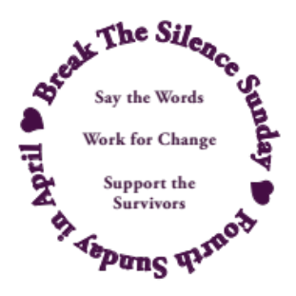
- I will walk beside you on your healing journey, accompanying you as best as I am able, and as you need to counseling appointments, court dates, or wherever else you need me to be with you.
- I am here for you, and with you.
- I stand with you.
- I believe you.

© Break The Silence Sunday, the Rev Moira Finley, October 2017

Some Statistics ~ compiled by the Rev Moira Finley

- There are an average of 321,500 people (age 12 and older) raped or sexually assaulted in the Untied States each year. (Source – U.S. Department of Justice, Office of Justice Programs, Bureau of Justice Statistics, National Crime Victimization Survey. 2010-2014)

- There is an average of one sexual assault every 73 seconds in the United States. (Source - Department of Justice, Office of Justice Programs, Bureau of Justice Statistics, National Crime Victimization Survey, 2018 (2019)).

- Let’s do some math with that statistic of every 73 seconds:
  - During an average song on the radio (3 minutes 30 seconds) there will be about 3 assaults;
  - During an average sitcom (30 minutes) there will be about 25 assaults;
  - During an average movie (1 hour 57 minutes) there will be about 96 assaults;
  - During a typical US football game (3 hours 12 minutes) there will be nearly 158 assaults;
  - During an office work day (8 hours) there will be 395 assaults;
  - During a single day there will be 1184 assaults
  - During a single year there will be 432,160 assaults

- All of those numbers are for people over the age of 12. In addition to those statistics, in a given year:
  - 80,600 inmates are raped to assaulted
  - 60,000 children are sexually abused
  - 18,900 members of the United States military are on the receiving end of unwanted sexual contact

- Approximately 55% of victims are assaulted in or near their own home, and an additional 12% are assaulted in or near a relative’s home. (Source: Department of Justice, Office of Justice Programs, Bureau of Justice Statistics, Female Victims of Sexual Violence, 1994-2010. 2013)

- As of 1998, 17.7 million women in the United States (1 out of every 6) and 2.78 million men in the United States (1 out of every 33) have been the victim of an attempted or completed rape in their lifetime (source – National Institute of Justice & Centers for Disease Control & Prevention. Prevalence, Incidence, and Consequences of Violence Against Women Survey. 1998)
- 15% of sexual assault and rape victims are under the age of 12 (source – U.S. Bureau of Justice Statistics, Sex Offenses and Offenders. 1997)

- The year in a man’s life when he is most likely to be the victim of a sexual assault is age 4. The year in a woman’s life is age 14. (Source – U.S. Bureau of Justice Statistics. 2000 Sexual Assault Of Young Children As Reported To Law Enforcement. 2000)

- 93% of juvenile sexual assault victims know their attacker (Source – U.S. Bureau of Justice Statistics. 2000 Sexual Assault Of Young Children As Reported To Law Enforcement. 2000)

A note on the statistics from RAINN (Rape, Abuse, Incest National Network): Sexual violence is notoriously difficult to measure, and there is no single source of data that provides a complete picture of the crime. On RAINN’s website, we have tried to select the most reliable source of statistics for each topic. The primary data source we use is the National Crime Victimization Survey (NCVS), which is an annual study conducted by the Justice Department. To conduct NCVS, researchers interview tens of thousands of Americans each year to learn about crimes that they’ve experienced. Based on those interviews, the study provides estimates of the total number of crimes, including those that were not reported to police. While NCVS has a number of limitations (most importantly, children under age 12 are not included), overall, it is the most reliable source of crime statistics in the U.S. We have also relied on other Justice Department studies, as well as data from the Department of Health and Human Services and other government and academic sources. When assembling these statistics, we have generally retained the wording used by the authors. Statistics are presented for educational purposes only. Each statistic includes a footnote citation for the original source, where you can find information about the methodology and a definition of terms.

For additional information on how the statistics are compiled, and additional crime reporting statistics please visit: https://www.rainn.org/about-rainns-statistics

Some Helpful Definitions ~ by the Rev Moira Finley

Should we use survivor or victim?
It’s a complicated question. Some folks think that victim is more appropriate to describe who they are, their feelings and their experience. Other folks think that survivor is more appropriate. What matters is that you listen to the person who has the lived experience of sexual violence. If you use one word and they tell you they prefer another, please respect that. Do not insist on your word to describe their experience. Listen to and respect all who have lived through these things.

Acquaintance Rape/Assault – where the perpetrator(s) is previously known to the victim; occurs in approximately 4 out of every 5 rapes/assaults in the United States; acquaintance may refer to a date (hence “date rape”), domestic partner, former partner, family member, classmate, neighbor, boss, coworker, and more.

Attempted Rape/Assault – a threat or rape or sexual assault, including verbal threats, and those made in other ways such as electronic communication (email, text), and on social media (Facebook, Tumbler, Twitter)

Domestic Violence – violence, and threats of violence, between spouses, domestic partners, and those who are co-habitating.

Force – methods used to coerce a victim into a non-consensual sex; this may include the use of a weapon, or physical violence, but also includes emotional and psychological manipulation, threats to the victim’s family, the withholding of finances, intimidation, threats regarding employment or child custody, and more.

Incest – sexual contact (which may or may not include penetration) between closely related persons such as parents, children, grandparents, aunts, uncles, siblings, cousins; in legal terms incest is often described as the crime of sexual contact between people who may not be legally married

Post Traumatic Stress Disorder (PTSD) – a condition resulting from the experiencing (or witnessing) of a traumatic event that causes long-term difficulty with flashbacks, intrusive memories, and severe anxiety; not all rape survivors will develop PTSD

Rape – a form of sexual assault; the U.S. Bureau of Justice Statistics defines rape as forced sexual intercourse which is defined as “vaginal, anal, or oral penetration by the offender(s)”; this also includes incidents where the penetration is by an object such as a bottle; legal definitions vary by state, and some states do not use this term at all in their laws instead they have degrees/grades of sexual assault.

Rape Culture – the way in which society blames victims of rape and sexual assault, and normalizes this violence, particularly male against female violence; the assumption that rape and sexual assault are an inevitable part of life; this includes the use of the word rape in other contexts (for example, when a sports team is defeated and commentators say “they were raped”), as well as the objectification of women’s bodies including school dress codes and purity movements that seek to control and limit women’s behaviors

Sexual Assault – sexual contact or behavior that occurs without explicit consent of the victim; this includes, but is not limited to: penetration of the victim’s body (see rape), attempted rape, forcing a victim to perform sexual acts on the perpetrator, fondling, unwanted sexual touching.

Stranger Rape/Assault – where the perpetrator(s) is previously unknown to the victim; occurs in approximately 1 of every 5 rapes/assaults in the United States.

Survivor Guilt – though most often associated with being a survivor after a mass catastrophe (such as an airplane crash), this phrase has also come to mean the guilt imposed on survivors of rape and sexual assault because of some perceived action, or inaction on their part

Victim Blaming – words and actions that imply the victim of rape or sexual assault is to blame for the actions of the perpetrator(s); this can be through questions about what the victim was wearing, why they were out alone, why they didn’t fight back, if they had been drinking or had previous sexual relations with the perpetrator, and questions about the previous sexual activity of the victim

Resources

General Information About Rape & Sexual Assault

- Rape Abuse Incest National Network (RAINN) – includes links to their online and telephone counseling services, http://www.rainn.org

- National Sexual Violence Resource Center, http://www.nsvrc.org

- Joyful Heart Foundation, http://www.joyfulheartfoundation.org

- No More (a national campaign to end sexual and domestic violence), http://nomore.org

- “What’s Their Problem? Sharing Our Pews With Sexual Abuse Victims and Survivors”, from Christ And Pop Culture, http://christandpopculture.com/whats-problem-sharing-pews-sexual-abuse-victims-survivors/

Resources About Recent Cases In The Media

- On the case of a UK woman convicted of lying about being raped on the island of Cyprus and what it tells us about rape culture: https://www.bbc.com/news/uk-scotland-51050656

- On the awarding of the 2018 Nobel Peace Prize to Dr Denis Mukwege and Nadia Murad: https://www.nobelprize.org/prizes/peace/2018/press-release/

- On the documentary “Surviving R Kelly” and its impact on boys: https://www.vice.com/en_us/article/bvgz78/sexual-assault-happens-to-boys-too?fbclid=IwAR3WGPoKS48MAhHxb8b1N6JaSF9aySp4lc_TmmkIVdixxpxEmk8ERzSG5ew

- An interview with Chanel Miller https://www.latimes.com/opinion/story/2019-09-24/abcarian-chanel-miller-sexual-assault-brock-turner?fbclid=IwAR2ZegY_qmvvP3fRTFCszEyuEB6nfwlN52YJ2fwIvhRC79DHMVqCBsUsH7A

- A speech from Dr Christine Blasey Ford about being a survivor https://sanfrancisco.cbslocal.com/2019/10/30/christine-blasey-ford-brett-kavanaugh-supreme-court-power-to-inspire/?fbclid=IwAR3roli9OitBA5zJVwT4ZGbDr0dtITcd3pwcgPcPm9qQ2Exs79lMKRC6_xk

- Very practical ideas about how to support survivors in your midst: https://www.bustle.com/p/14-ways-to-support-sexual-assault-survivors-right-now-7739137?fbclid=IwAR28CT1TCjWj28KosMybubll8nT2LVRnFxOD4BppC6bqQ1zGrRqkOfVIP50

Resources on PTSD

- From the Department of Veteran’s Affairs: https://www.ptsd.va.gov/index.asp
- From RAINN (specific to rape survivors)
https://www.rainn.org/articles/post-traumatic-stress-disorder

Resource Ideas For Family, Friends & Allies Of Survivors

- https://www.rainn.org/articles/help-someone-you-care-about

- Particularly for parents https://puckermob.com/moblog/10-things-every-parent-of-a-sexually-abused-child-needs-to-know/?fbclid=IwAR3DpmnSTDFV0US9DfL-pvCk5fu1mzfxdPUUFQ3L96-ySCxY8fhvUD_o4Oc

- Particularly to support male survivors https://cutacut.com/2019/10/24/how-to-help-male-survivors-of-sexual-violence/?fbclid=IwAR1xteiIiYYv56GKZ4GVT_8es6yzrJ9Z9ON-GCuxntiejRxFY01iaSY-7t0

State of Wisconsin Resources

- Wisconsin Coalition Against Sexual Assault

Telephone: 608-257-1516; http://www.wcasa.org
Offers information and referral on any issue related to sexual violence; does not offer direct services to victims/survivors, but will connect them to local agencies

- County by County resources – please visit our website http://www.breakthesilencesunday.org and the Resources tab to find a chart which will identify sexual assault resource organizations in each Wisconsin county

Space For Notes, Doodles, Dreams, Fears, Questions…

Feedback Form ~ Break The Silence Sunday 2020

Please return to: BTSS c/o Moira Finley
PO Box 691
Bonduel, WI 54017

You may also submit this information by email at breakthesilencesunday@gmail.com

Your name:________________________________________________________

Your position (pastor/worship leader/other):______________________________

Your community/church:_____________________________________________

Did you use the Break The Silence Sunday Liturgy?

- Yes, as it was provided

- Yes, but we adapted it; please list how you adapted it:

- We used parts of it, but not the entire liturgy; please list the parts used:

- No, we wrote our own liturgy; if you are willing to share the liturgy you used, please email it to breakthesilencesunday@gmail.com or post to the above address

Please continue to the other side --->

What did you use during the sermon time?
- A survivor in our community shared their story (if possible, please connect them with us by emailing contact information to breakthesilencesunday@gmail.com)
- A community resource person came to help our community think through issues of sexual assault and rape
- Wrote our own sermon (if you are willing to share, please email it to breakthesilencesunday@gmail.com or post to the above address)
- Something else; please describe…

What could we provide to you for 2021 that would help you better prepare, and lead Break The Silence Sunday?

Any additional comments, suggestions, concerns?

Martin Luther King Jr. "The Trumpet of Conscience" Steeler Lecture, November 1967

