Break The Silence Sunday

April 28, 2019

A time for the church to learn together

about the realities of rape and sexual violence;

about ways to create a community where survivors
can share their stories and receive support, hope, and love;

and to prayerfully consider ways in which they can be advocates
for change in their communities, and around the world.

Resources for Worship

http://www.breakthesilencesunday.org
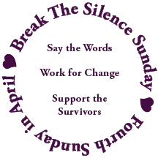

Table Of Contents

Acknowledgements 2

A Prayer to Begin 3

Introduction to The 2019 Break The Silence Sunday Materials &4
Notes For Worship Planners & Leaders 4

Sample Newsletter Article & Bulletin Announcement 10

Liturgy for Break The Silence Sunday 2019 11

Liturgical Resources 27

2019 Break The Silence Sunday Scripture Reflections 33

Sermon Suggestions & Advice For Preachers 35

Two Sample Sermons
Rev Moira Finley, 2018 BTSS Reflection 38

Jason Eisele, January 14, 2018 42

Talking With Children & Youth 48

Break The Silence Sunday Clergy Commitment 50

Break The Silence Sunday Proposed Resolution to General Synod 51

Some Statistics 59

Helpful Definitions 61

Resources 64

Space For Notes, Doodles, Dreams, Fears, Questions 66

Feedback Form 67

Acknowledgements

The work of Break The Silence Sunday would not be possible without those who contributed their words, their music, and their prayers. So many people have been a part of the years leading up to this project, who have patiently waited through the frustration, fears, anger, and silence.

- The Rev Franz Rigert for opening a door that has long felt firmly closed
- The friends who have held my hand, offered tea, coffee, wine, and snacks; who have listened to my anger and frustration, and just plain loved me, I owe you more than you know ~ Richard & Trish Bruxvoort Colligan, Bryan Sirchio, Christopher & Carla Grundy, Andra Moran, Lisa Hart, Conie Borchardt, Ben Welch, Amy Englesdorfer, Brent & Sara Smith, Jody Clegg, Darryl Commings, Maggie Schultz, Helen Rowinski & Lella Baker
- Bryan Sirchio for his amazing musical skills in setting my story to song and for the courage that entire experience has given me for this part of the work; yes I know you say it’s my song, but it shall forever be ours in my mind
- The folks who have contributed to the liturgy…
Don Neiderfrank, Richard Bruxvoort Colligan, Maren C Tirabassi,
William Kesting, Christopher Grundy, Stephen Price
- The amazing folks of the Tri-Jo Parish United Church of Christ (Trinity UCC Shiocton, WI and St John’s UCC Cecil, WI) who have journeyed with me these years; the wonderful folks of St. John’s UCC Black Creek, WI who are just beginning this pastoral journey with me; and all of them for trusting me with the privilege of being their pastor, and who graciously give me time every year to write these materials
- Severin Provance, for his logo design
- My survivor siblings, particularly Lella Baker, who understand how hard this work is, and how incredibly important it is as well
- My community of online friends around the world who remind me that I’m not alone, and that somewhere there is always someone awake who will talk me through the struggle;
- For all the survivors who are stronger than they imagine because they get up and face each day, I hope we have done well by your stories.
- For all of you reading this who shall faithfully plan and lead worship to help us break the silence; my gratitude for your courage.

In faith and hope, Moira Finley

A Prayer To Begin

As you begin planning for Break The Silence Sunday you may feel many things, wondering if you can bring this word of hope to your congregation, and how they will respond when you do. You could be wondering what kind of stories will be shared with you, and if you will be able to hear them with your whole heart. You might be afraid of not knowing answers that you think are needed by those who come to you with questions about this day, with stories of their own, with fears and insecurities. You might be hearing the voice of that parishioner who asks, “Why do we have to do this again?” and you’re trying to find the words to tell them that the reality of rape and sexual violence need to be confronted over and over again until justice is done. Whatever you’re feeling, and thinking, please don’t panic. This is a journey, and every step counts, no matter how tentative. So sit in a comfortable place, take a few breaths, and then pray this prayer for yourself...

A Prayer For Hesitant Clergy
by the Rev Don Niederfrank

Divine Companion, you have encouraged and comforted me
at so many times,
in so many places,
with so many persons.

One more time, I ask, though afraid even in my asking,
be with me.

Strengthen my trembling knees,
that I may stand with those who have too often and too long stood alone.

Call to me in the tumult of my self-focused anxiety,
that I may bring your Presence, your Peace, to those whose terror is real.

Deliver me from my silencing fears
that I may speak your Word.

Holy Shepherd, I am yours. Send me to those you love.

Introduction to The 2019 Break The Silence Sunday Materials &

Notes For Worship Planners and Leaders

The past year has seen tremendous joys and terrible sorrows, and has been one that has again revealed some of the most challenging aspects of our society. The veneer of civility has been stripped away and some truly ugly things have been revealed with emotions, thoughts, and actions once only shown in private are now out in the open. Racism, sexism, heterosexism and all the related prejudices are pouring out at bus stops, pubic parks, coffee shops, workplaces, and sanctuaries every day.

There is a climate of despair and burnout. The news can be overwhelming with so many different challenges facing us as individuals, and communities, and congregations, and a country, and a world. Where should we focus our attention? How can we speak truth and work for justice for all the groups and people in need? Nothing we seems to do makes much of a difference so maybe we should just turn off the internet, and the television, and curl up under the blankets and pretend it’s all ok, or at least that it will all go away.

And yet, there is also a climate of hope and renewed commitment to action. The mid-term elections in November 2018 brought a wave of people running in local, state, and national elections who had never even remotely considered serving in public offices before. I’m particularly proud of my home state of New Mexico for their election of Deb Haaland to the United States House of Representatives, one of the first two Native American women elected to the U.S. Congress (along with Sharice Davids of Kansas). In addition, folks are finding connections, and rediscovering the importance and power of community, of people who will love and encourage you when you get weary with the world, whether they’re your next-door neighbour or your internet friend from the other side of the world.

But perhaps you’re wondering what all this has to do with Break The Silence Sunday (BTSS), why this introduction seems to have gotten a little off course in discussing elections, and society, and activist burnout.

My friends, these have been incredibly difficult times for survivors of rape and sexual violence.
In recent days, the documentary “Surviving R. Kelly” has broken open old, incompletely healed wounds for many, remembering the abuse they too suffered at the hands of powerful, controlling people. This is particularly true because our black and indigenous (Native) sisters are far more likely to be assaulted, and far less likely to be believed, than white women.

This year we also saw the courageous testimony before the Senate Judiciary Committee, and the entire world, of Dr Christine Blasey Ford about her experience as a survivor during the confirmation hears of now Supreme Court Justice Brett Kavanaugh.

Closer to home in Wisconsin, Jayme Closs was abducted, and her parents killed, by a man who became obsessed with her. Jayme has only recently been found after several months of untold horrors at the hands of her kidnapper.

And in the midst of all that, there have been cases near and far, local and widely publicized, of rape, assault, abuse, trafficking, and sexual violence where survivors have been vilified for ruining someone’s life by bringing charges. Judges have handed down lenient sentences, fines and probation, or sometimes even dismissed cases entirely because, as one Irish judge said, the woman’s lacy thong underpants were a sign of her consent.

What, in the midst of all this, has the church done to respond? Sadly, the answer is not much. We haven’t wanted to wade in, thinking that the topics of rape and sexual violence are simply too difficult, too personal and private, too overwhelming for the church to take on. We, particularly clergy, think that we’re unequipped to handle what survivors might tell us, that it’s not been part of our training to counsel survivors forgetting that we would be one part of a healing team, working with a survivor and their couselor or therapist, helping survivors work through the complicated faith questions that sexual violence brings up.

We think, maybe, that when survivors share their stories with us we need to help them move quickly to forgiveness, holding it up as a cardinal Christian virtue, not willing to take the time to process with the survivor the intense emotions – guilt, shame, fear, anger, anxiety, and more – that they feel before they’re even ready to consider forgiveness.

We get caught up in thinking that these are crimes about sex and so we shift our attention to teaching about consent and healthy sexuality (which we absolutely must do) and forget that there are already survivors sitting in our pews, and at our Bible studies, and around our potluck tables who need the love and grace of the church to help them along their healing journey.

So that is why Break The Silence Sunday is here, in its fourth year, to help you and your community, to offer some ways that your faith community might reach out to survivors, and speak out, clearly denouncing rape and sexual violence as crimes against the body of God.

There is no doubt that this is hard work, and you will need to do a lot of preparation – of yourself, of your worship team, and of your congregation/community.

For yourself, start with some deep breaths and a nice cup of tea (or whatever helps you). Seriously, you need to care for yourself so that you are equipped to care for others. You need to pray, to ask God to guide and sustain you during this time, to fill you with a spirit of gentleness and humility, and to give you the words that you truly need to speak in this time, and in your particular place.

For your worship team, they might like some tea and cookies as well. Then start with some prayer, relying on God’s guidance and love as you plan your Break The Silence Sunday services. Think together about how this time will be structured, what the pace will be, what the lighting will be like, what all the other wordless things are that contribute to, or detract from, worship. Whether you’re using these materials to plan an entire service dedicated to BTSS, or you’re going to have a mid-week time of prayer, or an evening healing service, or a single prayer in the midst of other things, you need to pay attention to your feelings, and those of the other worship leaders, honoring and respecting the stories, fears, and hopes you bring to this moment.

For your congregation or community, prepare them far in advance. These materials come to you in February with a proposed observance in April because you really, truly do need these months. Everyone needs to be made aware that Break The Silence Sunday will be observed, that explicit words like rape and assault will be used during worship. They need to know that worship will likely be emotionally challenging, regardless of the specific words used, because you will be talking about things many would rather we never spoke of.

In addition, think about the survivors in your community. If you know who they are, please reach out to them individually to prepare them. Don’t let them just hear about BTSS in your newsletter or on your social media pages. Let them know, well in advance, what you are planning, perhaps even sharing a draft of the worship service to help them see what will happen. Reassure them that it’s OK if they opt out of worship that day, if the service is not something they are prepared for at this point in their lives, that you understand the opening of wounds that might happen during worship could be overwhelming. Remember that not every survivor is at a place where their participation in or presence at Break The Silence Sunday is either healthy, or safe. They may have resistance to the work of BTSS, and that’s ok. Go gently.

And if you’re thinking to yourself that there aren’t any survivors in your community or congregation, think again. You only hear the stories survivors can bear to tell, and the pure math tells us that there are absolutely survivors who worship with you.

The most conservative estimates are that 1 in 6 women and 1 in 33 men are victims of sexual violence in their lifetime. In reality, because of low reporting rates and other factors, it’s probably closer to 1 in 3 women and 1 in 10 men. Think of your community, the people you sit with during worship. Some of those people are survivors, most of them whose stories you won’t know. They need your help in preparing for Break The Silence Sunday as well.

You will also need to do some after-care – for yourself, your worship team, and your community – so prepare for that too. Take the time you need to think, pray, and reflect on how the observance of Break The Silence Sunday went.

Make sure you know your local resources for survivors who may come forward and need help accessing clinical help, and then offer to go with them, or meet them after for coffee, or simply be with them. When a survivor shares their story with you, be gentle and remember that they are trusting you with some of the hardest parts of their life, hoping that you will be the living presence of God in their lives.

Through all of this, please try to keep in mind that Break The Silence Sunday is a movement and a work of hope. It is a movement, and it takes time.

We believe that, as individuals, as congregations, and as the wider church we can do better in supporting survivors, creating space where they feel safe sharing their stories, and honoring their courage and resiliency.
We can find new ways of thinking about, and talking about our faith that don’t glorify suffering and don’t perpetuate the abuse that so many have suffered. And we believe that we can work together to change the culture that allows sexual violence to happen, building a future where survivors can share their stories without shame, and where all can live free from sexual violence.

And if nothing else gives us reason to hope it’s that you, yes you, are sitting here reading this material. Maybe your community has a supportive pastoral staff and all you need to participate fully. Maybe you’re the pastor who is going to invite your congregation to observe BTSS for the first time and you’re anxious, but also confident, that it’s what your community needs right now. Maybe you’re reading this and thinking you’d like to suggest it to your pastor or worship committee or whoever in your context might be most supportive and you’re just not sure any of them will be. Maybe you’re a survivor who thinks you’re perhaps, possibly ready to share your story and hoping your faith community will receive it with grace and love. Whoever you are, whatever the situation you find yourself in, you are the reason Break The Silence Sunday will ultimately make healthy, sacred space for survivors in our faith communities.

The suggested date for Break The Silence Sunday is the fourth Sunday of April. This keeps us within the national observance of Sexual Assault Awareness Month (SAAM), but it is just a suggested date. In 2019 it falls on the Sunday after Easter and many congregations have traditions for that date. There are also communities who will have observances of Earth Day that weekend, and in the U.C.C.’s calendar it is Pacific Islander Asian American (PAAM) Sunday which celebrates the diversity of our faith tradition.

Please feel free to pick a time that works best for your community. Some have held observances in October during the observance of Domestic Violence Awareness Month, remembering that much rape and sexual violence occurs within domestic relationships. Other communities observe during the summer, and still others find Lent an appropriate time to take on the challenging work of learning about sexual violence and creating space for survivors. Whatever date you choose please feel free to adapt these materials, use them for inspiration, and craft whatever you need – worship, prayer, study – that best fits the needs of your community.

As we are in the fourth year of BTSS, those of you who are familiar with the work may start to see similarities between this year’s liturgy and previous years.
We are currently leaning towards putting BTSS on a modified three year cycle of readings, and hymns, and prayers, and to gather together the various parts in new ways on our website. Speaking of the website, do please visit it for previous years’ materials, and blog posts about the work of BTSS. We are at: http://www.breakthesilencesunday.org

Please, whatever you do, we would appreciate feedback about what you liked, and didn’t like, about these materials, what worked for you, what was a challenge, and what could be provided in coming years to help you better implement BTSS in your community. There’s a feedback form at the end of these materials if you’d like to mail it in, of you’re welcome to send questions and comments to our email at breakthesilencesunday@gmail.com or call at 715-851-3080.

One last thing, in June 2019 the U.C.C.’s General Synod will meet in Milwaukee, Wisconsin to do the business of the national church, and to help guide the life of the church in all settings. As part of this meeting, the Synod will consider various resolutions. Some have to do with the structure and operations of the church, but many resolutions call on the church to be aware of, and act on issues of justice. We have submitted a resolution calling on the national church to make Break The Silence Sunday a more formal observance of our church, putting it on the calendar, and inviting churches and communities in all settings to participate. You’ll find the resolution on page 51 of these materials. We invite your prayerful support of the resolution. On our website you’ll find information about the financial support we need for advocating for the resolution at Synod, and you’re welcome to share it with anyone you know – delegate or visitor – who might be in attendance at Synod this summer.

Again, please be in touch if there’s anything here you need to talk through, if you have questions or concerns, if you need to share your story, or if you just need a cheerleader as you work towards bringing Break The Silence Sunday to your community. You can reach us at breakthesilencesunday@gmail.com and by phone or text at 715-851-3080.

God’s blessings on your work.

Peace and grace,
Moira Finley

Sample Newsletter Article & Bulletin Announcement

You’ve probably heard of the #metoo movement, the women and men speaking out about their experiences with sexual harassment, abuse, and violence. Every day, courageous people are speaking out, but it is not enough for them to do so.

We too, as people of faith, must be courageous.

The survivors of sexual violence are our friends, neighbors, colleagues, family, and members of our congregation. They need us to help them, to listen as they speak out, to create a place where their stories can be heard without fear, or judgment. They need us to witness with them to the pain of their stories, and to stand with them, reminding them of the healing love of God.

Join us for Break The Silence Sunday on _________________.

In worship we will acknowledge the reality of rape and sexual violence, that every 98 seconds someone in the United States is raped or sexually assaulted.

We will hear the stories of survivors, trusting in the good news of God’s love and grace.

We will commit ourselves to being a listening people, and a people dedicated to changing the reality of violence in the world.

This service may be difficult and challenging. Some parents may not want their young children to be present. Please take time to prepare yourself . Ask God for the strength to open your heart and mind, that we shall support all the survivors who are part of our church, our community, and the world.

If you have questions or concerns about the service, or if you would like to help with worship leadership, please contact ___________________

Liturgy For Break The Silence Sunday ~ April 29, 2019

Unless otherwise noted, prayers are written by the Rev Moira Finley.

Musical Prelude

Welcome

Welcome to worship. Today we stand with our sisters and brothers who have been victims of rape and sexual assault. We witness to their pain, and their strength; to their questions, and their faith; to what keeps them up at night, and what they need from us, as individuals and as communities of faith. Today we start to speak out, to break the silence of complicity and fear, and through it all trust in the good news of God’s incredible love for us, and for all the world.

Call To Worship

One: We come this day
Many: trusting in God’s grace,
One: confident of Jesus’ love,
Many: and aware to the Spirit’s guidance.

One: We come this day
Many: anxious and unsure,
One: hurting and frightened,
Many: confused and hopeful.

One: We come this day
Many: to listen,
One: to hear,
Many: and to speak out.

One: We come this day
All: to break the silence!

Gathering Prayer

This prayer could be said in unison, or responsively with the people speaking the line “Open us, Holy One” (in bold) and the leader or leaders speaking the remaining lines.

O God, Life giver, Pain bearer,
You know what our siblings
hold in their hearts, and minds.

Open us, Holy One.

You know the horrors they experienced,
the things they are afraid to speak,
because they have been silenced,
by their own shame,
and by our discomfort and fear.

Open us, Holy One.

Open our hearts,
our minds,
and our spirits
to the stories of those who have survived
the worst we do to one another.

Open us, Holy One.

Open us that together
we may listen with compassion,
and speak with conviction
that we may no longer be silent.

Open us, Holy One. Amen.

Hymn ~ “Amazing Grace”
By John Newton; tune Amazing Grace C.M., public domain

Amazing grace, how sweet the sound,
that saved a wretch like me.
I once was lost, but now am found,
was blind, but now I see.

‘Twas grace that taught my heart to fear,
and grace my fears relieved;
How precious did that grace appear
the hour I first believed.

Through many dangers, toils, and snares,
I have already come;
‘Tis grace has brought me safe thus far,
and grace will lead me home.

My God has promised good to me,
whose word my hope secures;
God will my shield and portion be
as long as life endures.

When we’ve been there ten thousand years,
bright shining as the sun,
We’ve no less days to sing God’s praise
than when we’d first begun.

Why We Have Come ~ Acknowledging The Reality Of Sexual Violence

This prayer is not necessarily one for survivors to pray. It is, instead, for those who have had the privilege of living free from these experiences, perhaps with blinders on, unaware of the reality of rape and sexual violence in our communities, and around the world. During this prayer you might consider lighting candles (or inviting survivors to do so) to symbolize the experience of all those who live this reality in their daily lives.

One: We have come to listen, and to hear things that will unsettle us, and make us uncomfortable, challenging things we think about the world.

Many: We have come…

One: to hear the guilt, fear, and shame that survivors carry, the stories of those who have survived things we cannot begin to imagine.

Many: We have come…

One: to listen to what keeps our siblings up at night, to listen with compassion, and love.

Many: We have come…

One: to be present for survivors, doing our own spiritual work, so that we might listen without judgement or pity.

Many: We have come…

One: to hear the memories, and nightmares, and flashbacks; the violation, cruelty, and suffering.

Many: We have come…

One: to remember that not everyone survives the violation of rape and sexual assault, and that the grief and pain overwhelm many who seek to escape through self-harm, and suicide.

Many: We have come…

One: to commit ourselves to the messy, difficult, sometimes excruciating work of changing the world, to the path that Christ showed us, the work of making the world whole.

Many: We have come…

One: to remember that taking small, uncertain steps is an okay way to begin, that we do not have to do everything, but that we must do something, that we must listen, and then raise our voices for the world is depending on us.

All: Amen.

Hymn ~ “We Have Come”
by Christopher Grundy, © Hand and Soil Music, 2009; used with permission

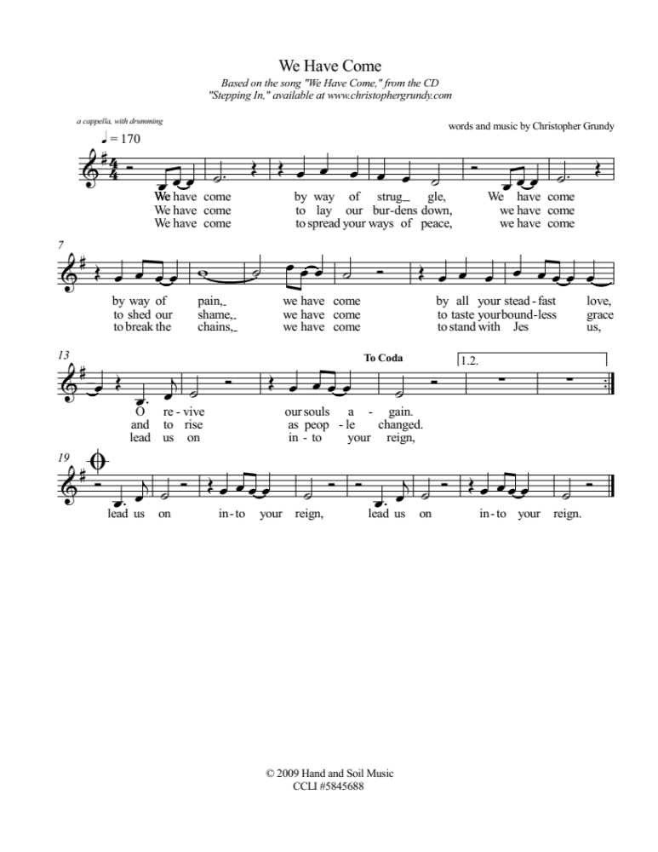
Breaking The Silence ~ A Time For Prayer

Silence in worship can be powerful, a time for people to listen to the voice of their heart and soul. However, this is Break The Silence Sunday, a time no longer keep silence. This time of prayer seeks to provide some silence, acknowledging the reality of rape and sexual assault, but also breaking the silence of our complicity. In the United States someone is sexually assaulted an average of every 98 seconds. Using that amount of time as its basis each silence will be progressively shorter to show the urgency of speaking out. While this prayer uses statistics for the U.S., the problem is not unique to our country, and so we stand with our sisters and brothers around the world who live in the shadow of rape, and sexual violence.

One: Once, in every ninety-eight seconds…

a silence of 98 seconds is held, then a bell is chimed

One: Once, in every ninety-eight seconds someone in the United States is sexually assaulted, and the church has been deafeningly silent.

a silence of 74 seconds is held, then a bell is chimed

One: Survivors have been shamed into silence, afraid to speak the truth of their experiences. When they have dared, they have been met with pity, contempt, hurtful and dangerous theologies, and victim blaming.

a silence of 50 seconds is held, then a bell is chimed

One: The time for our silence as the church is over. Rev Dr Martin Luther King, Jr once said, “In the end we will remember, not the words of our enemies, but the silence of our friends.” It is time for us, the body of Christ broken by rape and sexual assault, to be outspoken about this violence. It is time for us to open our hearts, our minds, and our churches to the stories of survivors, to share with them the hope of God’s grace that is with us in our moments of deepest despair, and can in time bring hope.

a silence of 26 seconds is held, then a bell is chimed

One: Now! Now is the time for us to break our silence!

a bell is chimed

Sung Response ~ refrain to “You Are Mine” by David Haas
Reproduced under OneLicense.net #A-707385

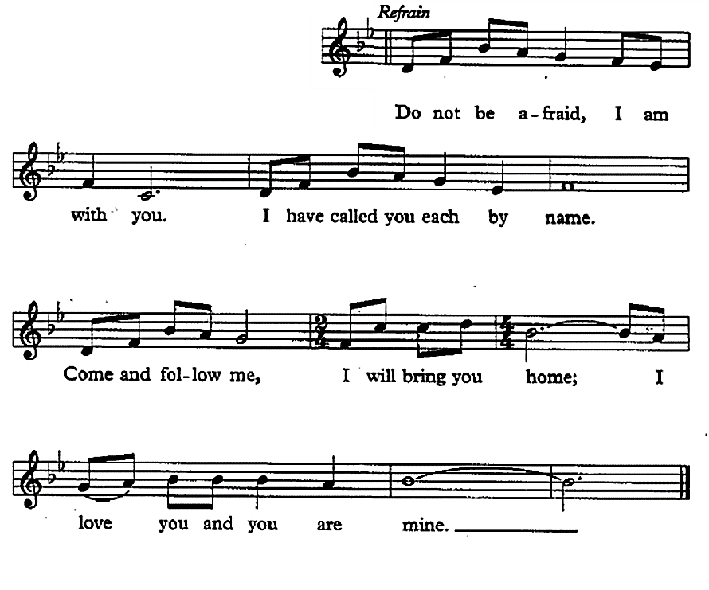

Invitation To Confession
We have, as the church and as its individual members, been silent when the lives of those who we know have been shattered by sexual violence. We have shied away from those who would share their stories, afraid of what we might hear, of what it might mean for us, and for our lives. We have been quick to ask questions – what were you doing, what were you wearing, why didn’t you fight back – placing blame on survivors instead of where it belongs, with the perpetrators. Together, trusting in God’s grace, let us confess our responsibility in creating and perpetuating a culture of silence.

Unison Prayer Of Confession

by the Rev Maren C Tirabassi, © 2015, used with permission

God, we confess that we put stumbling blocks
in the path of those who need to share
their stories of rape or of abuse,
of incest or of cyber-shaming.

We put the block of disbelief,
the block of our own discomfort
at visualizing sexual violence
and our own discomfort
at not knowing how to fix everything.

We put the block of liking church
to be vague and happy,
the block of blaming the victim,
the block of “you should have been careful,
found different kinds of friends,
worn different clothes.”

We put the block of insecurity,
the block of “I’m in too deep here -
please tell a therapist,”
the block of “get over it,”
and the block of “aren’t you over it yet?”

God, we confess that we are so proud
about not throwing the stones
we never notice that people
stumble and fall
on the way to our church door.

Assurance Of God’s Grace

by the Rev Maren C Tirabassi, © 2015, used with permission

Christ who named putting stumbling blocks in the paths of little ones as the most serious of sins, affirmed that giving one cup of cool listening is worth a world of blessing. We are forgiven, and given a chance to listen and love again.

Scripture Readings
Isaiah 43.1-7 God’s promise to name and claim each of us
Psalm 139.1-18 God created us, knows us, and is always with us
Luke 13.10-17 Jesus heals a woman on the Sabbath
Hymn ~ “I Love To Tell The Story
Re-sung For Break The Silence Sunday”
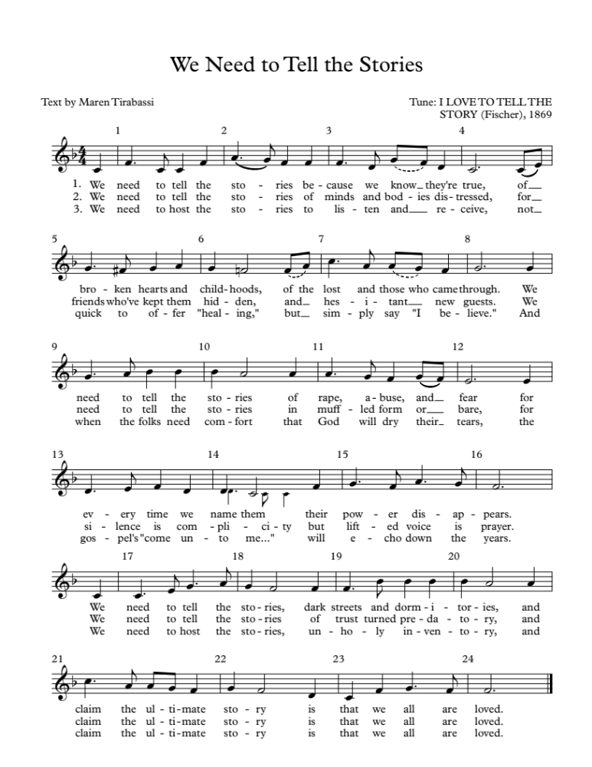

Sermon/Reflection/Stories from Survivors

Sung Response ~ “God Is Holding Your Life”
by Richard Bruxvoort Colligan
© 2006, Augsburg Fortress, Reprinted under OneLicense.net #A-707385

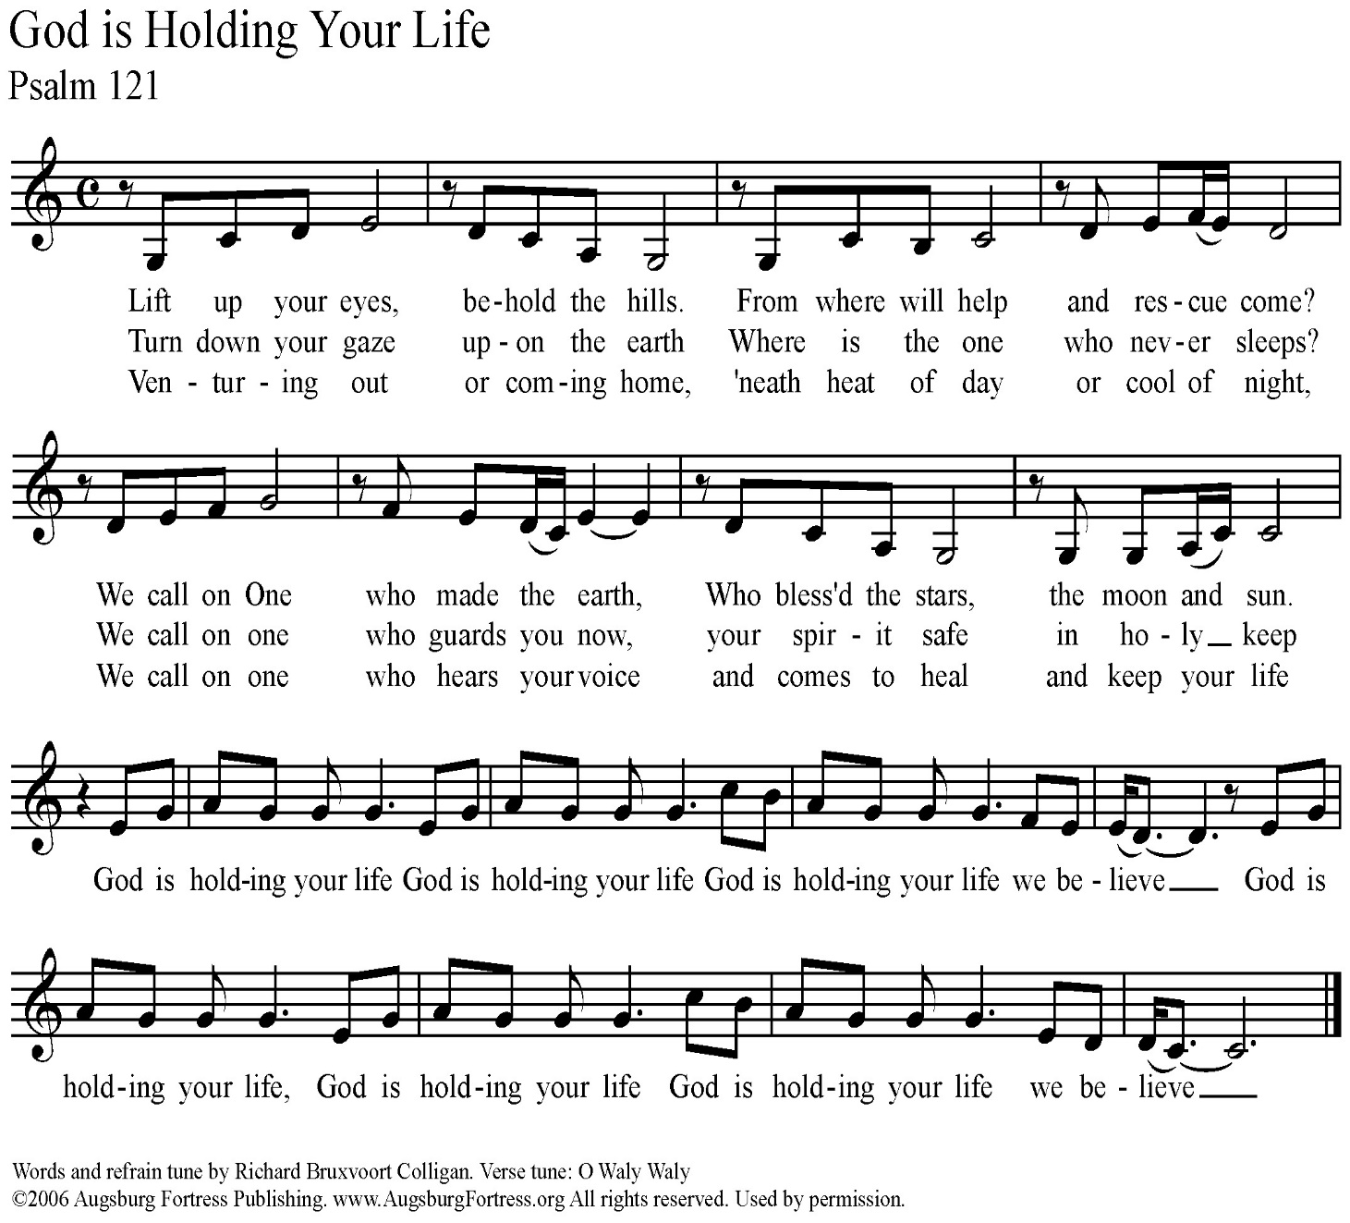
A Time Of Prayer

Holy One, you filled the world with your love, and your Spirit, breathing into each of us the breath of life.

You named each of us, and claimed each of us as your very own, but some of us, some of your beloved children have been hurt, deep in their souls.

They have experienced great violation through rape, abuse, incest, harassment, stalking, trafficking, and assault.

They come, asking to be heard, needing to be healed by your unending love, asking us to stand with them, and to work for justice.

We pray for that healing this day, O God.

We pray for your love and grace to be poured out abundantly on all who have been wounded by sexual assault – the survivors and all those that love them.

May your healing presence guide each survivor in their path towards wholeness, and hope.

May your courageous Spirit fill all of us this day.

Give us the strength to listen, to speak out, to be bold, and to trust in you completely.

Give us what we need to comfort those who struggle, and the commitment we need to work tirelessly for the wholeness of all your people.
These, and all our prayers, we pray with the words that Jesus taught his first disciples, saying together…

The Prayer Jesus Taught

Our Father, who art in heaven, hallowed be thy name, thy kingdom come, thy will be done, on earth as it is in heaven. Give us this day our daily bread, and forgive us our trespasses as we forgive those who trespass against us. Lead us not into temptation, but deliver us from evil. For thine is the kingdom, and the power, and the glory forever and ever. Amen.

Offering Our Gifts
You might consider designating the offering, or a portion of it, to the local sexual violence resource center in your area, or to a national organization such as RAINN (Rape Abuse Incest National Network).

Prayer Of Dedication

Generous God, we bring you these gifts, signs and symbols of our hope and gratitude. We entrust them to you in faith that the work Christ began – listen to the stories of God’s people, healing the brokenness of the world, and restoring creation – might continue in us and through us. Grant us the courage to listen, to pray, and to speak out. In faith we pray, Amen.

Celebrating Communion

One: This table is not ours, but it belongs to God. All who seek to be fed and nourished by God’s grace, and sustained by this community are welcome to share at this table. We come, from the shadows of a waiting, hurting world, knowing that, wherever we have been, whatever we have experienced, we will be fed and renewed. We reach for the cup of God’s love, aware of an unquenchable thirst in the depths of who we are, a thirst for justice and hope. We come, trusting that God will meet us here. Let us pray together…

All: Holy One, we come to share the richness of table. We ask for your healing grace to be poured out on all those who have suffered sexual violence. Renew and restore them, and your church. Be present with us, and remind us that your presence is with us always. Give us the courage to truly be the Body of Christ.

One: Gracious God, in Jesus you have given us the greatest gift. We come to this table to know you, to remember your love, and to confess that your grace is for all. Some of us come to this table tired and anxious. Some of us come with hope in our hearts. All of us come, trusting in your Spirit’s presence, and trusting in the promise that we might all be One, whole and healthy, as your people. Let us pray together…

All: We thank you God for giving yourself to us in Jesus Christ. We thank you that he lived among us, and knew what it was like to be human. Feed us at this table, and give us the courage to be faithful to the One who dared to come into our world. Renew and revive us. Give us the courage to listen, and to speak out today and always. Amen.

One: We know the stories about Jesus’ life, how he would come to share many meals with his disciples and friends. He would welcome those who had been cast to the margins of society, eating with sinners and prostitutes, with the sick and the lame, with the wealthy and the poor alike. On one of those occasions, as his earthly life was nearing an end, he found himself with his disciples and those who had followed him closely in an upper room in Jerusalem. They were there to share the story of hope, of release from captivity, of God’s promise of freedom. During the meal he would take the bread, bless it, break it, and offer it to them saying, “this is my body which is given for you.” Later, after supper, he would take the cup, give thanks, and say, “this cup is a reminder for us of the new relationship God has made possible between us, and all of creation.” The bread we share is a reminder for us that just as God blessed Jesus with an earthly body, so our earthly bodies are blessed. The cup we share is a reminder for us of Jesus’ life, and the grace of God that Jesus came to help us know. We pray that God would bless this bread, and this cup, and us as we receive them. We bring all our lives to God at this table, that we might be one people, united as the Body of Christ, working together for justice and peace. The gifts of God for the people of God. Come for all things are now ready. Come and see how good God is.

Sharing The Elements

Unison Prayer Of Thanksgiving
We give you thanks, Gracious God, that you come to us in bread and cup, and in the love of this community. Send us from this table, nourished and empowered. Help us listen with all our hearts, and speak with all our minds, that all your people might truly know peace. Amen.

Committing Ourselves To Change

One: In the presence of one another, we pledge ourselves to ending the violence of rape and sexual assault, working towards a vision of the Beloved Community where all can live in dignity and peace. We acknowledge the reality of rape and sexual violence, a plague that brings hopelessness and fear to our siblings here, and around the world.

Many: We stand in solidarity with those who have been victims. We promise to be open to their stories, and with the grace of God, to listen without judgment.

One: We know the promise of wholeness, and hope that Jesus came to bring to the world.

Many: We affirm the promise of God’s love for all the survivors in our world, those whose stories are known to us, and those whose stories are still shrouded in silence and fear.

One: We know that we have not done enough, that we have been silent when those around us have been struggling.

Many: We look forward with hope, trusting in God’s ability to give us strength to listen with courage, and to be silent no longer.

One: We believe that the future depends on us.

Many: We believe that there is something we can, and must do, as people of the Good News, and as members of one human family, to end the violence of rape and sexual assault.

One: We recognize that we cannot do this alone. We know we must learn to depend on each other, and on God, in the struggle to end sexual violence, and create justice.

All: Gracious God, help us to be aware of your loving disruption of our lives. Give us the courage to work with you, and with each other, to transform our hurting world. Empower us with your Spirit that we might break the silence of sexual violence. Help us listen and move together, from fear and pain towards your realm of peace and justice. In Jesus’ name we pray, Amen.

Hymn ~ “We Shall Overcome”

(tune: We Shall Overcome, public domain)

We shall overcome, we shall overcome,

We shall overcome, some day;

Oh, deep in my heart, I do believe,

We shall overcome, some day.

We’ll go hand in hand, we’ll go hand in hand,

We’ll go hand in hand, some day;

Oh, deep in my heart, I do believe,

We’ll go hand in hand, some day.

We are not afraid, we are not afraid,

We are not afraid, today.

Oh, deep in my heart, I do believe,

We are not afraid, today.

The truth shall make us free, the truth shall make us free,

The truth shall make us free, some day;

Oh, deep in my heart, I do believe,

The truth shall make us free, some day.

Benediction & Musical Postlude

Liturgical Resources

Notes On Music From The Liturgy

You’re thinking to yourself, “wow, that’s a lot of music for one worship,” and you’re right. There’s a reason for it. The content of Break The Silence Sunday is intense, and it requires a lot of heart-opening, a lot of willingness to let the Spirit move us in ways that probably make us uncomfortable. Music has the ability to let us rest, while also stretching and challenging us. It gives us the opportunity to hear, and learn our faith story, our theology, our call to God’s work in the world in a different way than simply spoken words do. Feel free to use all, or some, or none of these songs during your community’s worship time. There are additional suggestions for songs that speak well to the work of Break The Silence Sunday, and we welcome your suggestions of music that is helpful for your community.

“Amazing Grace” by John Newton

In the public domain it can be found in many hymnals including the U.C.C.’s New Century Hymnalat #547

“We Have Come” by Christopher Grundy

is intended to be sung acapella. You can listen to a recording at http://www.christophergrundy.com/recordings/

The song is on the album “Stepping In”, track number four.

“You Are Mine” by David Haas

Can be found in the supplement to the United Methodist Hymnal The Faith We Sing at #2218 and can be used with a OneLicense.net account. Only the refrain is used here, but the entire song is beautiful. A full version can be found on our website.

“I Love To Tell The Story Re-sung For Break The Silence Sunday”
Many thanks to Maren Tirabassi for her re-wording of this familiar hymn, and to Amy Englesdorfer for her transcription. “I Love To Tell The Story” is often sung to “Hankey” (in the New Century Hymnal #522), but here it is set to “Fischer”. Either setting will work.

“God Is Holding Your Life” by Richard Bruxvoort Colligan
Richard’s work as a psalm scholar and musician, writing contemporary songs inspired by the psalms, can be found at www.psalmimmersion.com
This song, an adaptation of Psalm 121, can be found on his website along with piano scores, guitar chords, and more.

“We Shall Overcome”

A powerful song for people struggling for justice and peace around the world. This song is in the public domain and can be found in many hymnals and song books including the U.C.C.’s New Century Hymnal at #570

In addition to the song suggestions in the liturgy, you might consider other hymns with themes of healing, and justice. These are some suggestions from the New Century Hymnal (NCH):

“I Was There To Hear Your Borning Cry” (NCH #351)
“Help Us Accept Each Other” (NCH #388)
“How Firm A Foundation” (NCH #407)
“My Life Flows On In Endless Song” (NCH #476)
“Out Of The Depths, O God, We Call” (NCH #554)
“Lead Us From Death To Life” (NCH #581) – particularly the chorus
“Let Justice Flow Like Streams” (NCH #588)

Additional music you might consider for choir, band, teaching the congregation, or simply for listening:

“God Who Remembers” by Richard Bruxvoort Colligan

http://www.psalmimmersion.com/psalm-136

“God Is Our Refuge And Strength” by Andra Moran
https://www.etsy.com/shop/AMMOMusic

“Light Of Heaven” by Andra Moran
http://www.andramoran.com/track/8132/light-of-heaven?feature_id=59929

“Here In This Place” by Christopher Grundy
http://sites.fastspring.com/christophergrundy/product/catalog

“From My Hands” by Christopher Grundy (particularly the second verse)
http://www.christophergrundy.com/recordings/
On the CD “In This Life”

“Welcome To This Circle” by The River’s Voice
http://www.riversvoice.com/shop.php

“Move (Psalm 109)” by Richard Bruxvoort Colligan
http://www.psalmimmersion.com/#!move/cd4h

“Stand With You” by Bryan Sirchio
http://sirchio.com/songs/f/c/196

“God Weeps” by Shirley Erena Murray
This hymn, a lament about “strength misused” and “trust betrayed” reminds us that God weeps at the way we walk with each other. It is included in The Faith We Sing at #2048

“I Will Change Your Name” by The Nebblett Family
This song talks about God changing the of those who struggle from “wounded, outcast, lonely or afraid” to “confidence, joyfulness, overcoming one”. You can see a video of the song here: https://www.youtube.com/watch?v=liOzd21u5MY

“God Will See Us Through” by Bryan Sirchio & Emma Ceurvels
For a recording and sheet music visit:
https://www.covergencemp.com/god-will-see-us-thoug.html

“I Am Welcome” by Bryan Sirchio
http://sirchio.com/cds/01--worship/01--CDs/937

“All Belong Here” by Hannah & Lenora Rand and The Many
https://www.themanyarehere.com/allbelonghere

An Additional Prayer For Your Consideration
By the Rev William Kesting

Everlasting God, we are thankful for the courage of the people of the Break The Silence Movement. May we hear their stories. We pray that all people would truly listen to them. We pray for the healing of their pain and devastation that has occurred in their lives. We ask that all people in any type of power position would follow through on their accusations concerning their abuse. We seek justice for these victims. May this movement find your blessing of their sharing. May they feel your presence in their life long journey of healing. May the people in their lives who are secondary victims be caring and supportive of their search for wholeness. May they continue to choose life every day. In the name of the Holy One. Amen.

A Call To Worship
By the Rev Stephen Price © 2015
Interim pastor, Heritage Baptist Church, Annapolis, MD

There is anger in this prayer, a holy anger that has been building up, rising against the silence that so many survivors face on a daily basis, rising against the shame and guilt survivors feel, and rising against those who would seek to keep us silent. The words are intense, and point to a deep need for survivors to be heard.

Leader: We come to break our silence this morning. We will shatter it like a plate thrown in rage.

People: It has not been a holy silence where we could meet God; but one in which the demonic howled in the darkness, and toxic feelings drifted like fog.

Leader: It has not been a silence we asked for, but a rag stuffed down our throats, the waterboarding of our souls.

People: A silence in which we hurt ourselves, or others, just to lessen our anguish.

Leader: A silence in which we ran from those who loved us, and clung to those who caused us pain; because they spoke the language the silence had taught us.

People: A silence we thought was God’s silence because we could not imagine God loving people like us.

Leader: Our breaking the silence will not be pretty, this is not a Hallmark moment. Someone stole from us, then pawned the pieces.

People: This morning we are kicking in the doors and windows of the pawnshop; we are taking ourselves back.

All: Join hands with us this morning, if you dare. But know this, we will break the silence, we will not be broken by it. And where once we cowered in paralyzed fear, we will rise, and rise, and rise.

A Prayer for Peace After Sexual Assault
by Julia Park Rodrigues
From Women’s Uncommon Prayers Our Lives Revealed, Nurtured, Celebrated
Edited by Elizabeth Rankin Geitz, Marjorie A Burke & Ann Smith et al
Morehouse Publishing, Harrisburg, PA, 2000

This is one survivor’s prayer, and it moves through anger towards asking God to forgive their offender. This is not the path all survivors take, or need to. Coming to forgiveness is different for all survivors. This prayer is one approach, not the only approach.

Loving God, I know that you hold me in the palm of your hand.
I know it is so.
But why, O Lord, why?
I rage at this sin against me, at this defilement of my body,
this assault on my peace of mind.

I mourn my lost serenity, security, confidence;
I mourn the loss of my ease and open nature.
I hate what his assault has done to me.
I feel that my body and soul may never be the same.
What has been forced upon me may never be forgotten.

But send your healing upon me like cool rain.
Sooth my spirit with the balm of your tender love.
Help me to feel secure again, as safe as ever within the shelter of the Lord.

Let my anger not turn inward to self-loathing,
but outward for action and purpose: to help others like me,
to bring hope to those whose faith is not so strong.
Help me, with your grace,
to move beyond victim, to call myself survivor instead.

May you forgive this man’s offense against me,
and grant me the peace and serenity
of a mind and body made whole again.

Amen.

2019 Break The Silence Sunday Scripture Reflections

Isaiah 43.1-7

One of the things many survivors struggle with is feeling as if what happened to them has damaged the core of who they are, that the violation of rape and sexual abuse has made them damaged goods, unclean in the eyes of the world, and unworthy in God’s eyes. This passage from Isaiah offers a powerful reminder that each of us has been named, and claimed by God, that whatever challenges might come in life we are secure in God’s care for us, a God who will be with us always. In addition, many (most) survivors ask where God was when they were in the midst of their trauma, and where God is now that they are trying to heal. Without dismissing the pain, this passage reminds us that God is with us when the rivers overflow, and when the fires feel as if they will consume us. God is with us in the midst of the suffering, continuing to claim us as God’s very own, and perhaps in that there is hope, a realization that God stands with us, weeps with us, and holds us in the darkest moments of our lives.

Psalm 121

This is a traveler’s song, perhaps meant for those who were making the pilgrimage to Jerusalem for the celebration of the Passover, or another festival. It is an important psalm for survivors because the work of healing is a journey, the journey of an entire lifetime. Healing from rape and sexual violence is not something that can be accomplished by checking off a series of steps and then leaving it all behind. Instead, it is a journey full of U-turns, and pitfalls, moments of great clarity, and moments when if feels like all the work has been for nothing and you’re right back where you started. In all those moments, the psalmist reminds us that God will never tire of walking with us; will be with us in the heat of the day and in the depths of the night; will keep our lives through whatever challenges may come. Much like the passage from Isaiah, this psalm is a reminder that God is with us in the muck of life, carrying us when we feel like we can no longer carry ourselves. How might the church model this kind of journeying together in supporting survivors?

Luke 13.10-17

In the midst of his travels throughout the region of Galilee, Jesus comes to a particular synagogue. It happens to be the Sabbath day, and Jesus meets a woman who has been unable to stand, completely bent over, for eighteen years. Immediately Jesus calls her and frees her from her illness, laying his hands on her and straightening her spine. The leaders of the synagogue don’t celebrate with the woman, but demand to know why Jesus would break the law by curing her on the Sabbath. Jesus calls out their hypocrisy saying that eighteen years is long enough and that this woman should be set free from her struggles, particularly on the Sabbath, a day dedicated to the God who desires our wholeness. As a survivor, I both love and fear this scripture. The fear comes from the idea of brokenness, of this woman’s infirmity being used as a direct parallel to being a survivor. I already struggle with feeling broken, less than whole, impure, and more. I don’t need the scriptures to reinforce those feelings, and I surely don’t need a preacher to go on about how if I just trusted in God enough, or believed in Jesus enough, then I would be freed from all those feelings, that I would be as whole and healed as the woman in the scriptures. But there is also great hope in this scripture, that in coming to God, in standing in the synagogue where God’s people gather, in being seen and known by the Holy One, I and other survivors might begin the process of becoming whole, and healed, and standing up straight for the first time in many years. When I read this scripture I think of the idea, “If not here, where? If not now, when?” Shouldn’t the children of God come to the church for healing, to be seen and knows as they are, and to be freed from what has kept them bent over with shame and fear for all these years? Shouldn’t the children of God come to the church on the Sabbath day itself, when the presence of God is felt more keenly, when the holiness of all whom God has created is known more clearly, that their stories might be heard in love, and transformed with grace?

Sermon Suggestions & Advice For Preachers

You need to carefully consider what your community needs during the sermon or reflection time on Break The Silence Sunday.

Are you part of a community that is already familiar with the issues of rape and sexual violence?

Is yours a community where these are new, and frightening topics?

Does your community frequently engage in justice work in the world beyond the church doors?

Are you aware of survivors in your pews, some who have shared their stories with you?

Is this your first year participating and so all this seems overwhelming?

Have you been part of Break The Silence Sunday for several years and it still feels overwhelming, but at least you’ve been there before?

You could choose to use one of the sample sermons included in these materials, or one of the survivor stories on our website. You could invite someone from a local resource organization to speak about their services to your community. It’s possible that there’s a survivor in your community who is willing and able to share their story, but please ask gently and kindly. You don’t want to overwhelm them if they aren’t ready to take their story public, or if the idea of public speaking is simply too much.

And, of course, you can craft your own sermon. If you choose to write your own sermon, you need to go carefully. The work of Break The Silence Sunday is to support survivors in their journey of healing. Don’t preach about any shoulds. Don’t tell survivors that they should forgive those who have hurt them, or should share their stories, or should behave in any particular way. Don’t focus on perpetrators and the need to welcome them into the community. This is also not the moment to glorify the cross, so please don’t preach about the redemptive suffering of Jesus.

This is a time to speak about healing and wholeness, and the hope that Christ’s community can provide. This is a time to talk about justice – a justice for individual survivors (perhaps through the criminal justice system, but surely through having their voice heard and their stories honored in the church); and justice for all creation as we work to change the culture that allows this violence to continue.

There are scripture suggestions in the included liturgy. Isaiah 43.1-7 speaks of God’s claiming and naming each of us, walking with us through the struggles and fear of our lives; Psalm 121 is a prayer of trust, remembering that our lives are in God’s care and keeping all our days; and that God will always be with us; and Luke 13.10-17 tells the story of Jesus healing a woman and encountering resistance from the religious establishment because the healing took place on the Sabbath day.

These scriptures all point toward a God of hope, of companionship, and of justice. There are other scriptures that you could use to speak of God’s support for those who are suffering, those who have been victims of injustice and violence, and those who have been silenced. You might also consider some of the other healing stories in the New Testament, but remember that healing is not necessarily physical, but an ability to fully participate in the life and work of the community, the chance for someone to be remembered, honored, and respected.

If your community is already engaged in the difficult work of justice on behalf of survivors, if you feel you have the trust and support of the folks you’ll be preaching with, and if you’re feeling particularly brave, you might consider the story in Judges 19.

It is a difficult scripture, and you will want to do considerable exegetical work, some discussion in small group Bible study, and a lot of faithful preparation of your community so they are ready to hear, and receive the text.
You are invited to consider the final lines of Judges 19, whether you use that scripture in worship or not. Verse 20 reads (from the NRSV, emphasis added):

Then he commanded the men he sent, saying, “Thus shall you say to all the Israelites, ‘Has such a thing ever happened since the day that the Israelites came up from the land of Egypt until this day? Consider it, take counsel, and speak out.’”

That is the work of Break The Silence Sunday, and your work in preaching and leading worship …
- Consider it - recognize the problem, admit that rape and sexual violence are real, hurting members of your community, and society as a whole
- Take Counsel – learn about rape and sexual violence, listen to the stories of survivors without judgment, walk with them through the struggles, support and encourage them as they journey towards healing and hope
- Speak Out – say something, often, be a voice for justice, for changing our communities, for creating places of peace and safety for all
Sample Sermon

By Moira Finley, preached at Trinity United Church of Christ, Shiocton, Wisconsin and St. John’s United Church of Christ, Cecil, Wisconsin

April 22, 2018

**Note: G-d is used instead of God in this sermon as a reminder of the reverence due to the Holy One**

Apparently I say this every year, but I truly wish we didn’t have to be here this morning. Not in church together for worship, but observing Break The Silence Sunday, honoring and supporting survivors of rape and sexual violence. But we have to be here, working and praying through our fears, because the problem isn’t going to go away.

Someone asked me last summer how long I would continue to create resources for Break The Silence Sunday, how long I thought we would need to keep having these services, when the work might be, in their words, finished. My answer was, as it has always been, that we will continue to Break The Silence, to support survivors as they seek to heal with faith and hope, until rape and sexual violence are no more, until they are a memory, until our children can ask us “what was rape”.

And so, here we are, a year later, three years into the work of Break The Silence Sunday. And it’s been a heck of a year.

This last year has seen a sort of awakening in our culture about just how pervasive, how wide spread, the problem of sexual harassment, and violence, is. The #metoo movement, started in 2006 by survivor advocate Tarana Burke, went viral. It took off.

Suddenly it seemed survivors were everywhere. People came forward in droves to talk about their experiences, sometimes for the first time in decades. It happened in the richest suburbs, and the most poverty stricken neighborhoods. It takes no notice of religion, or political party, or anything else.

Celebrities, farm workers, hotel maids, teachers, Olympic athletes, secretaries, engineers, nurses, doctors, pilots, pastors, stay at home moms, assembly line and factory workers, lawyers, shop clerks, waitresses … there wasn’t a part of society, a job, a sphere of society where women were free from harassment and violence.

And, of course, it is important to remember that this isn’t just about women. While the vast majority of survivors of sexual harassment, sexual violence, and rape are women, there are many men who suffer even more damaging silence because of the expectations about what it means to be a man in our world; of whether or not a man can really be harassed, or abused, or raped.

And how did the church respond? Mostly, it didn’t. The church was silent while hundreds and thousands of women stepped up to talk about their experiences. In churches from the most liberal to the most conservative there was a lot of silence, a lot of looking the other way, of trying to ignore the reality that survivors were sharing.

Of course, there were exceptions, and some churches, some pastors, some communities rose to the challenge and are finding ways to support survivors, to challenge the toxic parts of our culture that allow these crimes to happen, to be excused as “boys will be boys”, and to work for meaningful, long-lasting social change.

It all reminds me of the reading from Luke’s gospel we heard this morning. Jesus is traveling through the region near the Sea of Galilee. He comes to a synagogue and it happens to be the Sabbath day, a day of holy rest ordained by G-d from the beginning of creation.

But while Jesus is teaching a woman comes who has been bent over, crippled and unable to fully stand up. She has been struggling with this for eighteen long years, the scripture tells us. So when Jesus sees her he doesn’t hesitate. He calls her over, lays his hands on her to confer the healing power of the Holy Spirit, and sets her free from her troubles. She immediately stands up, for the first time in nearly two decades, and begins praising G-d.

But how do the leaders of the synagogue respond? What do they do in the presence of this miracle, this woman regaining not only her health and strength, but her ability to participate in the community?

They don’t celebrate it. They come to Jesus and demand to know why he would do such a thing on the Sabbath day. Why, when there are six other days in the week, would he heal this unnamed woman today? Why couldn’t it wait, until tomorrow, and maybe not in the synagogue, not in this holy place, but somewhere private where we don’t have to see it.

Jesus responds, silencing his critics, that this woman has waited long enough, suffered long enough. And why not, on the Sabbath, the day we remember and give thanks to G-d; why not in the synagogue, the place dedicated to worshiping the G-d who created this woman. Enough, Jesus says. Enough time has passed. The time for this woman to be heard, and honored, and respected, the time for this woman’s healing has come.

But the leaders of the synagogue aren’t the only ones who respond to Jesus’ healing this woman. There’s a crowd, the other people who had come to hear Jesus teach. When they see what happened, when they witness the courage of this woman who, despite her illness, her years of suffering and struggle that no doctor could heal, when they see her restored to her life, what do they do? They celebrate. They rejoice at, the scripture tells us, “all the wonderful things that Jesus was doing.”

My friends, we have a choice before us, a choice of how we are going to respond to the courageous survivors who are telling their stories, to the survivors who are waiting to see how we will respond before they dare to speak about their experience, and to the culture around us.

We can respond, as the church has done, as the leaders of that synagogue by the Sea of Galilee did – we can question why now, why here, why did you wait to tell? We can do the work of victim blaming and shaming – asking survivors if what they experienced was “really that bad”, or what they were wearing, or why they were alone with someone, or any of the thousand other questions survivors face every day when they tell their stories, when they share what they have experienced.

Or, we could respond the way that Jesus and the crowd do – embracing and welcoming those who have a story to tell; listening and hearing their pain; seeing in them beautiful children of G-d who deserve to be healed, not tomorrow, not somewhere else, but right here, right now, in the midst of the community of G-d, in the presence of this congregation; and ultimately celebrating their bravery, their courage, their strength, their faith, and their resilience.

We have a choice, and it will tell survivors what we truly believe, if we are willing to listen, to hear, to acknowledge that we can’t take away their pain, but in the telling and the hearing, with love and compassion, healing can happen.

My prayer today, and every day, is that this holy place will be a place where survivors can tell our stories, knowing that they are held not only in G-d’s love, but in ours, and that in each of us they can find a person willing to walk with them on a journey of healing, and hope.

Sample Sermon

By Jason Eisele, preached at Church of the Good Shepherd U.C.C. In Carbondale, IL on January 14, 2018

Psalm 139:1-6, 13-18

May the words spoken and those received be only in your service, great God of Love. Amen.

Today’s scripture is about the intimate relationship between human beings and God. In Genesis 1:27 we are told that God created us in God’s own image. In the New Testament, we see God put on our own humanity to live and die as one of us through the person of Jesus of Nazareth. The connection between God and humanity is so close and intimate that in Matthew 25 we are told that whatever we have done or failed to do to our neighbor is also how we have treated God.

Friends, throughout scripture, we are referred to as God’s beloved children. All of us. You, me, and everyone we meet is beloved to God. And that needs to define how we treat others in all areas of our lives.

Today’s sermon is going to be about the importance of consent and respect in Christian sexual ethics- not really what today’s scripture is about on face value, but something that’s been on my heart all week, and not irrelevant to today’s scripture if we believe that God really knows and cares about every aspect of our lives. I decided not to preach on another text the lectionary offered, 1 Corinthians 6:12-20, which was on the topic of sexual ethics because, frankly, I know I’m not the only person here that has been hurt by churches before. And a lot of folks here have had scripture verses used as a club to hurt them in the past.

I’m not going to do that- I love y’all, and I hope that you trust me to not try to do anything that would hurt you. That’s actually the opposite of what I’m trying to do today- Sex can be a beautiful gift from God, and one that I want to make sure that those of us who choose to engage in sexual activity are doing so in a respectful and consensual manner that lifts up others, and doesn’t hurt God’s beloved sons and daughters.

I’m not going to get graphic or crude in today’s sermon, but I also want to give people a chance to step out of the room if you’re not comfortable hearing a sermon on the topic of ensuring that sex is respectful and consensual, or if you would prefer for your children not to hear it. After all, it would be a bit hypocritical of me to preach on consent without first giving everyone a chance to opt out. Nobody will think any less of you if you would prefer to step into the narthex for a few minutes, and then re-join us after the sermon is over.

I believe that sex is intended to be among the countless beautiful and amazing gifts that God has given us in this world, and that, done properly, it can be a wonderful thing. But it’s like a lot of gifts God has given us. We can use this gift to lift up our neighbor and make this world a kinder, better place, or we can weaponize this gift and use it in a manner that causes suffering to both God and to human beings. It’s up to us how we’re going to use it.

Love and romantic relationships can be beautiful, and I believe that they are pleasing to God. I’ll specifically say that gay, straight, and other genuinely mutual, consensual, adult relationships are something that I believe can bring tremendous joy to the heart of God. I don’t know if anyone else feels like this- but you know that sweet, happy feeling you get in your heart when you see two doves cuddling on a power line? I think God feels the same way looking at a happy couple.

But real love always includes genuine respect. 1 Corinthians 13 sums up what real love looks like: “Love is patient. Love is kind. Love is not envious or boastful or arrogant or rude. Love does not insist on its own way, it is not irritable or resentful; it does not rejoice in wrongdoing, but rejoices in the truth.”

That is how the Bible describes love. And that’s how we treat someone that we genuinely love and respect. We’ve been called to love all of our neighbors- see the first and greatest commandment in Matthew 22:34-40, when Jesus was asked what the most important commandment was and he responded by telling us to love God and our neighbor. In fact, in 1 John 4:20, we’re told that we cannot truly love God, who we cannot see directly, if we don’t love our neighbor who is right there in front of us. And I think this should be especially true when it comes to someone with whom we are sharing our bodies in an intimate manner.

Getting back to 1 Corinthians 13 Love is patient- God doesn’t want us to pressure people into sex. Love is kind- If we’re being faithful Christians, we should avoid making unwanted advances towards others or doing things that might make another person feel uncomfortable or afraid. Christians have been called to understand and respect it when someone says no, whether it’s to a physical act or even regarding spoken words. If someone doesn’t want you coming on to them, then leave them alone. It’s as simple as that. They have a right to tell you no.

Love is not envious or boastful or arrogant or rude. Love does not insist on its own way, it is not irritable or resentful; it does not rejoice in wrongdoing, but rejoices in the truth.

Friends, consent is sacred. I think about it this way: Even God respects human free will, and we are not above God. Consent is tremendously important, but we don’t talk about it nearly enough. When it comes to sex, everyone has a right to say no, and that right should always be respected immediately, never questioned, and never responded to with pressure.

Silence is not consent, especially among people that may feel uncomfortable voicing their concerns to you. Especially if you are in a position of power or authority over someone, like a boss, a pastor, or –God forbid- a parent or grandparent (those are both specifically forbidden in Leviticus 18) where they have reason to be concerned about saying no, then they can’t really agree to say yes, either. It’s another sermon entirely, but scripture is consistent and clear about the evil of abusing authority.

Families can come in all shapes and sizes, and I’m not here to judge anything that’s harmless and consensual. But I think the Bible meant what it says about adultery. If you have agreed to a monogamous relationship with a partner and they haven’t willingly consented to let you sleep with someone aside from them, please don’t cheat on them. Few things can hurt someone worse. There’s a good reason that adultery made the list of Ten Commandments from Exodus 20.

Some people just plain can’t consent to sex, no matter what they do, so leave them alone until such a time as they can. If someone is drunk, for example- it is evil to take advantage of them. They aren’t thinking normally, and it’s wrong to take advantage of them. They cannot consent, and the answer is no until they sober up. Going back to Matthew 25, where Jesus tells us that whatever we’ve done to our neighbor we’ve also done to him, would you really want to be standing in front of God at the final judgment and hear Jesus tell us “I was drunk, and you took advantage of that and violated me?” Our neighbor is sacred and beloved to God, and we owe it to them and to God to respect that.

Children or anyone else that can’t be held responsible for their own actions have every right to say no, but it shouldn’t be their responsibility to do so. If you’re a victim of childhood sexual abuse, please let me assure you that it is absolutely, positively NOT your fault. Even if the adult got you to agree to what they did to you, and you’ve spent your whole life feeling like it was your decision, it’s not your fault. If you were a vulnerable child, there is literally nothing you could have done that would make it your fault. It’s the adult’s responsibility to be the adult and respect you enough not to take advantage of a child.

Friends, we need to work together to change rape culture in our society. We need to model respect towards our fellow human beings in the way we live, the way we talk, and the way we act. And when male or female survivors of sexual harassment, assault, or rape trust us enough to share their stories, listen to them. Don’t argue, don’t rationalize. For the love of God, don’t minimize. Believe them. When we’re around other men, we can’t risk sending the message that rape or acts demeaning of others are ever funny or acceptable to us.

Respect your partners. Don’t pretend to love someone to get them in bed. In today’s age of digital media, if someone shares private pictures with you, keep them private. Even if you later have a nasty break up- never release private pictures or videos of them without their consent. Too many people have committed suicide over that nonsense already. Don’t do it. And guys- if she wants to see pictures of any particular part of you, she’ll ask. Don’t send her unsolicited pictures of your anatomy. Just because you want to see someone else naked doesn’t mean they want to see you naked.

This sermon isn’t going to lecture you on abstinence prior to marriage - we’re not in the Bronze Age anymore. For straight couples, understand that birth control is both partner’s responsibility. For all couples, even if it’s painful, don’t keep secrets that could be dangerous to your partner.

We’ve all read the Golden Rule from Luke 6:31: Do unto others as you would have them do unto you. You wouldn’t want anyone risking exposing you to diseases, so don’t risk exposing them to anything. Tell the truth about your status, whether it’s regarding diseases or whether or not you’re a woman on birth control. Respect your partner the way you want to be respected.

Your body is yours. Your partner’s body is theirs. And consent over what you agree to allow someone else to do to your body is absolutely and exclusively yours, just as consent regarding what they allow you to do with their body is entirely theirs. Nothing is consent other than happily and enthusiastically agreeing to something. A past sexual history, to include marriage, is not consent. The way someone is dressed is not consent.

Agreeing to a date is not consent for anything more than that, and even then, either party should feel free to leave if they start feeling uncomfortable. Just because someone agrees to one thing doesn’t mean that they agree to anything more than that, and people have the right to change their mind and ask their partner to stop at any point. If your partner does that, you stop. Immediately. No questions asked. Either party has the right to put the brakes on at any time, no matter what has happened in the past. Even if you’ve slept together before, that doesn’t constitute an agreement to do anything again without permission.

Now we’ve covered the basics, there’s just one more thing that I would like to leave you with. These are some good guidelines that are intended to keep everyone safe and happy in intimate situations. The first and most widely known is SSC: Ask yourself if both partners agree that each act is Safe, Sane, and Consensual?

Another acronym, RACK, is often used by people with more extreme practices, but I actually think it’s better than SSC because it’s a lot less subjective. After all, different people are likely to define “sane” differently.

RACK stands for Risk Aware Consensual Kink. In other words, do both partners understand any and all risks associated with what they’re doing, and where necessary, have they taken steps to minimize them? Consent- it’s an ongoing process. My wife and I have been married for years, and I never assume consent with her until she’s verified it for me. Kink? Well, things don’t really have to be kinky to effectively use this acronym, but it won’t spell the word RACK without it.

Talking With Children & Youth

It’s a scary thought, that we need to talk to our children and youth about rape and sexual assault, but the reality of the world we live in means we need to prepare them to be aware of their bodies, how to set boundaries, and that, should something happen, they will be safe in telling about it.

Everything needs to be age appropriate, using words and ideas that each child can understand. The conversations should start early, when children are young, giving children the words to describe their bodies accurately, talking about what is and isn’t appropriate touch, and how to speak up when something feels wrong. Help young children understand that some body parts are private, that it’s ok to say no, and that they won’t be in trouble if they tell you something.

As children grow into their teen years the conversation needs to change. Sexual assault needs to be addressed directly. Continue conversations about consent, about the right everyone has to say no concerning their body; about staying aware about what is happening at parties, and when they’re out with their friends; and help them understand that most people who are sexually assaulted are the victims of someone they know, that perpetrators don’t look like the bad guy in the dark alley sometimes portrayed in the media, but in reality 93% of victims who are minors know their perpetrator. Help teens understand that violence has no place in a loving relationship.

Keep in mind that clergy in the state of Wisconsin are mandatory reporters of child abuse (sexual or otherwise).

Information about the mandatory reporting requirements, and what they mean for the clergy, can be found via the Wisconsin Child Welfare Professional Development System at: http://wcwpds.wisc.edu/mandatedreporter/requirements.html

These links may also be helpful in gathering information to talk to children and youth about rape, sexual abuse, and sexual violence:

Talking To Your Kids About Sexual Assault ~ RAINN

https://www.rainn.org/articles/talking-your-kids-about-sexual-assault

Tip Sheet For Talking To Children and Teens ~ Stop It Now

http://www.stopitnow.org/ohc-content/tip-sheet-8

Start Talking (to engage teens about dating violence) ~ Love Is Respect

http://www.loveisrespect.org/resources/start-talking/

Talking To Your Children ~ US Department of Justice National Sex Offender Public Website

https://www.nsopw.gov/en-US/Education/TalkingChild?AspxAutoDetectCookieSupport=1 - top

Break The Silence Sunday Clergy Commitment

As a Christian pastor, as someone who tries to follow in the footsteps of Jesus of Nazareth, and as a human being committed to working for the dignity and equality of all people, I declare to survivors of sexual violence that:

- I am a person to whom you can tell your story of sexual abuse, harassment, assault, violence, and more.
- I will listen without judgement, and without condemnation.
- I will hold all you tell me in sacred confidence, within the bounds of law.
- I will listen to whatever you need to say, and however you need to say it.
- I will honor your story, and remind you of the dignity and worth you have as a child of God, created in God’s own image, and I will remind you that you are more than your story.
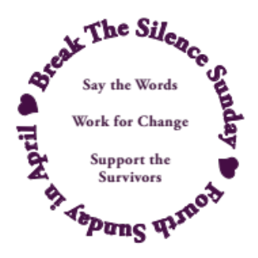
- I will walk beside you on your healing journey, accompanying you as best as I am able, and as you need to counseling appointments, court dates, or wherever else you need me to be with you.
- I am here for you, and with you.
- I stand with you.
- I believe you.

© Break The Silence Sunday, the Rev Moira Finley, October 2017

Break The Silence Sunday Proposed Resolution
to General Synod

The United Church of Christ’s General Synod will meet June 21 – 25, 2019 in Milwaukee, Wisconsin to help guide the work of the church in all its settings in the coming years. We have submitted a resolution calling on the national church to adopt Break The Silence Sunday and promote it across all levels of the church. Below you will find the resolution as it was submitted, with the list of sponsoring churches and conferences. Additional churches may sign on as supporting congregations with a vote of their congregation or governing board. If you’re interested in doing that, please be in touch at breakthesilencesunday@gmail.com.

There is still a process ahead of us before Break The Silence Sunday becomes an observance of the national church. First the resolution must be accepted by the Committee on Disposition. If that happens, it will then be assigned to a General Synod working committee. That committee will make changes, and adjustments before the resolution is submitted to the voting delegates on the Synod floor. The delegates would then vote on the amended resolution (all resolutions ever submitted are amended in some way). If the vote is positive then the national church will determine how best to implement the resolution, and encourage congregations and communities to participate in Break The Silence Sunday.

*******

The following resolution has been received by the Office of the General Minister and President prior to the deadline established by the Standing Rules of the Thirty-second General Synod. Receipt and release of this resolution for pre-Synod consideration by delegates and other interested parties should not be considered an indication it will come before the General Synod. This resolution is now being researched by the Board of Director’s Committee on Disposition and its staff, before consideration by the full Board of Directors in March 2019. Any resolution must meet all of the requirements of the Standing Rules (see Standing Rule 11). The Board of Directors will decide in March whether this resolution meets those requirements and make a determination as to its disposition.

Supporting Survivors Of Rape and Sexual Violence Through An Ongoing Church-Wide Observance of Break The Silence Sunday (BTSS)

A Prudential Resolution

Submitted by
- St. John’s United Church of Christ of Cecil, Wisconsin with the concurrence of
- Trinity United Church of Christ of Shiocton, Wisconsin;
- St. John’s United Church of Christ of Black Creek, Wisconsin;
- Orchard Hill United Church of Christ of Chillicote, Ohio;
- Valley City Congregational United Church of Christ of Valley City, North Dakota;
- Westmoreland Congregational United Church of Christ of Bethesda, Maryland;
- Second Christian Congregational United Church of Christ of Kittery, Maine;
- Bethesda United Church of Christ of Bethesda, Maryland;
- First Congregational United Church of Christ of Rochester, New Hampshire;
- Alfred Parish Church United Church of Christ of Alfred, Maine;
- Trinity United Church of Christ of Manchester, Maryland;
- Claremont United Church of Christ of Claremont, California;
- Epiphany United Church of Christ of St. Louis, Missouri;
- Berkeley Chinese Community Church United Church of Christ of Berkeley, California;
- First Congregational United Church of Christ of Grand Junction, Colorado;
- First Congregational United Church of Christ of Indianapolis, Indiana;
- Immanuel United Church of Christ of West Bend, Wisconsin
- Chinese Congregational Church United Church of Christ of San Francisco, California;
- Pilgrim United Church of Christ of Grafton, Wisconsin;
- Peace United Church of Christ of Webster Groves, Missouri;
- Wisconsin Conference United Church of Christ
- and the Penn Northeast Conference UCC

Summary
Lifting up the Biblical witness to compassion and courage and responding to the crisis of rape and sexual violence in our society, this resolution calls upon General Synod for a new and vital ministry of care and advocacy for survivors of sexual violence, and forthright prophecy to a society which hides, belittles or condones such abuse.

Historical Background ~ Actions Of Previous General Synods
In 1981, at General Synod Thirteen in Rochester, New York delegates approved a Resolution On Violence In Relation To Women. The Resolution read, in part, “Whereas the United Church of Christ believes that the local church can provide sanctuary from the many forms of physical and sexual violence experienced by women and others in American society through healing actions of support for victims, and public policy education and advocacy; Whereas the United Church of Christ recognizes that the climate of violence involving women is an urgent and present reality in our society.” The Resolution went on to call for a pronouncement and proposal for action to be considered at the following General Synod, and to call on churches and other parts of the United Church of Christ to study the issue and to “minister with sensitivity to victims of violence.”

In 1983, at General Synod Fourteen in Pittsburgh, Pennsylvania the delegates were presented with the Pronouncement and an accompanying Proposal For Action Related To The Pronouncement On Violence In Relation To Women, recognizing the responsibility the church has because of a history of mixed interpretation of biblical story and theological doctrine in regard to women and children.

The Pronouncement concludes by saying, “We are called as a Church to be a sanctuary for those who are abused. Jesus foreshadowed this ministry in his story of the Good Samaritan, who cared for one victimized by the violence of his society. Among us today the victims of violence and abuse lie by the side of the road: beaten, humiliated, bruised, and exploited. Too often the Church, like the Priest and the Levite of the Gospel story, has passed by on the other side. We are called to be the Samaritan – to support, shelter, love, and heal those who are victims of violence of this world.”

Few other resolutions, pronouncements, or calls to action by General Synods have assumed and affirmed the role of the church in supporting victims of rape and sexual violence: General Synod Seventeen (1989, Fort Worth, Texas) adopted a Resolution In Support Of the Ecumenical Decade Of Churches In Solidarity With Women; General Synod Nineteen (1993, St. Louis, Missouri) adopted a Resolution On The Brutalization And Objectification Of Women In Times Of War, particularly relating to the systematic use of rape as a means of terror and ethnic cleansing during the conflict in Bosnia-Herzegovina; General Synod Twenty-Nine (2013, Long Beach, California) adopted a Resolution on Resisting Actions Seeking To Undermine The Status Of Women In Society; and General Synod Thirty-One (2017, Baltimore, Maryland) adopted a Resolution Of Witness In Support Of Adult Survivors Of Child Abuse and Neglect.

Historical Background ~ Break The Silence Sunday
Break The Silence Sunday was created in 2016 by the Rev Moira Finley (Wisconsin) as a resource for churches to actively support survivors of sexual violence, particularly in the context of worship. The goal is three-fold: to help congregations learn about the reality and scope of the problem of sexual violence; to create communities where survivors can share their stories and be received with hope and love; and for congregations to commit themselves to prayerfully consider ways in which they can support survivors, be advocates for change in their communities, and around the world. Materials, available each February, include complete liturgies, prayers, scripture reflections, sermon suggestions, music resources, statistics, ideas about talking to and with children and teens, and the Break The Silence Sunday Clergy Commitment. Resources and a historical archive are added to the website (breakthesilencesunday.org) each year as well.

Reaffirming the Spirit present in these documents, lifting up the Biblical witness to compassion and courage, and responding to the crisis in our contemporary society, we call upon General Synod for a new and vital ministry of care and advocacy for survivors of sexual violence, and forthright prophecy to a society which hides, belittles or condones such abuse.

Biblical and Theological Background
The scriptural testimony of Genesis (1.26-27, 5.1-2, 9.6) as well as Psalm 8.3-8, James 3.9 and others declare that all humanity is created in the very image of God, the human body being holy and sacred. Following in this scriptural tradition, the theology and practice of the United Church of Christ affirms the sacredness of all bodies. Violations of any human body, particularly the intimate nature of the violation of rape and sexual violence, are therefore violations against the image and body of God.

In addition, the testimony of 2 Corinthians 5.17 declares that through faith in Jesus Christ we are all a new creation, and in numerous healing stories in the Gospels (Matthew 9.20-22, Mark 5.25-34, Mark 10.46-52, Luke 17.11-19, and Luke 18.35-43) Jesus reaches out to those who are in need of healing and hope with the words, “your faith has made you whole”. Speaking the truth of our stories is a part of what can save us, can restore our bodies and our relationships with God and with others. The community of the church can offer a powerful place for stories to be told and honored, and for healing to begin, but only if the church is willing and able to listen. Survivors need the listening heart of the church’s community to support them in their healing journey.

Finally, in Judges 19 the story of rape and violence ends with a clear call to the faithful to, “Consider it, take council, and speak out” (Judges 19.30). The church is called to nurture and care for those who suffer at the hands of others, and to speak out about injustice. Instead of supporting the wounded, the church has perpetuated theologies that do additional damage, including those that glorify suffering, leave survivors believing they should stay in abusive relationships, and advocate for unconditional forgiveness of perpetrators. Too often, historically, the church has chosen silence when face to face with survivors of sexual violence instead of bravely and courageously supporting and nurturing survivors, and speaking out against the violence that was perpetrated against them.

TEXT OF THE MOTION

WHEREAS, in the more than thirty years since General Synod Fourteen the church has made little progress in truly supporting survivors of rape and sexual violence;

WHEREAS, survivors of rape and sexual violence are hesitant to come forward and share their stories with clergy or congregations because of theologies that perpetuate, glorify, or even encourage suffering and that advocate quick and uncomplicated forgiveness;

WHEREAS, the church often perpetuates the victim blaming and shaming, mirroring the painful doubt and disbelief survivors face in the wider society, and contributes to the rape culture in which we all live;

WHEREAS, due to the intensely personal nature of the crimes, the relationships that often exist between perpetrator and victim, and the challenges of the criminal justice system, the scope of rape and sexual violence is difficult to measure.

WHEREAS, it is estimated that every ninety-eight seconds someone in the United States is sexually assaulted;

WHEREAS, the most conservative statistics estimate that one in every six women and one in every thirty-three men in the United States will be the victim of an attempted or completed sexual assault in their lifetime and that an estimated 63,000 children are sexually abused each year.

WHEREAS, we are in the midst of a cultural transformation, in the United States and around the world, with the #metoo movement empowering survivors to come forward and share their stories of rape, abuse, sexual harassment, and other sexual violence;

WHEREAS, with the testimony before the Senate Judiciary Committee by Dr. Christine Blasey Ford during the confirmation hearings for Supreme Court Justice Brett Kavanaugh, the United States has clearly seen the challenges survivors face in coming forward with their stories, particularly after many years of carrying those stories in silence;

WHEREAS, the backlash many survivors face after telling their stories often forces them back into silence and fear, and frequently complicates or damages healing already accomplished;

WHEREAS, the scriptural testimony of Genesis (1.26-27, 5.1-2, and 9.6) along with Psalm 8.3-8, James 3.9 and others affirm that humanity is created in the very image of God;

WHEREAS, in Judges 19 the story of rape and violence ends with a clear call to the faithful to, “Consider it, take council, and speak out” (Judges 19.30);

WHEREAS, in numerous healing stories in the Gospels (Matthew 9.20-22, Mark 5.25-34, Mark 10.46-52, Luke 17.11-19, Luke 18.35-43) Jesus, reaching out to those in need who have come to him for healing and hope, declares “your faith has made you whole”, recognizing that the speaking the truth of our stories can save us;

WHEREAS, the scriptural testimony of 2 Corinthians 5.17 declares that through faith in Jesus Christ we are all a new creation;

THEREFORE, BE IT RESOLVED that the Thirty Second General Synod calls upon the national church leadership, Conferences, Associations, and local churches to speak out in support of survivors of rape and sexual violence, offer care to individuals, including silent supportive witness in courtrooms, and advocate for sexual violence prevention education;

BE IT FURTHER RESOLVED that the national setting of the United Church of Christ add a yearly observance of Break The Silence Sunday (BTSS) to its calendar with the suggested date of the fourth Sunday of April so as to occur within national sexual assault awareness month;

BE IT FURTHER RESOLVED that local churches be invited to participate in a yearly observance of Break The Silence Sunday, honoring within their worship contexts the stories and struggles of survivors of rape and sexual violence, and encourage such an observance in the ecumenical community;

BE IT FINALLY RESOLVED that all settings of the United Church of Christ be encouraged to educate clergy and laity on how to support survivors of rape and sexual violence including trauma-informed care, and to advocate on behalf of those not yet ready to speak openly so that the voices of survivors do not speak alone.

FUNDING
Funding for the implementation of the resolution will be made in accordance with the overall mandates of the affected agencies and the funds available.

IMPLEMENTATION
The Officers of the Church, in consultation with appropriate ministries or other entities within the United Church of Christ, will determine the implementing body.

Some Statistics ~ compiled by the Rev Moira Finley

- There are an average of 321,500 people (age 12 and older) raped or sexually assaulted in the Untied States each year. (Source – U.S. Department of Justice, Office of Justice Programs, Bureau of Justice Statistics, National Crime Victimization Survey. 2010-2014)

- Let’s do some math: there are 31,536,000 seconds per year (in a non-leap year). If we divide the number of victims (321,500) by the number of seconds it means that there is an average of one assault every 98 seconds.

- In addition to the 321,500 people listed above, each year an additional:
  - 80,600 inmates are raped to assaulted
  - 60,000 children are sexually abused
  - 18,900 members of the United States military are on the receiving end of unwanted sexual contact

- Approximately 55% of victims are assaulted in or near their own home, and an additional 12% are assaulted in or near a relative’s home. (Source: Department of Justice, Office of Justice Programs, Bureau of Justice Statistics, Female Victims of Sexual Violence, 1994-2010. 2013)

- As of 1998, 17.7 million women in the United States (1 out of every 6) and 2.78 million men in the United States (1 out of every 33) have been the victim of an attempted or completed rape in their lifetime (source – National Institute of Justice & Centers for Disease Control & Prevention. Prevalence, Incidence, and Consequences of Violence Against Women Survey. 1998)

- 15% of sexual assault and rape victims are under the age of 12 (source – U.S. Bureau of Justice Statistics, Sex Offenses and Offenders. 1997)

- The year in a man’s life when he is most likely to be the victim of a sexual assault is age 4. The year in a woman’s life is age 14. (Source – U.S. Bureau of Justice Statistics. 2000 Sexual Assault Of Young Children As Reported To Law Enforcement. 2000)

- 93% of juvenile sexual assault victims know their attacker (Source – U.S. Bureau of Justice Statistics. 2000 Sexual Assault Of Young Children As Reported To Law Enforcement. 2000)

For additional information on how the statistics are compiled, and additional crime reporting statistics please visit:

https://www.rainn.org/statistics/scope-problem

Some Helpful Definitions ~ by the Rev Moira Finley

Acquaintance Rape/Assault – where the perpetrator(s) is previously known to the victim; occurs in approximately 4 out of every 5 rapes/assaults in the United States; acquaintance may refer to a date (hence “date rape”), domestic partner, former partner, family member, classmate, neighbor, boss, coworker, and more.

Attempted Rape/Assault – a threat or rape or sexual assault, including verbal threats, and those made in other ways such as electronic communication (email, text), and on social media (Facebook, Tumbler, Twitter)

Domestic Violence – violence, and threats of violence, between spouses, domestic partners, and those who are co-habitating.

Force – methods used to coerce a victim into a non-consensual sex; this may include the use of a weapon, or physical violence, but also includes emotional and psychological manipulation, threats to the victim’s family, the withholding of finances, intimidation, threats regarding employment or child custody, and more.

Incest – sexual contact (which may or may not include penetration) between closely related persons such as parents, children, grandparents, aunts, uncles, siblings, cousins; in legal terms incest is often described as the crime of sexual contact between people who may not be legally married

Post Traumatic Stress Disorder (PTSD) – a condition resulting from the experiencing (or witnessing) of a traumatic event that causes long-term difficulty with flashbacks, intrusive memories, and severe anxiety; not all rape survivors will develop PTSD

Rape – a form of sexual assault; the U.S. Bureau of Justice Statistics defines rape as forced sexual intercourse which is defined as “vaginal, anal, or oral penetration by the offender(s)”; this also includes incidents where the penetration is by an object such as a bottle; legal definitions vary by state, and some states do not use this term at all in their laws instead they have degrees/grades of sexual assault.

Rape Culture – the way in which society blames victims of rape and sexual assault, and normalizes this violence, particularly male against female violence; the assumption that rape and sexual assault are an inevitable part of life; this includes the use of the word rape in other contexts (for example, when a sports team is defeated and commentators say “they were raped”), as well as the objectification of women’s bodies including school dress codes and purity movements that seek to control and limit women’s behaviors
Sexual Assault – sexual contact or behavior that occurs without explicit consent of the victim; this includes, but is not limited to: penetration of the victim’s body (see rape), attempted rape, forcing a victim to perform sexual acts on the perpetrator, fondling, unwanted sexual touching.

Stranger Rape/Assault – where the perpetrator(s) is previously unknown to the victim; occurs in approximately 1 of every 5 rapes/assaults in the United States.

Survivor Guilt – though most often associated with being a survivor after a mass catastrophe (such as an airplane crash), this phrase has also come to mean the guilt imposed on survivors of rape and sexual assault because of some perceived action, or inaction on their part

Victim Blaming – words and actions that imply the victim of rape or sexual assault is to blame for the actions of the perpetrator(s); this can be through questions about what the victim was wearing, why they were out alone, why they didn’t fight back, if they had been drinking or had previous sexual relations with the perpetrator, and questions about the previous sexual activity of the victim

Resources

General Information About Rape & Sexual Assault

- Rape Abuse Incest National Network (RAINN) – includes links to their online and telephone counseling services, http://www.rainn.org

- National Sexual Violence Resource Center, http://www.nsvrc.org

- Joyful Heart Foundation, http://www.joyfulheartfoundation.org

- No More (a national campaign to end sexual and domestic violence), http://nomore.org

- “What’s Their Problem? Sharing Our Pews With Sexual Abuse Victims and Survivors”, from Christ And Pop Culture, http://christandpopculture.com/whats-problem-sharing-pews-sexual-abuse-victims-survivors/

Resources about Cases In The Media

- On the scandal in U.S.A. Gymnastics, the scope of the abuse, and the cover-up: https://www.huffingtonpost.com/entry/larry-nassar-abuse-victims-public-outrage_us_5a58f619e4b03c4189654efe

- On Pope Francis and the abuse scandal in Chile: http://time.com/5109212/pope-francis-sexual-abuse-chile-barros-karadima/

- Time Magazine on their Person of the Year: http://time.com/time-person-of-the-year-2017-silence-breakers/

- U.S. Supreme Court Justice Ruth Badger Ginsberg speaking about her own experience of #metoo (video): http://abcnews.go.com/Politics/supreme-court-justice-ginsburg-shares-metoo-experience/story?id=52518887

- Actress Viola Davis’ speech at the 2018 Women’s March in Washington, D.C. (video): http://www.cnn.com/videos/us/2018/01/20/viola-davis-full-speech-womens-march-la.cnn

- Gymnast Aly Raisman’s testimony against U.S.A. Gymnastics Dr. Larry Nasser before his sentencing for sexual assault against Ms Raisman and others (video & full text of her statement): http://time.com/5110455/aly-raisman-larry-nassar-testimony-trial/

- Singer Halsey reading her poem at the 2018 Women’s March in New York City, this video includes graphic descriptions of sexual violence: https://www.cnn.com/videos/us/2018/01/22/halsey-women-march-speech-poem-abuse-jnd-sot.cnn

- There are hundreds of articles about Dr Christine Blasey Ford, video of her testimony and subsequent questioning before the U.S. Senate Judiciary Committee, and analysis of all that happened from many different perspectives. We commend to you two:
  - Dr Blasey Ford’s opening statement which you can read here: https://www.npr.org/2018/09/26/651941113/read-christine-blasey-fords-opening-statement-for-senate-hearing
  - This story from the Washington Post about what Dr Blasey Ford says might have come from her testimony: https://www.washingtonpost.com/nation/2018/11/27/christine-blasey-ford-says-some-good-came-out-her-terrifying-testimony-against-kavanaugh/?noredirect=on&utm_term=.bf8046542058

Resources on PTSD

- From the Department of Veteran’s Affairs: http://www.ptsd.va.gov/public/PTSD-overview/basics/index.asp

- From the Rape Abuse Incest National Network (specific to rape victims): https://rainn.org/effects-of-sexual-assault/post-traumatic-stress-disorder

State of Wisconsin Resources

- Wisconsin Coalition Against Sexual Assault

Telephone: 608-257-1516; http://www.wcasa.org
Offers information and referral on any issue related to sexual violence; does not offer direct services to victims/survivors, but will connect them to local agencies

- County by County resources – please visit our website http://www.breakthesilencesunday.org and the Resources tab to find a chart which will identify sexual assault resource organizations in each Wisconsin county

Space For Notes, Doodles, Dreams, Fears, Questions…

Feedback Form ~ Break The Silence Sunday 2019

Please return to: BTSS c/o Moira Finley
PO Box 691
Bonduel, WI 54017

You may also submit this information by email at breakthesilencesunday@gmail.com

Your name:________________________________________________________

Your position (pastor/worship leader/other):______________________________

Your community/church:_____________________________________________

Did you use the Break The Silence Sunday Liturgy?

- Yes, as it was provided

- Yes, but we adapted it; please list how you adapted it:

- We used parts of it, but not the entire liturgy; please list the parts used:

- No, we wrote our own liturgy; if you are willing to share the liturgy you used, please email it to breakthesilencesunday@gmail.com or post to the above address

Please continue to the other side --->

What did you use during the sermon time?
- A survivor in our community shared their story (if possible, please connect them with us by emailing contact information to breakthesilencesunday@gmail.com)
- A community resource person came to help our community think through issues of sexual assault and rape
- Wrote our own sermon (if you are willing to share, please email it to breakthesilencesunday@gmail.com or post to the above address)
- Something else; please describe…

What could we provide to you for 2020 that would help you better prepare, and lead Break The Silence Sunday?

Any additional comments, suggestions, concerns?

Martin Luther King Jr. "The Trumpet of Conscience" Steeler Lecture, November 1967

