Break The Silence Sunday

April 22, 2018

A time for the church to learn together

about the realities of rape and sexual violence;

about ways to create a community where survivors
can share their stories and receive support, hope, and love;

and to prayerfully consider ways in which they can be advocates
for change in their communities, and around the world.

Resources for Worship

http://www.breakthesilencesunday.org
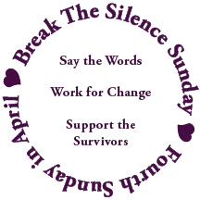

Table Of Contents

A Prayer to Begin 2

Introduction to The 2018 Break The Silence Sunday Materials 3

Acknowledgements 6

Notes for Worship Planners & Leaders 7

Sample Newsletter Article & Bulletin Announcement 10

Liturgy for Break The Silence Sunday 11

Liturgical Resources 29

Scripture Reflections From A Survivor 32

Sample Sermon 34

Sermon Suggestions 39

Talking With Children & Youth 41

Break The Silence Sunday Clergy Commitment 43

Some Statistics & Helpful Definitions 44

Resources 48

Feedback Form 50

A Prayer To Begin

As you begin planning for Break The Silence Sunday you may feel many things, wondering if you can bring this word of hope to your congregation, and how they will respond when you do. You could be wondering what kind of stories will be shared with you, and if you will be able to hear them with your whole heart. You might be afraid of not knowing answers that you think are needed by those who come to you with questions about this day, with stories of their own, with fears and insecurities. You might be hearing the voice of that parishioner who asks, “Why do we have to do this again?” and you’re trying to find the words to tell them that the reality of rape and sexual violence need to be confronted over and over again until justice is done. Whatever you’re feeling, and thinking, please don’t panic. This is a journey, and tentative first steps are still first steps. So sit in a comfortable place, take a few breaths, and then pray this prayer for yourself...

A Prayer For Hesitant Clergy
by the Rev Don Niederfrank

Divine Companion, you have encouraged and comforted me
at so many times,
in so many places,
with so many persons.

One more time, I ask, though afraid even in my asking,
be with me.

Strengthen my trembling knees,
that I may stand with those who have too often and too long stood alone.

Call to me in the tumult of my self-focused anxiety,
that I may bring your Presence, your Peace, to those whose terror is real.

Deliver me from my silencing fears
that I may speak your Word.

Holy Shepherd, I am yours. Send me to those you love.

Introduction to The 2018 Break The Silence Sunday Materials

When I sat down to prepare the 2017 Break The Silence Sunday materials President Trump had just recently been inaugurated, and the first global women’s marches were only a few days old. The 2016 presidential election had been a tough time for many survivors, with allegations of sexual violence and abuse being raised, and dismissed; the voice of many survivors feeling once again silenced by public opinion which seemed to say that we were somehow responsible for what happened to us, or that it’s simply how the world is because “boys will be boys”.

Little did I know that sexual harassment, abuse, and violence would take center stage in 2017. Everywhere we turned there would be stories of people coming forward, breaking their own silence about their experiences. In 2006, activist and survivor advocate Tarana Burke created the Me Too movement as a way for survivors to support one another, to know that they were not alone in what they had experienced. In 2017, with allegations of harassment and abuse against movie producer Harvey Weinstein, the #metoo hashtag went viral. Stories were told, and silence was broken again, and again.

And yet, churches and denominations remained largely silent. There were a few supportive social media posts, and a few public statements, but in large part survivors who came forward were left to their own devices, alone to sort out how their experiences affect their faith, their spirituality, and their participation in a community of Christ’s people.

When Time Magazine chose the Silence Breakers as their Person of the Year (December 18, 2017), churches and denominations once again responded with congratulatory posts, praising the courage of those who were speaking out, but with little else in terms of supporting survivors in their midst, of providing theological and spiritual reflection on what it means to be a survivor in the church, and how the church might help nurture and encourage survivors to tell their stories in the context of their faith community.

Since beginning the work of Break The Silence Sunday two years ago, I have been honored to listen as many survivors have told me their stories; some that have been told before, some that have lingered in silence for more than seventy years; some where the survivor received support and encouragement from their families and communities, and more where the survivor was met with doubt, suspicion, victim blaming, and more.

With survivors (largely women, but also men) coming forward, and breaking their silence in ever larger numbers it looks like progress is being made, but there is still a long way to go. Italian-American human rights activist Ginetta Sagan said, “Silence in the face of injustice is complicity with the oppressor.” The silence of the church (again regardless of denomination) is deafening, and so therefore is our complicity.

When U.S.A. Gymnastics is all over the news because of the abuse inflicted on our Olympic gymnasts, and the cover-up by those who knew of the abuse, and the church says nothing, it is complicit.

When the leader of the Roman Catholic Church, Pope Francis, says that victims of a pedophile priest in Chile are guilty of slander and that he won’t speak out against the abuse because he doesn’t believe the victims, the church (regardless of denomination), is complicit.

When movements committed to justice won’t include freedom from sexual violence as part of their work, the church is complicit.

When survivors come forward with their stories and are met with doubts, and shame, and victim blaming, and bad theology instead of the support, encouragement, and companionship they deserve, the church is complicit.

And yet, Break The Silence Sunday is nothing if not a movement about hope, about the belief that we, as the church together, can do better. We can support and honor survivors and their stories. We can find ways of thinking about our faith that do not perpetuate abuse or glorify suffering. We can work to challenge the cultural systems that allow sexual violence to continue. We can build a future together where survivors feel safe sharing their stories in church, and an even further view of the future where there are no more survivors of rape and sexual violence.

There is hope because you are here reading this, because you’re thinking of ways you might introduce this in your congregation – in worship, in adult education classes, around the table at a council meeting. There is hope because survivors, as scared as we are, who aren’t going to stop telling our stories. There is hope because there are people willing to do the hard work of listening. There is hope because we are, as Christians, ultimately a people of hope, a people who believe that life and love will always have the last word.

I am grateful for whatever way you are considering using this year’s Break The Silence Sunday Materials, for your courage in allowing this difficult topic into your heart, and into the holiness of your sanctuary.

In these pages you will find:
- advice about newsletter articles and advance promotion of the event;
- new liturgy for 2018;
- scripture reflections & sermon resources;
- ideas about talking with about sexual violence with children and youth

On our website (http://www.breakthesilencesunday.org) you will also find the materials from 2016, 2017, and additional resources including a healing service. The website also includes links to accompaniment for the less familiar songs included in the liturgy.

As always, you are invited to adapt these materials, or simply use them as inspiration, to craft a worship or study opportunity that best fits the needs of your community. And we hope to receive feedback from you, about what you liked and didn’t like about these materials, what worked for you, what was a challenge, and what could be provided next year to help you better implement Break The Silence Sunday in your community. You’re welcome to email at any time to breakthesilencesunday@gmail.com or call me at 715-851-3080.

Acknowledgements

The work of Break The Silence Sunday would not be possible without those who contributed their words, their music, and their prayers. So many people have been a part of the years leading up to this project, who have patiently waited through the frustration, fears, anger, and silence.

- The Rev Franz Rigert for opening a door that has long felt firmly closed
- Lisa Hart for her support, and administrative resources
- The friends who have held my hand, offered tea, coffee, wine, and snacks; who have listened to my anger and frustration, and just plain loved me, I owe you more than you know ~ Richard & Trish Bruxvoort Colligan, Bryan Sirchio, Christopher & Carla Grundy, Andra Moran, Conie Borchardt, Ben Welch, Amy Englesdorfer, Brent & Sara Smith, Jody Clegg, Darryl Commings, Lella Baker
- Bryan Sirchio for his amazing musical skills in setting my story to song; yes I know you say it’s my song, but it shall forever be ours in my mind
- The folks who have contributed to the liturgy…
Don Neiderfrank, Richard Bruxvoort Colligan, Bryan Sirchio,
Maren C Tirabassi, Holly Near, Christopher Grundy
- The amazing folks of the Tri-Jo Parish United Church of Christ (Trinity UCC Shiocton, WI and St John’s UCC Cecil, WI) who have journeyed with me these years, trusting me with the privilege of being their pastor, and who graciously give me time every January to get out of the cold and to write these materials
- Hel Rowinski, for her editing skills
- Severin Provance, for his logo design
- My survivor sisters and brothers, particularly Lella Baker, who understand how hard this work is, and how incredibly important it is as well
- My community of online friends around the world who remind me that I’m not alone, and that somewhere there is someone awake who will talk me through the struggle;
- For all the survivors who are stronger than they imagine because they get up and face each day, I hope we have done well by your stories.
- For all of you reading this who shall faithfully plan and lead worship to help us break the silence; my gratitude for your courage.

In faith and hope, Moira Finley

Notes For Worship Planners & Leaders

There is no doubt that rape and sexual assault are difficult subjects. They are hard for our society to address, and no less difficult for the church.

It may feel like the flood gates have opened, that everywhere you turn survivors are telling their stories. Perhaps you think that means your community doesn’t need to participate in Break The Silence Sunday. Perhaps you think that survivors simply “know” you are a safe, and trusted person to talk with. But the reality is that the deluge of stories being told can actually force survivors into silence. If publicly powerful people like movie stars and TV news reporters have been forced into silence by fear of repercussions, what chance, survivors wonder, do they have of being heard with dignity, and respect? If the church has perpetuated the idea that suffering is somehow holy, encouraged women to stay in abusive situations because of ideas about family honor, and passed judgement on survivors because of misguided ideas about rape being a crime of sex not violence, then survivors wonder if what they tell you about their experience will really be heard, or will be used against them.

The survivors in your congregation and your community need you to step up, and be clear. Make it known that you are someone who will hear their story without guilt or shaming. Say it over and over again that what they have to tell you will be heard, honored, and treated with dignity. Help survivors know that the God you preach each week is one whose heart broke when their abuse and violence happened, and that the God you profess will walk with them through every step of reclaiming their lives. Help them know, through your words and your actions, that their journey as a survivor is holy, and is welcome in your community – whatever details they need to share, and whatever details they need to keep private.

It is extremely important that you prepare before Break The Silence Sunday. You need to prepare yourself, and your worship team. Talk about how this time will be structured, what the pace will be, what the lighting will be like, and all the other wordless things that contribute to worship. Whether you are planning an entire Sunday morning dedicated to Break The Silence Sunday, or a single prayer in the midst of other things, or a mid-week time of prayer, you need to pay particular attention to how you and the other worship leaders will honor and respect your own feelings, fears, and stories.

You also, of course, need to prepare your congregation. Everyone needs to be made aware, well in advance, what worship will be like on Break The Silence Sunday. They need to know that explicit words like rape will be used. They need to know that the content of worship will be emotionally challenging.

If there are survivors in your community that you are aware of, please make a special effort to reach out to them in advance. Let them know, personally, what you are planning for this day. Make sure they know it’s OK to opt out of worship if they are not prepared for the re-opening of wounds that might happen.

Talk with parents, of children of all ages, to make sure they know how to prepare their children for worship. Parents of middle school and high school students may well want their children to attend worship, but they need time to pray about it, and discuss it at home so that lines of communication are open.

Make sure you have announcements in worship, and bulletins, as well as newsletter articles and posts on your social media. Included here is a sample newsletter article/announcement that you are welcome to best suit your context.

In the pages that follow, you will find a complete liturgy for Break The Silence Sunday. You are welcome to use the liturgy as it is, or adapt it for your particular setting, using the prayers, and hymn suggestions as a guide for your own community worship. There are also additional liturgical resources beginning on page 29.

There are many options for the sermon/reflection time during Break The Silence Sunday. There is also a page of sermon suggestions and ideas to get you started, one complete sermon on consent, and on our website you will find survivor stories and other resources which you are welcome to use during worship. There may be a survivor in your community who would share their story, or someone from a local support agency who could speak to the needs of survivors in your community. The website also contains a link to county-by-county resource agencies in Wisconsin who may well be able to help you as you plan your observance.

You may also find it helpful to work with survivors in your community to shape this service to best suit their needs. Survivors may well find it incredibly empowering, and healing, to be involved in the work of Break The Silence Sunday.

Every survivor’s story is different, and so every survivor’s healing journey is different as well. You need to go gently, taking care not to say there is one right way to do any of this. When we speak of healing it’s not necessarily physical, but the work of mending heart and soul, of making some sense of what has happened. Anything that involves the words should or must would best be avoided. Survivors have had enough of that already. What they need from you, and from their faith community, is a place to work at their own pace, to tell their story in their own way, to be heard with compassion, but not pity.

Be careful when you speak of forgiveness. It is indeed a part of the life of faith, but it is not easy, and cannot be done quickly. Forgiveness may well be the work of this lifetime, and into life everlasting, but for a survivor to forgive their abuser is their work, and not something for the church, or its leaders, to set the schedule for.

Remember that not every survivor is at a place where it is safe, or healthy, for them to share their story, and they may have resistance to Break The Silence Sunday. Go gently.

At the end of this packet there are some statistics, definitions, and resources to help you respond to the needs of your community. If you don’t know them already, get to know the people in your community who are on the front lines of helping survivors.

The suggested date for Break The Silence Sunday is the fourth Sunday in April. This keeps us within the national observance of Sexual Assault Awareness Month, but it is just a suggested date. I am aware that this is also Earth Day, and that many congregations have long-standing commitments on this important day. Please feel free to pick a day when it works best for your community.

And please, when a survivor shares their story with you don’t just refer them to someone else. Offer to go with them, to reflect with them over a cup of coffee, to wrestle with their questions about God, and faith, and church. Be a part of their healing journey.

If you have questions as you prepare, please feel free to contact the Rev Moira Finley by email at breakthesilencesunday@gmail.com or by phone at 715-851-3080.

God’s blessings on your work.

Sample Newsletter Article & Bulletin Announcement

You’ve probably heard of the #metoo movement, the women and men speaking out about their experiences with sexual harassment, abuse, and violence. Every day, courageous people are speaking out, but it is not enough for them to do so. We too, as people of faith, must be courageous.

The survivors of sexual violence are our friends, neighbors, colleagues, family, and members of our congregation. They need us to help them, to listen as they speak out, to create a place where their stories can be heard without fear, or judgment. They need us to witness with them to the pain of their stories, and to stand with them, reminding them of the healing love of God.

Join us for Break The Silence Sunday on April 22, 2018

In worship we will acknowledge the reality of rape and sexual violence, that every 98 seconds someone in the United States is raped or sexually assaulted.

We will hear the stories of survivors, trusting in the good news of God’s love and grace.

We will commit ourselves to being a listening people, and a people dedicated to changing the reality of violence in the world.

This service may be difficult and challenging.

Some parents may not want their young children to be present.

Please take time to prepare yourself . Ask God for the strength to open your heart and mind, that we shall support all the survivors who are part of our church, our community, and the world.

If you have questions or concerns about the service, or if you would like to help with worship leadership, please contact ___________________

Liturgy For Break The Silence Sunday ~ April 22, 2018

Unless otherwise noted, prayers are written by the Rev Moira Finley.

Musical Prelude

Welcome

Welcome to worship. Today we stand with our sisters and brothers who have been victims of rape and sexual assault. We witness to their pain, and their strength; to their questions, and their faith; to what keeps them up at night, and what they need from us, as individuals and as communities of faith. Today we start to speak out, to break the silence of complicity and fear, and through it all trust in the good news of God’s incredible love for us, and for all the world.

Call To Worship

One: We come today…
Many: empowered and afraid,
One: hopeful and unsure,
Many: to break the silence.

One: We come today…
Many: to hear our sisters and brothers,
One: to listen with open hearts and minds,
Many: to break the silence.

One: We come today…
Many: as people who follow Jesus,
One: who walk in the way of justice,
Many: to break the silence.

One: We come today…
Many: a people of compassion and hope,
One: to worship and pray,
All: to break the silence.

Gathering Prayer ~ by the Rev Maren Tirabassi © 2017

This prayer could be said in unison, or responsively with the people speaking the line “Wherever you are in the silence you are welcome here.” (in bold) and the leader or leaders speaking the remaining lines.

Wherever you are in the silence you are welcome here.

Whether you have been waiting
to be asked for your story
knowing someone will listen
and not express an opinion…

or you cannot imagine
telling your story
until fill-in-the-blank has died
you finish therapy, start therapy
or until hell freezes over.

Wherever you are in the silence you are welcome here.

Whether it’s someone else’s story,
but as parent or sibling or child
you are grateful to be quiet
in a place where this kind of truth
is being told…

or you are really, really quiet
because suddenly you remember
something you were a part of long ago
that everyone then called
funny of stupid or insignificant,
but you know now –
it was sexual assault.

Wherever you are in the silence you are welcome here.

Whether you are stunned by statistics,
or uncomfortable because
this isn’t churchly stuff,
or scared because you suspect
you are starting to remember
what happened to you,
or sorry you told the pastor
you would share your story…
or are so glad, so glad,
so wishing you be text three people
and tell them to be here.

Wherever you are in the silence you are welcome here.

Hymn ~ “How Firm A Foundation”, New Century Hymnal #407
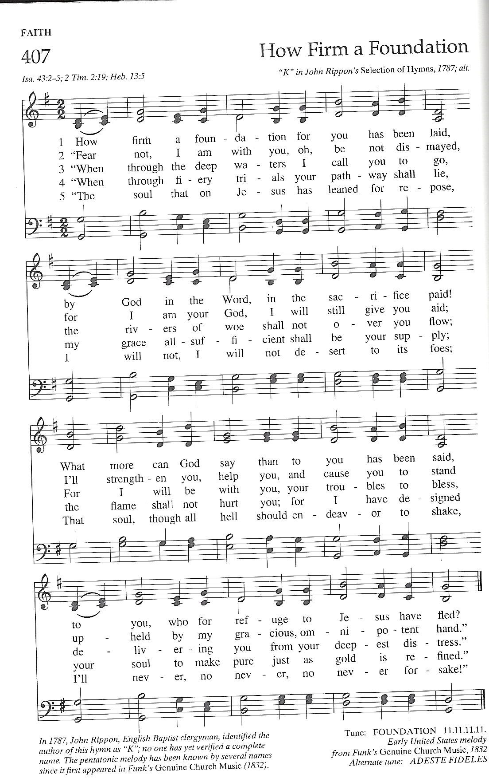
Tune: Foundation

Why We Have Come ~ Acknowledging The Reality Of Sexual Violence

This prayer is not necessarily one for survivors to pray. It is, instead, for those who have had the privilege of living free from these experiences, perhaps with blinders on, unaware of the reality of rape and sexual violence in our communities, and around the world. During this prayer you might consider lighting candles (or inviting survivors to do so) to symbolize the experience of all those who live this reality in their daily lives.

One: We have come

Many: to listen, and to hear things that will unsettle us, and make us uncomfortable, challenging things we think about the world.

One: We have come

Many: to hear the guilt, fear, and shame that survivors carry, the stories of those who have survived things we cannot begin to imagine.

One: We have come

Many: to listen to what keeps our sisters and brothers up at night, to listen with compassion, and love.

One: We have come

Many: to be present for survivors, doing our own spiritual work, so that we might listen without judgement or pity.

One: We have come

Many: to hear the memories, and nightmares, and flashbacks; the violation, cruelty, and suffering.

One: We have come

Many: to remember that not everyone survives the violation of rape and sexual assault, and that the grief and pain overwhelm many who seek to escape through self-harm, and suicide.

One: We have come

Many: to commit ourselves to the messy, difficult, sometimes excruciating work of changing the world, to the work that Christ showed us, the work of making the world whole.

One: We have come

Many: to remember that taking small, uncertain steps is an okay way to begin, that we do not have to do everything, but that we must do something, that we must listen, and then raise our voices for our sisters and brothers are depending on us.

All: Amen.

Hymn ~ “We Have Come”
by Christopher Grundy, © Hand and Soil Music, 2009; used with permission
(this is intended to be sung acapella)
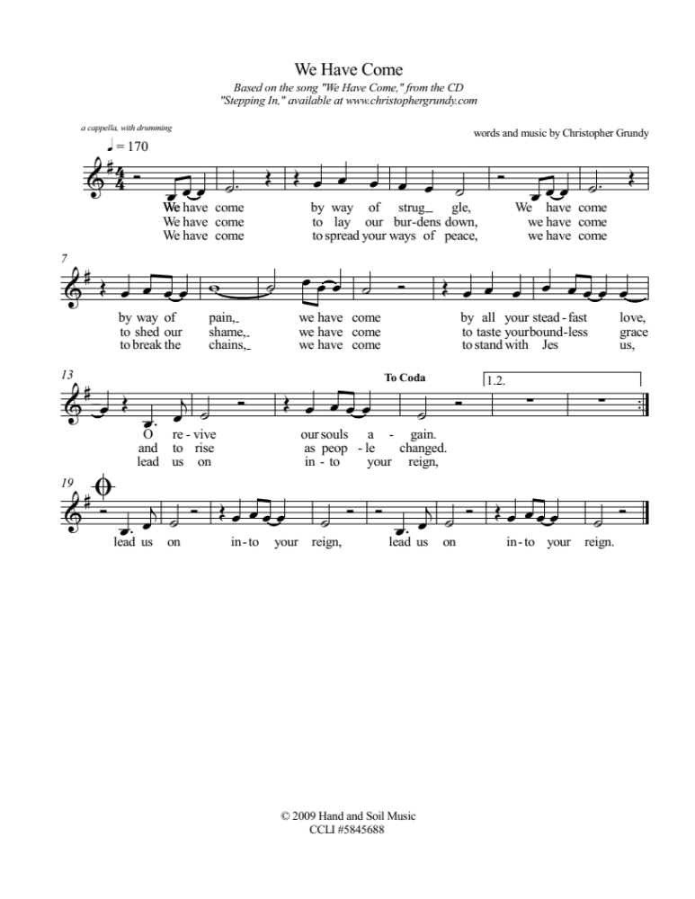

Breaking The Silence ~ A Time For Prayer

Silence in worship can be powerful, a time for people to listen to the voice of their heart and soul. However, this is Break The Silence Sunday, a time no longer keep silence. This time of prayer seeks to provide some silence, acknowledging the reality of rape and sexual assault, but also breaking the silence of our complicity. In the United States someone is sexually assaulted an average of every 98 seconds. Using that amount of time as its basis each silence will be progressively shorter to show the urgency of speaking out. While this prayer uses statistics for the U.S., the problem is not unique to our country, and so we stand with our sisters and brothers around the world who live in the shadow of rape, and sexual violence.

One: Once, in every ninety-eight seconds…

a silence of 98 seconds is held, then a bell is chimed

One: Once, in every ninety-eight seconds someone in the United States is sexually assaulted, and the church has been deafeningly silent.

a silence of 74 seconds is held, then a bell is chimed

One: Survivors have been shamed into silence, afraid to speak the truth of their experiences. When they have dared, they have been met with pity, contempt, hurtful and dangerous theologies, and victim blaming.

a silence of 50 seconds is held, then a bell is chimed

One: The time for our silence as the church is over. Rev Dr Martin Luther King, Jr once said, “In the end we will remember, not the words of our enemies, but the silence of our friends.” It is time for us, the body of Christ broken by rape and sexual assault, to be outspoken about this violence. It is time for us to open our hearts, our minds, and our churches to the stories of survivors, to share with them the hope of God’s grace that is with us in our moments of deepest despair, and can in time bring hope.

a silence of 26 seconds is held, then a bell is chimed

One: Now! Now is the time for us to break our silence!

a bell is chimed

Sung Response ~ “I Am Welcome” by Bryan Sirchio, used with permission
please see Liturgical Resources section for a link to the accompaniment and recording

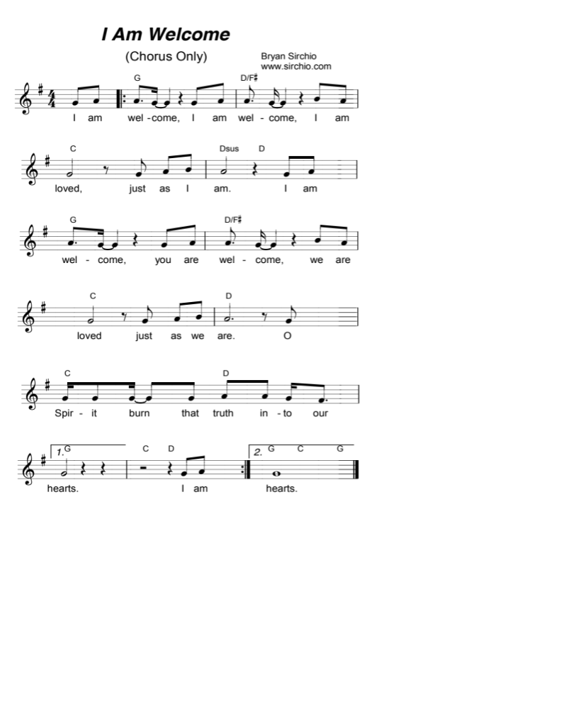

Invitation To Confession
We have, as the church and as its individual members, been silent when the lives of those who we know have been shattered by sexual violence. We have shied away from those who would share their stories, afraid of what we might hear, of what it might mean for us, and for our lives. We have been quick to ask questions – what were you doing, what were you wearing, why didn’t you fight back – placing blame on survivors instead of where it belongs, with the perpetrators. Together, trusting in God’s grace, let us confess our responsibility in creating and perpetuating a culture of silence.

Responsive Prayer Of Confession

Gracious, and loving God, we have come to listen, aware of our deafness in the past, and to take responsibility, aware of all we have failed to do.

We confess that, because of our fear, our doubts, and our insecurities we have allowed sexual violence to continue, and we have created a world in which survivors feel they cannot share their stories within the walls of your church.

We confess that we know sexual violence is real, in our communities, in our church, in our families, and around the world. We confess that this makes us afraid, and that it would be easier to believe that the statistics are wrong, that survivors are exaggerating, that it can’t be as bad as it seems.

We confess that we would like to pretend that this violence, and violation can’t happen to us, or to someone we love and care about. We would rather believe it happens somewhere else, to someone else, and that no one in our family, or our group of friends, and surely no member of our church could possibly have endured what we cannot bear to hear.

We confess that we are part of the problem, that the church has often silenced survivors. We know the church has offered up bad, abusive, and dangerous theology. The ideals of faithful living have shamed and silenced survivors with assumptions about purity, and sexuality, and forgiveness.

We confess we don’t know what to do. The problem is so big it is overwhelming, and we don’t know how to help. We want to listen, but we are afraid of what we might hear. We don’t want our words, however well intentioned, to make things worse. We feel like anything we do will be too little, too small, to make any difference.

And yet, we confess that we know we must do something. We know our sisters and brothers are depending on us. We know they need us to listen, to hear, to honor their questions. We know that we need to witness with them to the presence of God that lives within them, that no amount of violence could ever change. We know we need to speak out, and change the world we live in, that no one else might know this pain.

We pray for the grace to be present, to open ourselves to all that we will hear. We pray that wounds might be healed, not through our work, but through our willingness to listen. We pray that the world might be changed, not through our actions alone, but through your grace moving in us, and with us.

In hope we pray, Amen.

Assurance Of God’s Grace

Holy One, you created each of us, nurturing us while we were yet in our mother’s wombs. You know where we have fallen short of your call, failing to do the work of listening, of supporting, and of working on behalf of those who have suffered sexual violence. And you know who we might yet become. We trust in your love, and give thanks for this opportunity to do better, to be good companions on the journey with all those who have experienced the trauma of rape and sexual abuse. We pray for your continued guidance, and for the courage to walk in the footsteps of Jesus, in this and in all things. Thanks be to God.

Scripture Readings
Isaiah 43.1-7 God’s promise to name and claim each of us
Psalm 139.1-18 God created us, knows us, and is always with us
Luke 13.10-17 Jesus heals a woman on the Sabbath

Sung Response ~ “All Belong Here” CHORUS
written by Hannah Rand and Lenora Rand © 2017
Performed by The Many, used with permission
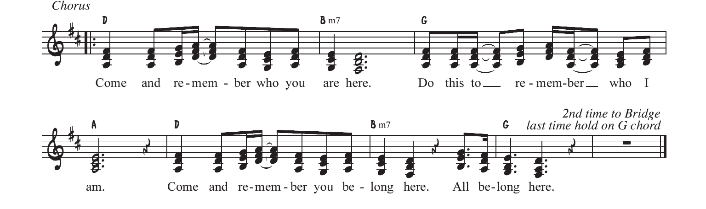
please see the Liturgical Resources section for the link to the accompaniment and recording

Sermon/Reflection/Stories from Survivors

A Time Of Prayer ~ with thanks to First Congregational United Church of Christ of South Milwaukee, WI for the inspiration

One: God of mercy, today we pray for all those, here at home and around the world, who have experienced the violence and violate of rape. We hear their pain, and grief; their hopelessness and fear. We pray for the comfort that only you and your love can provide to those who are wounded.

Many: Hear us, O God.

One: God of compassion, we pray for those who are still caught in the midst of the cycle of violence; for those who cannot break the silence because it is not safe for them to do so; for those who continue to suffer in their bodies, minds, and spirits because of what others have done to them.

Many: Hear us, O God.

One: God of wisdom, we pray for the strength and courage to acknowledge the reality of sexual violence in our midst. We pray for the guidance of your Spirit as we move forward, listening to those who have suffered, and speaking out on behalf of a new world. Teach us when to keep silent, listening to those who have suffered, and each us when to speak, giving us the words and actions that will lead towards the transformation of our world.

Many: Hear us, O God.

One: God of justice, we pray for community, and for ourselves. We know we are called to be a place of healing, and hope. We pray our survivor sisters and brothers might trust us, even in the smallest of ways, with their stories. We pray that we might have the grace to offer them open hearts, and minds. Give us the courage to take responsibility for the transformation of our world.

Many: Hear us, O God.

One: God of hope, we know that in and through the life of Jesus you offered the world a new way of thinking, a new way of being, and a reminder that your Word will always be stronger than the powers of destruction. We pray that all who live in the silence and fear of sexual violence might find newness and hope in you. May life, and joy, and love return. May we all know your presence, and the confidence to truly be people of the Resurrected One.

Many: Hear us, O God.

One: These, and all our prayers, we pray with the words that Jesus taught his first disciples saying together…

The Prayer Jesus Taught

Our Father, who art in heaven, hallowed be thy name, thy kingdom come, thy will be done, on earth as it is in heaven. Give us this day our daily bread, and forgive us our trespasses as we forgive those who trespass against us. Lead us not into temptation, but deliver us from evil. For thine is the kingdom, and the power, and the glory forever and ever. Amen.

Offering Our Gifts
You might consider designating the morning offering, or a portion of it, to the local sexual violence resource center in your area, or to a national organization such as RAINN (Rape Abuse Incest National Network).

Prayer Of Dedication

God of abundance, the gifts you give us are more than we could ever count. You shower blessings upon us each day, giving us the opportunity to be your people together, to participate in the work of rebuilding and recreating the world. We bring you these gifts, signs and symbols of our gratitude. We entrust them to you that the work Jesus began might continue in us, and through us, in this place, and around the world. May we follow in Jesus’ footsteps – listening to the stories of God’s people. May we listen with courage, and speak out with faith. In Jesus’ name we pray, Amen.

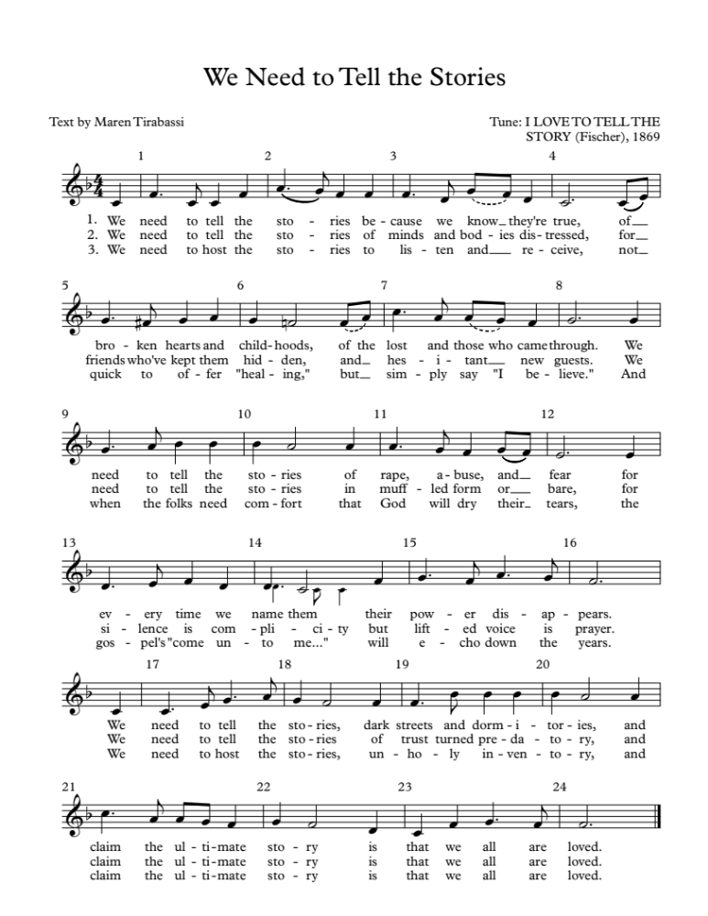
Hymn ~ “I Love To Tell The Story Re-sung For Break The Silence Sunday”

Celebrating Communion

One: This table is not ours, but it belongs to God. All who seek to be fed and nourished by God’s grace, and sustained by this community are welcome to share at this table. We come, from the shadows of a waiting, hurting world, knowing that, wherever we have been, whatever we have experienced, we will be fed and renewed. We reach for the cup of God’s love, aware of an unquenchable thirst in the depths of who we are, a thirst for justice and hope. We come, trusting that God will meet us here. Let us pray together…

All: Holy One, we come to share the richness of table. We ask for your healing grace to be poured out on all those who have suffered sexual violence. Renew and restore them, and your church. Be present with us, and remind us that your presence is with us always. Give us the courage to truly be the Body of Christ.

One: Gracious God, in Jesus you have given us the greatest gift. We come to this table to know you, to remember your love, and to confess that your grace is for all. Some of us come to this table tired and anxious. Some of us come with hope in our hearts. All of us come, trusting in your Spirit’s presence, and trusting in the promise that we might all be One, whole and healthy, as your people. Let us pray together…

All: We thank you God for giving yourself to us in Jesus Christ. We thank you that he lived among us, and knew what it was like to be human. Feed us at this table, and give us the courage to be faithful to the One who dared to come into our world. Renew and revive us. Give us the courage to listen, and to speak out for our sisters and brothers, today and always. Amen.

One: We know the stories about Jesus’ life, how he would come to share many meals with his disciples and friends. He would welcome those who had been cast to the margins of society, eating with sinners and prostitutes, with the sick and the lame, with the wealthy and the poor alike. On one of those occasions, as his earthly life was nearing an end, he found himself with his disciples and those who had followed him closely in an upper room in Jerusalem. They were there to share the story of hope, of release from captivity, of God’s promise of freedom. During the meal he would take the bread, bless it, break it, and offer it to them saying, “this is my body which is given for you.” Later, after supper, he would take the cup, give thanks, and say, “this cup is a reminder for us of the new relationship God has made possible between us, and all of creation.”
The bread we share is a reminder for us that just as God blessed Jesus with an earthly body, so our earthly bodies are blessed. The cup we share is a reminder for us of Jesus’ life, and the grace of God that Jesus came to help us know. We pray that God would bless this bread, and this cup, and us as we receive them. We bring all our lives to God at this table, that we might be one people, united as the Body of Christ, working together for justice and peace. The gifts of God for the people of God. Come for all things are now ready. Come and see how good God is.

Sharing The Elements

Unison Prayer Of Thanksgiving
We give you thanks, Gracious God, that you come to us in bread and cup, and in the love of this community. Send us from this table, nourished and empowered. Help us listen with all our hearts, and speak with all our minds, that all your people might truly know peace.

Committing Ourselves To Change

One: In the presence of one another, we pledge ourselves to ending the violence of rape and sexual assault, working towards a vision of a healed community where all can live in dignity and peace.

One: We acknowledge the reality of rape and sexual violence, a plague that brings hopelessness and fear to our sisters and brothers.

Many: We stand in solidarity with those who have been victims. We promise to be open to their stories, and with the grace of God, to listen without judgment.

One: We know the promise of wholeness, and hope that Jesus came to bring to the world.

Many: We affirm the promise of God’s love for all the survivors in our world, those whose stories are known to us, and those whose stories are still shrouded in silence and fear.

One: We know that we have not done enough, that we have been silent when those around us have been struggling.

Many: We look forward with hope, trusting in God’s ability to give us strength to listen with courage, and to be silent no longer.

One: We believe that the future depends on us.

Many: We believe that there is something we can, and must do, as people of the Good News, and as members of one human family, to end the violence of rape and sexual assault.

One: We recognize that we cannot do this alone. We know we must learn to depend on each other, and on God, in the struggle to end sexual violence, and create justice.

All: Gracious God, help us to be aware of your loving disruption of our lives. Give us the courage to work with you, and with each other, to transform our hurting world. Empower us with your Spirit that we might break the silence of sexual violence. Help us listen and move together from fear and pain towards your realm of peace and justice. In Jesus’ name we pray, Amen.

Hymn ~ “God Will See Us Through”

Music by Emma Ceurvels; words by Bryan Sirchio

© 2017, Convergence Music Project; Used with permission

please see the Liturgical Resources section for a link to the accompaniment and recording

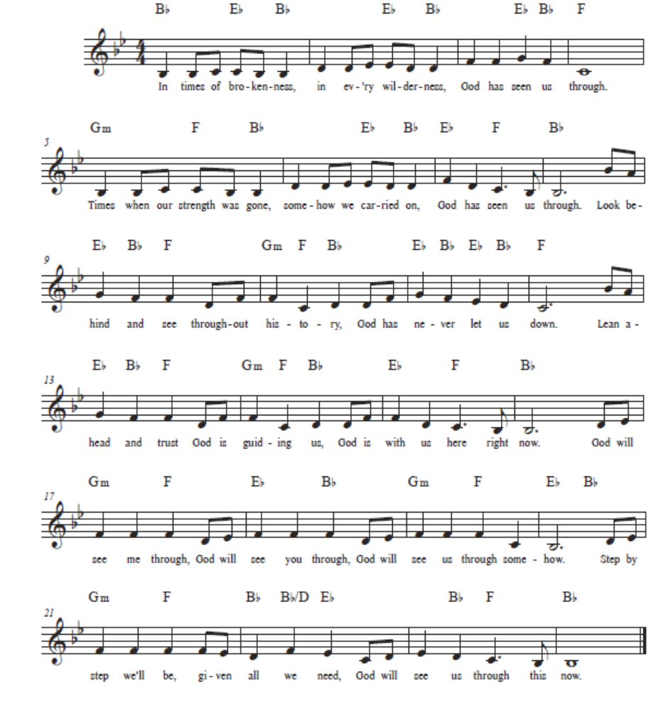

Benediction & Musical Postlude

Liturgical Resources

Notes On Music From The Liturgy

You’re thinking to yourself, “wow, that’s a lot of music for one worship,” and you’re right. There’s a reason for it. The content of Break The Silence Sunday is intense, and it requires a lot of heart-opening, a lot of willingness to let the Spirit move us in ways that probably make us uncomfortable. Music has the ability to let us rest, while also stretching and challenging us. It gives us the opportunity to hear, and learn our faith story, our theology, our call to God’s work in the world in a different way than simply spoken words do. Feel free to use all, or some, or none of these songs during your community’s worship time. There are additional suggestions for songs that speak well to the work of Break The Silence Sunday, and we welcome your suggestions of music that is helpful for your community.

“How Firm A Foundation” ~ From the New Century Hymnal #407

“We Have Come” by Christopher Grundy

is intended to be sung acapella. You can listen to a recording at http://www.christophergrundy.com/recordings/

The song is on the album “Stepping In”, track number four.

“I Am Welcome” by Bryan Sirchio

Used with grateful permission; for full accompaniment visit the Break The

Silence Sunday website; you can listen to a recording at:

http://sirchio.com/cds/01--worship/01--CDs/937

“All Belong Here”

Many thanks to Hannah & Lenora Rand and The Many for their beautiful song. You can find music, and a recording for the full song at: https://www.themanyarehere.com/allbelonghere

“I Love To Tell The Story Re-sung For Break The Silence Sunday”
Many thanks to Maren Tirabassi for her re-wording of this familiar hymn, and to Amy Englesdorfer for her transcription. “I Love To Tell The Story” is often sung to “Hankey” (in the New Century Hymnal #522), but here it is set to “Fischer”. Either setting will work.

“God Will See Us Through” by Emma Ceurvels and Bryan Sirchio

Used with grateful permission; for full accompaniment visit the Break The

Silence Sunday website; you can listen to a recording at: https://www.convergencemp.com/god-will-see-us-thoug.html

In addition to the song suggestions in the liturgy, you might consider other hymns with themes of healing, and justice. These are some suggestions from the New Century Hymnal (NCH):

“I Was There To Hear Your Borning Cry” (NCH #351)
“Help Us Accept Each Other” (NCH #388)
“My Life Flows On In Endless Song” (NCH #476)
“Amazing Grace” (NCH #547)
“Out Of The Depths, O God, We Call” (NCH #554)
“Lead Us From Death To Life” (NCH #581) – particularly the chorus
“Let Justice Flow Like Streams” (NCH #588)

Additional music you might consider for choir, band, teaching the congregation, or simply for listening:

“God Who Remembers” by Richard Bruxvoort Colligan

http://www.psalmimmersion.com/psalm-136

“God Is Our Refuge And Strength” by Andra Moran
https://www.etsy.com/shop/AMMOMusic

“Light Of Heaven” by Andra Moran
http://www.andramoran.com/track/8132/light-of-heaven?feature_id=59929

“Here In This Place” by Christopher Grundy
http://sites.fastspring.com/christophergrundy/product/catalog

“From My Hands” by Christopher Grundy (particularly the second verse)
http://www.christophergrundy.com/recordings/
On the CD “In This Life”

“Welcome To This Circle” by The River’s Voice
http://www.riversvoice.com/shop.php

“God Is Holding Your Life (Psalm 121)” by Richard Bruxvoort Colligan
http://www.psalmimmersion.com/psalm-121

“Move (Psalm 109)” by Richard Bruxvoort Colligan
http://www.psalmimmersion.com/#!move/cd4h

“Stand With You” by Bryan Sirchio
http://sirchio.com/songs/f/c/196

“You Are Mine” by David Haas
This wonderful song reflects on God’s promises in Isaiah 43. It is in several hymnals including The Faith We Sing at #2218

“God Weeps” by Shirley Erena Murray
This hymn, a lament about “strength misused” and “trust betrayed” reminds us that God weeps at the way we walk with each other. It is included in The Faith We Sing at #2048

“I Will Change Your Name” by The Nebblett Family
This song talks about God changing the of those who struggle from wounded, outcast, lonely or afraid” to “confidence, joyfulness, overcoming one”. You can see a video of the song here: https://www.youtube.com/watch?v=liOzd21u5MY

An Additional Prayer For Your Consideration
By the Rev William Kesting

Everlasting God, we are thankful for the courage of the people of the Break The Silence Movement. May we hear their stories. We pray that all people would truly listen to them. We pray for the healing of their pain and devastation that has occurred in their lives. We ask that all people in any type of power position would follow through on their accusations concerning their abuse. We seek justice for these victims. May this movement find your blessing of their sharing. May they feel your presence in their life long journey of healing. May the people in their lives who are secondary victims be caring and supportive of their search for wholeness. May they continue to choose life every day. In the name of the Holy One. Amen.

Scripture Reflections From A Survivor ~ the Rev Moira Finley

Isaiah 43.1-7

One of the things many survivors struggle with is feeling as if what happened to them has damaged the core of who they are, that the violation of rape and sexual abuse has made them damaged goods, unclean in the eyes of the world, and unworthy in God’s eyes. This passage from Isaiah offers an antidote to those ideas, a reminder that each of us has been named, and claimed by God, that whatever challenges might come in life we are secure in God’s care for us, a God who will be with us always. In addition, many (most) survivors ask where God was when they were in the midst of their trauma, and where God is now that they are trying to heal. Without dismissing the pain, this passage reminds us that God is with us when the rivers overflow, and when the fires feel as if they will consume us. God is with us in the midst of the suffering, continuing to claim us as God’s very own, and perhaps in that there is hope, a realization that God stands with us, weeps with us, and holds us in the darkest moments of our lives.

Psalm 139.1-18

This is one of my favorite psalms, both comforting and challenging, reminding me that that, whatever the world might say or do to us, it is God who knows who I have been, who I am now, and who I might yet become. God has known us our entire lives, from before the beginning, while we were still being formed in our mother’s wombs. As a survivor, the idea that there is nowhere I can go that God is not already present has been a great comfort. Even in the depths of Sheol (sometimes translated hell), God is with us. This reminds me that while I was suffering at the hands of the men who raped me, God was present with me, suffering alongside me, weeping and screaming with me. It’s a common struggle for survivors to ask, “where was God when I was being raped or abused?” I think that comes from our collective misunderstanding about what God can and can’t do in this world considering the free will God gave to humanity. That’s a longer conversation for another day, but it has been incredibly important in my journey towards healing to think of God’s being the first heart to break the night I was raped, that the God who created me, and knows me, and has loved me from all time was there with me, in the midst of the struggle, rather than far away ignoring what I was going through. One note about the rest of this psalm, verses 19-24. Generally I’m not a fan of leaving off the hard bits of scripture readings, of skipping over the parts we don’t like, but in this instance, given the weight of Break The Silence Sunday, and the importance of honoring survivors and creating space for them, I’d rather leave off the final verses here that deal with the wicked. There is surely a time and place for a discussion about the wicked in the work of dismantling rape culture, and maybe your Break The Silence Sunday Bible study is that place, but I don’t feel it’s either necessary or appropriate in the context of worship on this day.

Luke 13.10-17

In the midst of his travels throughout the region of Galilee, Jesus comes to a particular synagogue. It happens to be the Sabbath day, and Jesus meets a woman who has been unable to stand, completely bent over, for eighteen years. Immediately Jesus calls her and frees her from her illness, laying his hands on her and straightening her spine. The leaders of the synagogue don’t celebrate with the woman, but demand to know why Jesus would break the law by curing her on the Sabbath. Jesus calls out their hypocrisy saying that eighteen years is long enough and that this woman should be set free from her struggles, particularly on the Sabbath, a day dedicated to the God who desires our wholeness. As a survivor, I both love and fear this scripture. The fear comes from the idea of brokenness, of this woman’s infirmity being used as a direct parallel to being a survivor. I already struggle with feeling broken, less than whole, impure, and more. I don’t need the scriptures to reinforce those feelings, and I surely don’t need a preacher to go on about how if I just trusted in God enough, or believed in Jesus enough, then I would be freed from all those feelings, that I would be as whole and healed as the woman in the scriptures. But there is also great hope in this scripture, that in coming to God, in standing in the synagogue where God’s people gather, in being seen and known by the Holy One, I and my survivor sisters and brothers might begin the process of becoming whole, and healed, and standing up straight for the first time in many years. When I read this scripture I think of the idea, “If not here, where? If not now, when?” Shouldn’t the children of God come to the church for healing, to be seen and knows as they are, and to be freed from what has kept them bent over with shame and fear for all these years? Shouldn’t the children of God come to the church on the Sabbath day itself, when the presence of God is felt more keenly, when the holiness of all whom God has created is known more clearly, that their stories might be heard in love, and transformed with grace?

A Sample Sermon

By Jason Eisele, preached at Church of the Good Shepherd U.C.C. In Carbondale, IL on January 14, 2018

Psalm 139:1-6, 13-18

May the words spoken and those received be only in your service, great God of Love. Amen.

Today’s scripture is about the intimate relationship between human beings and God. In Genesis 1:27 we are told that God created us in God’s own image. In the New Testament, we see God put on our own humanity to live and die as one of us through the person of Jesus of Nazareth. The connection between God and humanity is so close and intimate that in Matthew 25 we are told that whatever we have done or failed to do to our neighbor is also how we have treated God.

Friends, throughout scripture, we are referred to as God’s beloved children. All of us. You, me, and everyone we meet is beloved to God. And that needs to define how we treat others in all areas of our lives.

Today’s sermon is going to be about the importance of consent and respect in Christian sexual ethics- not really what today’s scripture is about on face value, but something that’s been on my heart all week, and not irrelevant to today’s scripture if we believe that God really knows and cares about every aspect of our lives. I decided not to preach on another text the lectionary offered, 1 Corinthians 6:12-20, which was on the topic of sexual ethics because, frankly, I know I’m not the only person here that has been hurt by churches before. And a lot of folks here have had scripture verses used as a club to hurt them in the past.

I’m not going to do that- I love y’all, and I hope that you trust me to not try to do anything that would hurt you. That’s actually the opposite of what I’m trying to do today- Sex can be a beautiful gift from God, and one that I want to make sure that those of us who choose to engage in sexual activity are doing so in a respectful and consensual manner that lifts up others, and doesn’t hurt God’s beloved sons and daughters.

I’m not going to get graphic or crude in today’s sermon, but I also want to give people a chance to step out of the room if you’re not comfortable hearing a sermon on the

topic of ensuring that sex is respectful and consensual, or if you would prefer for your children not to hear it. After all, it would be a bit hypocritical of me to preach on consent without first giving everyone a chance to opt out. Nobody will think any less of you if you would prefer to step into the narthex for a few minutes, and then re-join us after the sermon is over.

I believe that sex is intended to be among the countless beautiful and amazing gifts that God has given us in this world, and that, done properly, it can be a wonderful thing. But it’s like a lot of gifts God has given us. We can use this gift to lift up our neighbor and make this world a kinder, better place, or we can weaponize this gift and use it in a manner that causes suffering to both God and to human beings. It’s up to us how we’re going to use it.

Love and romantic relationships can be beautiful, and I believe that they are pleasing to God. I’ll specifically say that gay, straight, and other genuinely mutual, consensual, adult relationships are something that I believe can bring tremendous joy to the heart of God. I don’t know if anyone else feels like this- but you know that sweet, happy feeling you get in your heart when you see two doves cuddling on a power line? I think God feels the same way looking at a happy couple.

But real love always includes genuine respect. 1 Corinthians 13 sums up what real love looks like: “Love is patient. Love is kind. Love is not envious or boastful or arrogant or rude. Love does not insist on its own way, it is not irritable or resentful; it does not rejoice in wrongdoing, but rejoices in the truth.”

That is how the Bible describes love. And that’s how we treat someone that we genuinely love and respect. We’ve been called to love all of our neighbors- see the first and greatest commandment in Matthew 22:34-40, when Jesus was asked what the most important commandment was and he responded by telling us to love God and our neighbor. In fact, in 1 John 4:20, we’re told that we cannot truly love God, who we cannot see directly, if we don’t love our neighbor who is right there in front of us. And I think this should be especially true when it comes to someone with whom we are sharing our bodies in an intimate manner.

Getting back to 1 Corinthians 13 Love is patient- God doesn’t want us to pressure people into sex. Love is kind- If we’re being faithful Christians, we should avoid making unwanted advances towards others or doing things that might make another person feel uncomfortable or afraid. Christians have been called to understand and respect it when someone says no, whether it’s to a physical act or even regarding spoken words. If someone doesn’t want you coming on to them, then leave them alone. It’s as simple as that. They have a right to tell you no.

Love is not envious or boastful or arrogant or rude. Love does not insist on its own way, it is not irritable or resentful; it does not rejoice in wrongdoing, but rejoices in the truth.

Friends, consent is sacred. I think about it this way: Even God respects human free will, and we are not above God. Consent is tremendously important, but we don’t talk about it nearly enough. When it comes to sex, everyone has a right to say no, and that right should always be respected immediately, never questioned, and never responded to with pressure.

Silence is not consent, especially among people that may feel uncomfortable voicing their concerns to you. Especially if you are in a position of power or authority over someone, like a boss, a pastor, or –God forbid- a parent or grandparent (those are both specifically forbidden in Leviticus 18) where they have reason to be concerned about saying no, then they can’t really agree to say yes, either. It’s another sermon entirely, but scripture is consistent and clear about the evil of abusing authority.

Families can come in all shapes and sizes, and I’m not here to judge anything that’s harmless and consensual. But I think the Bible meant what it says about adultery. If you have agreed to a monogamous relationship with a partner and they haven’t willingly consented to let you sleep with someone aside from them, please don’t cheat on them. Few things can hurt someone worse. There’s a good reason that adultery made the list of Ten Commandments from Exodus 20.

Some people just plain can’t consent to sex, no matter what they do, so leave them alone until such a time as they can. If someone is drunk, for example- it is evil to take advantage of them. They aren’t thinking normally, and it’s wrong to take advantage of them. They cannot consent, and the answer is no until they sober up. Going back to Matthew 25, where Jesus tells us that whatever we’ve done to our neighbor we’ve also done to him, would you really want to be standing in front of God at the final judgment and hear Jesus tell us “I was drunk, and you took advantage of that and violated me?” Our neighbor is sacred and beloved to God, and we owe it to them and to God to respect that.

Children or anyone else that can’t be held responsible for their own actions have every right to say no, but it shouldn’t be their responsibility to do so. If you’re a victim of childhood sexual abuse, please let me assure you that it is absolutely, positively NOT your fault. Even if the adult got you to agree to what they did to you, and you’ve spent your whole life feeling like it was your decision, it’s not your fault. If you were a vulnerable child, there is literally nothing you could have done that would make it your fault. It’s the adult’s responsibility to be the adult and respect you enough not to take advantage of a child.

Friends, we need to work together to change rape culture in our society. We need to model respect towards our fellow human beings in the way we live, the way we talk, and the way we act. And when male or female survivors of sexual harassment, assault, or rape trust us enough to share their stories, listen to them. Don’t argue, don’t rationalize. For the love of God, don’t minimize. Believe them. When we’re around other men, we can’t risk sending the message that rape or acts demeaning of others are ever funny or acceptable to us.

Respect your partners. Don’t pretend to love someone to get them in bed. In today’s age of digital media, if someone shares private pictures with you, keep them private. Even if you later have a nasty break up- never release private pictures or videos of them without their consent. Too many people have committed suicide over that nonsense already. Don’t do it. And guys- if she wants to see pictures of any particular part of you, she’ll ask. Don’t send her unsolicited pictures of your anatomy. Just because you want to see someone else naked doesn’t mean they want to see you naked.

This sermon isn’t going to lecture you on abstinence prior to marriage- We’re not in the Bronze Age anymore. For straight couples, understand that birth control is both partner’s responsibility. For all couples, even if it’s painful, don’t keep secrets that could be dangerous to your partner. We’ve all read the Golden Rule from Luke 6:31: Do unto others as you would have them do unto you. You wouldn’t want anyone risking exposing you to diseases, so don’t risk exposing them to anything. Tell the truth about your status, whether it’s regarding diseases or whether or not you’re a woman on birth control. Respect your partner the way you want to be respected.

Your body is yours. Your partner’s body is theirs. And consent over what you agree to allow someone else to do to your body is absolutely and exclusively yours, just as consent regarding what they allow you to do with their body is entirely theirs. Nothing is consent other than happily and enthusiastically agreeing to something. A past sexual history, to include marriage, is not consent. The way someone is dressed is not consent.

Agreeing to a date is not consent for anything more than that, and even then, either party should feel free to leave if they start feeling uncomfortable. Just because someone agrees to one thing doesn’t mean that they agree to anything more than that, and people have the right to change their mind and ask their partner to stop at any point. If your partner does that, you stop. Immediately. No questions asked. Either party has the right to put the brakes on at any time, no matter what has happened in the past. Even if you’ve slept together before, that doesn’t constitute an agreement to do anything again without permission.

Now we’ve covered the basics, there’s just one more thing that I would like to leave you with. These are some good guidelines that are intended to keep everyone safe and happy in intimate situations. The first and most widely known is SSC: Ask yourself if both partners agree that each act is Safe, Sane, and Consensual?

Another acronym, RACK, is often used by people with more extreme practices, but I actually think it’s better than SSC because it’s a lot less subjective. After all, different people are likely to define “sane” differently. RACK stands for Risk Aware Consensual Kink. In other words, do both partners understand any and all risks associated with what they’re doing, and where necessary, have they taken steps to minimize them? Consent- it’s an ongoing process. My wife and I have been married for years, and I never assume consent with her until she’s verified it for me. Kink? Well, things don’t really have to be kinky to effectively use this acronym, but it won’t spell the word RACK without it.

Sermon Suggestions

You need to carefully consider what your community needs during the sermon time on Break The Silence Sunday. Are you part of a community that is already familiar with the issues of rape and sexual violence? Is yours a community where these are new, and frightening topics? Does your community frequently engage in justice work in the world beyond the church doors? Are you aware of survivors in your pews, some who have shared their stories with you?

You could choose to use one of the survivor stories included in these materials. You could invite someone from a local resource organization to speak about their services to your community. And, of course, you can craft your own sermon.

If you choose to write your own sermon, you need to go carefully. The work of Break The Silence Sunday is to support survivors in their journey of healing. Don’t preach about any shoulds. Don’t tell survivors that they should forgive those who have hurt them, or should share their stories, or should behave in any particular way. This is not the moment to glorify the cross, so please don’t preach about the redemptive suffering of Jesus.

This is a time to speak about healing and wholeness, and the hope that Christ’s community can provide. This is a time to talk about justice – a justice for individual survivors (perhaps through the criminal justice system, but surely through having their voice heard and their stories honored in the church); and justice for all creation as we work to change the culture that allows this violence to continue.

There are scripture suggestions in the included liturgy. Isaiah 43.1-7 speaks of God’s claiming and naming each of us, walking with us through the struggles and fear of our lives; Psalm 130 is a prayer of trust that God will always be with us; and Luke 8.42b-48 tells the story of a woman with an issue of blood who is healed by Jesus’ touch, the important portion of this scripture being the freedom she feels to tell her story to the gathered community.

These scriptures all point toward a God of hope, of companionship, and of justice. There are other scriptures that you could use to speak of God’s support for those who are suffering, those who have been victims of injustice and violence, and those who have been silenced. You might also consider some of the other healing stories in the New Testament, but remember that healing is not necessarily physical, but an ability to fully participate in the life and work of the community, the chance for someone to be remembered, honored, and respected.

If your community is already engaged in the difficult work of justice on behalf of survivors, you might consider the story in Judges 19. It is a difficult scripture, and you will want to do considerable exegetical work, as well as much faithful preparation of your community so they are ready to hear, and receive the text.

You are invited to consider the final lines of Judges 19, whether you use that scripture in worship or not. Verse 20 reads (from the NRSV, emphasis added):

Then he commanded the men he sent, saying, “Thus shall you say to all the Israelites, ‘Has such a thing ever happened since the day that the Israelites came up from the land of Egypt until this day? Consider it, take counsel, and speak out.’”

That is the work of Break The Silence Sunday, and your work in preaching and leading worship …
- Consider it - recognize the problem, admit that rape and sexual violence are real, hurting members of your community, and society as a whole
- Take Counsel – learn about rape and sexual violence, listen to the stories of survivors without judgment, walk with them through the struggles, support and encourage them as they journey towards healing and hope
- Speak Out – say something, often, be a voice for justice, for changing our communities, for creating places of peace and safety for all

Talking With Children & Youth

It’s a scary thought, that we need to talk to our children and youth about rape and sexual assault, but the reality of the world we live in means we need to prepare them to be aware of their bodies, how to set boundaries, and that, should something happen, they will be safe in telling about it.

Everything needs to be age appropriate, using words and ideas that each child can understand. The conversations should start early, when children are young, giving children the words to describe their bodies accurately, talking about what is and isn’t appropriate touch, and how to speak up when something feels wrong. Help young children understand that some body parts are private, that it’s ok to say no, and that they won’t be in trouble if they tell you something.

As children grow into their teen years the conversation needs to change. Sexual assault needs to be addressed directly. Continue conversations about consent, about the right everyone has to say no concerning their body; about staying aware about what is happening at parties, and when they’re out with their friends; and help them understand that most people who are sexually assaulted are the victims of someone they know, that perpetrators don’t look like the bad guy in the dark alley sometimes portrayed in the media, but in reality 93% of victims who are minors know their perpetrator. Help teens understand that violence has no place in a loving relationship.

Keep in mind that clergy in the state of Wisconsin are mandatory reporters of child abuse (sexual or otherwise). Information about the mandatory reporting requirements, and what they mean for the clergy, can be found via the Wisconsin Child Welfare Professional Development System at: http://wcwpds.wisc.edu/mandatedreporter/requirements.html

These links may also be helpful in gathering information to talk to children and youth about rape, sexual abuse, and sexual violence:

Talking To Your Kids About Sexual Assault ~ RAINN

https://www.rainn.org/articles/talking-your-kids-about-sexual-assault

Tip Sheet For Talking To Children and Teens ~ Stop It Now

http://www.stopitnow.org/ohc-content/tip-sheet-8

Start Talking (to engage teens about dating violence) ~ Love Is Respect

http://www.loveisrespect.org/resources/start-talking/

Talking To Your Children ~ US Department of Justice National Sex Offender Public Website

https://www.nsopw.gov/en-US/Education/TalkingChild?AspxAutoDetectCookieSupport=1 - top

Break The Silence Sunday Clergy Commitment

As a Christian pastor, as someone who tries to follow in the footsteps of Jesus of Nazareth, and as a human being committed to working for the dignity and equality of all people, I declare to survivors of sexual violence that:

- I am a person to whom you can tell your story of sexual abuse, harassment, assault, violence, and more.
- I will listen without judgement, and without condemnation.
- I will hold all you tell me in sacred confidence, within the bounds of law.
- I will listen to whatever you need to say, and however you need to say it.
- I will honor your story, and remind you of the dignity and worth you have as a child of God, created in God’s own image, and I will remind you that you are more than your story.
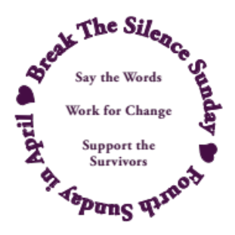
- I will walk beside you on your healing journey, accompanying you as best as I am able, and as you need to counseling appointments, court dates, or wherever else you need me to be with you.
- I am here for you, and with you.
- I stand with you.
- I believe you.

© Break The Silence Sunday, the Rev Moira Finley, October 2017

Some Statistics

- There are an average of 321,500 people (age 12 and older) raped or sexually assaulted in the Untied States each year. (Source – U.S. Department of Justice, Office of Justice Programs, Bureau of Justice Statistics, National Crime Victimization Survey. 2010-2014)

- Let’s do some math: there are 31,536,000 seconds per year (in a non-leap year). If we divide the number of victims (321,500) by the number of seconds it means that there is an average of one assault every 98 seconds.

- In addition to the 321,500 people listed above, each year an additional:
  - 80,600 inmates are raped to assaulted
  - 60,000 children are sexually abused
  - 18,900 members of the United States military are on the receiving end of unwanted sexual contact

- Approximately 55% of victims are assaulted in or near their own home, and an additional 12% are assaulted in or near a relative’s home. (Source: Department of Justice, Office of Justice Programs, Bureau of Justice Statistics, Female Victims of Sexual Violence, 1994-2010. 2013)

- As of 1998, 17.7 million women in the United States (1 out of every 6) and 2.78 million men in the United States (1 out of every 33) have been the victim of an attempted or completed rape in their lifetime (source – National Institute of Justice & Centers for Disease Control & Prevention. Prevalence, Incidence, and Consequences of Violence Against Women Survey. 1998)

- 15% of sexual assault and rape victims are under the age of 12 (source – U.S. Bureau of Justice Statistics, Sex Offenses and Offenders. 1997)

- The year in a man’s life when he is most likely to be the victim of a sexual assault is age 4. The year in a woman’s life is age 14. (Source – U.S. Bureau of Justice Statistics. 2000 Sexual Assault Of Young Children As Reported To Law Enforcement. 2000)

- 93% of juvenile sexual assault victims know their attacker (Source – U.S. Bureau of Justice Statistics. 2000 Sexual Assault Of Young Children As Reported To Law Enforcement. 2000)

For additional information on how the statistics are compiled, and additional crime reporting statistics please visit:

https://www.rainn.org/statistics/scope-problem

Some Helpful Definitions

Acquaintance Rape/Assault – where the perpetrator(s) is previously known to the victim; occurs in approximately 4 out of every 5 rapes/assaults in the United States; acquaintance may refer to a date (hence “date rape”), domestic partner, former partner, family member, classmate, neighbor, boss, coworker, and more.

Attempted Rape/Assault – a threat or rape or sexual assault, including verbal threats, and those made in other ways such as electronic communication (email, text), and on social media (Facebook, Tumbler, Twitter)

Domestic Violence – violence, and threats of violence, between spouses, domestic partners, and those who are co-habitating.

Force – methods used to coerce a victim into a non-consensual sex; this may include the use of a weapon, or physical violence, but also includes emotional and psychological manipulation, threats to the victim’s family, the withholding of finances, intimidation, threats regarding employment or child custody, and more.

Incest – sexual contact (which may or may not include penetration) between closely related persons such as parents, children, grandparents, aunts, uncles, siblings, cousins; in legal terms incest is often described as the crime of sexual contact between people who may not be legally married

Post Traumatic Stress Disorder (PTSD) – a condition resulting from the experiencing (or witnessing) of a traumatic event that causes long-term difficulty with flashbacks, intrusive memories, and severe anxiety; not all rape survivors will develop PTSD

Rape – a form of sexual assault; the U.S. Bureau of Justice Statistics defines rape as forced sexual intercourse which is defined as “vaginal, anal, or oral penetration by the offender(s)”; this also includes incidents where the penetration is by an object such as a bottle; legal definitions vary by state, and some states do not use this term at all in their laws instead they have degrees/grades of sexual assault.

Rape Culture – the way in which society blames victims of rape and sexual assault, and normalizes this violence, particularly male against female violence; the assumption that rape and sexual assault are an inevitable part of life; this includes the use of the word rape in other contexts (for example, when a sports team is defeated and commentators say “they were raped”), as well as the objectification of women’s bodies including school dress codes and purity movements that seek to control and limit women’s behaviors
Sexual Assault – sexual contact or behavior that occurs without explicit consent of the victim; this includes, but is not limited to: penetration of the victim’s body (see rape), attempted rape, forcing a victim to perform sexual acts on the perpetrator, fondling, unwanted sexual touching.

Stranger Rape/Assault – where the perpetrator(s) is previously unknown to the victim; occurs in approximately 1 of every 5 rapes/assaults in the United States.

Survivor Guilt – though most often associated with being a survivor after a mass catastrophe (such as an airplane crash), this phrase has also come to mean the guilt imposed on survivors of rape and sexual assault because of some perceived action, or inaction on their part

Victim Blaming – words and actions that imply the victim of rape or sexual assault is to blame for the actions of the perpetrator(s); this can be through questions about what the victim was wearing, why they were out alone, why they didn’t fight back, if they had been drinking or had previous sexual relations with the perpetrator, and questions about the previous sexual activity of the victim

Resources

General Information About Rape & Sexual Assault

- Rape Abuse Incest National Network (RAINN) – includes links to their online and telephone counseling services, http://www.rainn.org

- National Sexual Violence Resource Center, http://www.nsvrc.org

- Joyful Heart Foundation, http://www.joyfulheartfoundation.org

- No More (a national campaign to end sexual and domestic violence), http://nomore.org

- “What’s Their Problem? Sharing Our Pews With Sexual Abuse Victims and Survivors”, from Christ And Pop Culture, http://christandpopculture.com/whats-problem-sharing-pews-sexual-abuse-victims-survivors/

Current Resources about Cases In The Media

- On the scandal in U.S.A. Gymnastics, the scope of the abuse, and the cover-up: https://www.huffingtonpost.com/entry/larry-nassar-abuse-victims-public-outrage_us_5a58f619e4b03c4189654efe

- On Pope Francis and the abuse scandal in Chile: http://time.com/5109212/pope-francis-sexual-abuse-chile-barros-karadima/

- Time Magazine on their Person of the Year: http://time.com/time-person-of-the-year-2017-silence-breakers/

- U.S. Supreme Court Justice Ruth Badger Ginsberg speaking about her own experience of #metoo (video): http://abcnews.go.com/Politics/supreme-court-justice-ginsburg-shares-metoo-experience/story?id=52518887

- Actress Viola Davis’ speech at the 2018 Women’s March in Washington, D.C. (video): http://www.cnn.com/videos/us/2018/01/20/viola-davis-full-speech-womens-march-la.cnn

- Gymnast Aly Raisman’s testimony against U.S.A. Gymnastics Dr. Larry Nasser before his sentencing for sexual assault against Ms Raisman and others (video & full text of her statement): http://time.com/5110455/aly-raisman-larry-nassar-testimony-trial/

- Singer Halsey reading her poem at the 2018 Women’s March in New York City, this video includes graphic descriptions of sexual violence: https://www.cnn.com/videos/us/2018/01/22/halsey-women-march-speech-poem-abuse-jnd-sot.cnn

Resources on PTSD

- From the Department of Veteran’s Affairs: http://www.ptsd.va.gov/public/PTSD-overview/basics/index.asp

- From the Rape Abuse Incest National Network (specific to rape victims): https://rainn.org/effects-of-sexual-assault/post-traumatic-stress-disorder

State of Wisconsin Resources

- Wisconsin Coalition Against Sexual Assault

Telephone: 608-257-1516; http://www.wcasa.org
Offers information and referral on any issue related to sexual violence; does not offer direct services to victims/survivors, but will connect them to local agencies

- County by County resources – please visit our website http://www.breakthesilencesunday.org and the Resources tab to find a chart which will identify sexual assault resource organizations in each Wisconsin county

Feedback Form ~ Break The Silence Sunday 2018

Please return to: BTSS c/o Moira Finley
PO Box 691
Bonduel, WI 54017

You may also submit this information by email at breakthesilencesunday@gmail.com

Your name:________________________________________________________

Your position (pastor/worship leader/other):______________________________

Your community/church:_____________________________________________

Did you use the Break The Silence Sunday Liturgy?

- Yes, as it was provided

- Yes, but we adapted it; please list how you adapted it:

- We used parts of it, but not the entire liturgy; please list the parts used:

- No, we wrote our own liturgy; if you are willing to share the liturgy you used, please email it to breakthesilencesunday@gmail.com or post to the above address

Please continue to the other side --->

What did you use during the sermon time?
- A survivor in our community shared their story (if possible, please connect them with us by emailing contact information to breakthesilencesunday@gmail.com)
- A community resource person came to help our community think through issues of sexual assault and rape
- Wrote our own sermon (if you are willing to share, please email it to breakthesilencesunday@gmail.com or post to the above address)
- Something else; please describe…

What could we provide to you for 2019 that would help you better prepare, and lead Break The Silence Sunday?

Any additional comments, suggestions, concerns?

Martin Luther King Jr. "The Trumpet of Conscience" Steeler Lecture, November 1967

